Tuesday 12th January
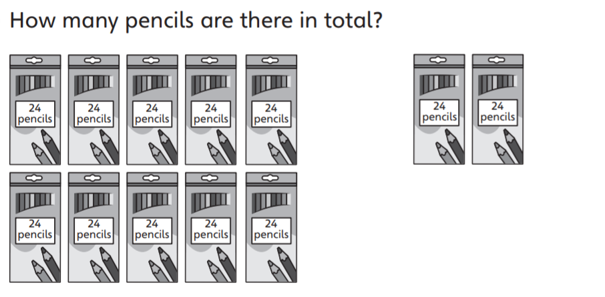
10 x = 2 x =
+ =
There are …………. Pencils in total.

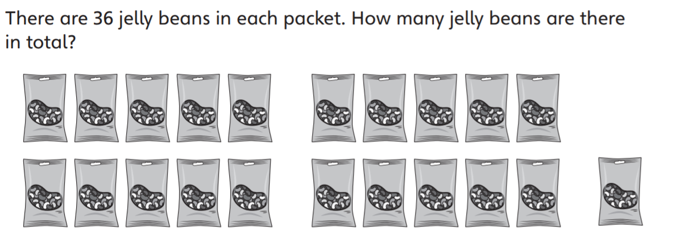
21 x 36= x 36 + x 36 + x 36
= + +
= There are ………. Jelly beans in total.

Whose method did you prefer and why?
…………………………………………………………………………………………………………….
…………………………………………………………………………………………………………….

Work out.
- 25 x 13

- 41 x 24

- 14 x 62



