Science home learning for week beginning 13th July 2020
LO: To make careful observational drawings of an insect found in the local environment.

Watch the video clip about award the winning photographer, Levon Biss.
http://microsculpture.net/
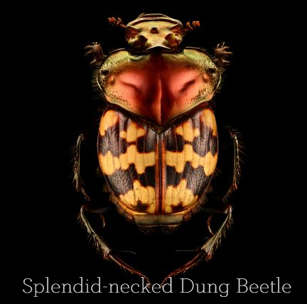
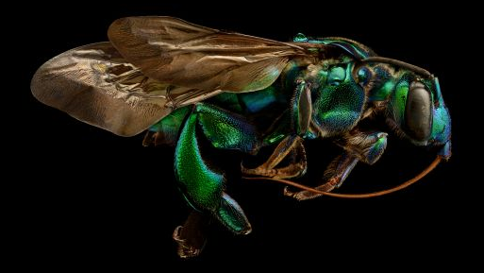

Look in your garden or local environment. Can you find an insect? Can you find an invertebrate? Take a photo of it with a device (phone, ipad, camera). Can you magnify your image and on an A4 piece of paper create a wonderful large scale drawing of your insect? Keep looking again and again at your photo and see the detail. Try to include that in your drawing.
Below are some tips to help you with your drawing.


