Focus: Ceremonies that mark milestones in life.
LO: To learn about the Sikh baby naming ceremony – Naam Karan.
Look at the powerpoint about Naam Karan.
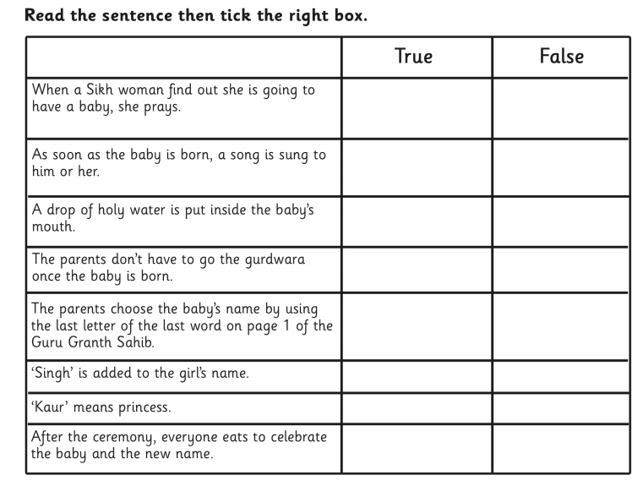
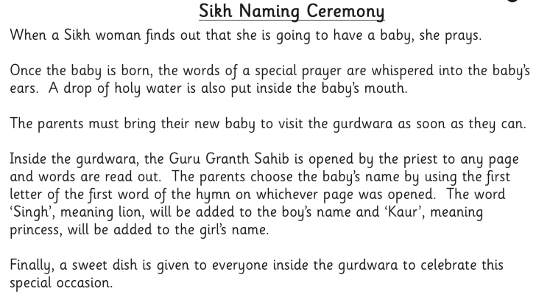
Read the text below and decide if the statements are true or false

