French Home learning week beginning 13.7.20
LO: To identify items of clothing

Look at the clothes below. Draw an outline of a person and then dress your person with the clothes below. Or, if you have chalk, you could draw it on the floor outside and take a picture.
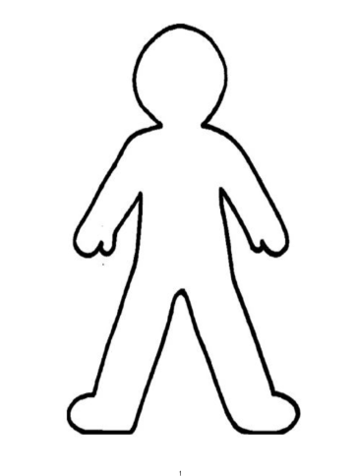
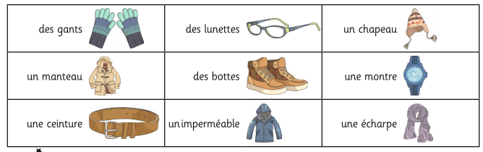
Label each piece of clothing.

