Year 3 Home Learning-WB 22.06.20
Our key priorities for learning this week:
- Maths- Times table practice, MyMaths angles + turns, angle worksheets
- English-coastal poetry and SPAG booklet
- Reading- Read to an adult each day (must) + reading comprehension
  English-please complete every day:  Writing: This week we would like you to plan and write a poem all about our coast and sea animals.  OR make an information poster about your chosen sea creatures eg. a crab, a lobster, a seahorse, a seal….  Reading: reading 1:1 and reading comprehension  LINK to the comprehension here ROCKPOOLS:  https://www.vocabularyninja.co.uk/uploads/1/1/0/0/110032277/7-8_9781472969231_preview.pdf  Words of the week: exile, puddle, savage, emptiness, ocean |  | Maths-please complete every day:  Choose from…….  - Please complete a page a day on ultimate times table practice  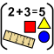  - Turns and Angles : meet the angle family (bubble Brown loved this!). Then have a go at the worksheets looking at angles and then there are some tasks on MyMaths o do too about angles.
Choose at least one activity per day from the list below

Science  ICE CUBE challenge:  We are going to investigate the best insulation for an ice cube!  First: put two ice cubes into a bowl of water. Use a stop watch to time how long it takes them to melt. Record.  Next: think of insulation materials eg.foil, paper, plastic etc. to insulate an ice cube.  Get resources ready.  Now, wrap up your ice cubes into chosen insulations.  Place into the bowl and start timing. Record.  What happened? Was there a difference in time this time?  Have fun, this will be a laugh!   | Music  Charanga.    Use your login and follow the lesson. |  | PSHE    In Exmouth there are an amazing team who keep us safe when we go the beach with our families. The RNLI charity funded sea rescue service are amazing and we would like you to research about them and then make a thank you poster and send it to Miss Brown who will send it to them.
PE  It’s the Summer term so let’s practice for sports day as this is what we would be doing if we were in school.  - Try timing yourself or ask mum or dad to help you, running a spring of 60m.  - You could try throwing tennis balls into an empty bin, 10 points for each one in!  - Standing Jump- see how far you can jump from two feet, landing on two feet.  - Hurdles: Make an obstacle course / create a hurdle race jumping over objects.  Or    Design your own P.E. activity that we could use in a P.E. lesson. The best ideas I will use for P.E. home learning in the coming weeks! | Geography/French  Learn all about Devon! Where it is. What is famous about Devon and where we live in Devon. Then turn your facts into a visitor guide to Devon. Try and persuade people why Devon is the best place ever!!  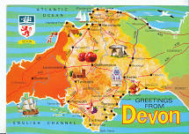 |  | Art  Water colour paint sea scapes- Use water colours to make a coastal sea scape. There are lots of images on google, here’s one: 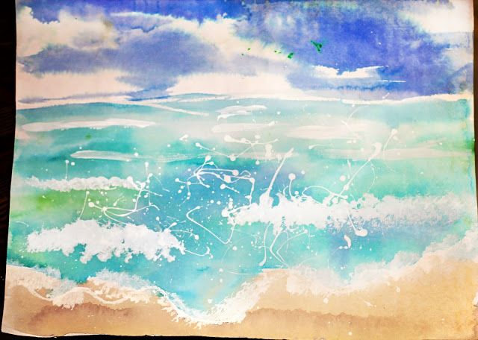  Design Technology  Design a beach hut - two-week project using 2l juice cartons to create them  
We miss you all so much!!!
Miss Brown, Mrs Keilty & Mrs Cameron


