Monday 11th January
LO: to multiply 2 digit numbers

- Use the area model to calculate 26x14

X | 20 | 6
10 | ……. X ……….= | …. X ……. =
4 | …. X ……. = | …. X ……. =

- Use the area model to work work out 17x 24

X

- Work out these multiplications
- 27 x 34 = b) 53 x 38 =

- Each day, Mike runs 41km. How far does he run in 19 days?

- Bella has worked out 53 x 27
Circle the mistakes Bella has made. What is the correct answer?
X | 50 | 3
20 | 50 x 20= 100 | 3 x 20 = 60
7 | 50 x 7 = 350 | 3 x 7 = 10
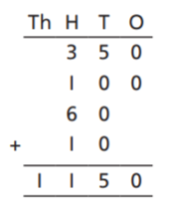
6.
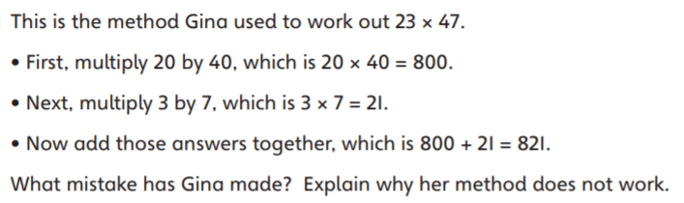

……………………………………………………………………………………………………………………………………………………………………………..
7.
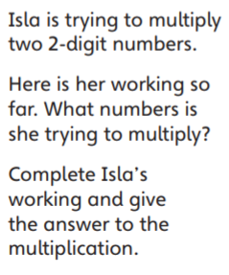
X
 | 900 | 240
 |  | 48

