Year 3 Home Learning-WB 08.06.20
Our key priorities for learning this week:
- Maths- maths summer booklet.
- English- maths summer booklet
- Reading- Reading comprehension each day. Choose from the website
  English-please complete every day:  Writing: Work your way through the summer booklet. Please can you do at least 1 page a day but if you want to do a few each day that is fine.  Reading: Reading comprehension sheets + reading to an adult each day. Please record in records.  Words of the week:  mansion, grimy, cautiously, trespass, disagreeable |  | Maths-please complete every day:  Choose from…….  - Summer activity booklet (minimum 1 page per day)  - classroom secrets  - TT rockstars  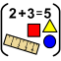
Choose at least one activity per day from the list below

Science    Read through and have a look at the powerpoint all about the parts of the flower. Follow the powerpoint and then select the correct worksheet to try at home. | Music    Follow https://www.bbc.co.uk/bitesize/topics/zbnrmfr/articles/zrwkhbk and sing along with the choir of children to ‘Somewhere only we know’ and then learn about the different aspects of music: diction, tuning, phrasing etc……. |  | PSHE  This Is Me! I Am Special!  We would like you to create a fact file about you. You could write s short report or make a top trumps style information card/ favourite foods, drinks/hobbies/pets/your family / things people don’t know about you etc….what makes you YOU!!!    Add a portrait of you doing your favourite things too!
PE  It’s the Summer term so let’s practice for sports day as this is what we would be doing if we were in school.    Now it is time to practice our long jump. Set this up safely in your garden (maybe use a yoga mat if you have one). Set a line out where you will jump from and then get somebody at home to measure how far you jump! Can you beat your jumping distance each day? Remember you must measure from the back of your landing foot (no cheating!) | Geography  Begin to look at maps and how to use them. I would like you to just start this week by trying to learn about symbols that are used on a map and their meanings.  Use the matching activity to look at each symbol and match it to the correct meaning. You can check your answers on page 3. |  |   Art & Design  This project is over the next 2 weeks. We would like the children to design and make a stone age scene from a shoe box. You could make little stone age people from clay or paper, create another hut to put in the box….. below are some ideas:  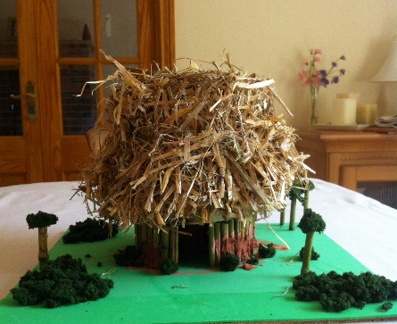  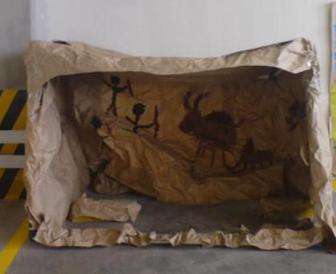  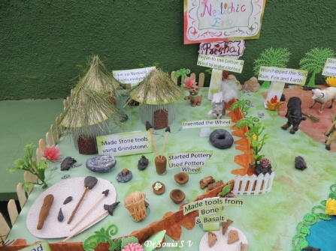  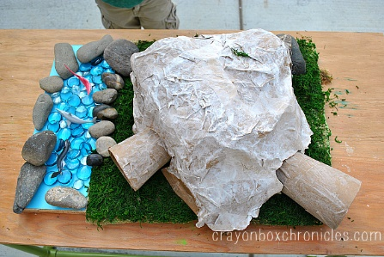
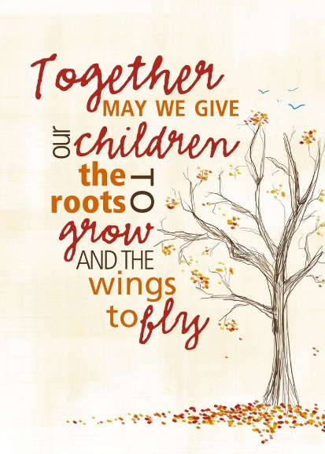

We miss you all so much!!!
Miss Brown, Mrs Keilty & Mrs Cameron

