EYFS Home Learning – 11.2.22
Sorry you can’t be in class with us today.
Below are some activities linked to the learning we will be doing in school.
Phonics: | Please practise previously taught sounds – see Tapestry.  This week we are practising reading and writing words made up of 4 sounds.  We will be building the words slam, slip, swill. Your child is to use the sound  cards you have at home to build these words. Make sure they say the sounds as they build the word. They are then to practise writing these words. Again, encourage your child to say the sounds as they write them.  Challenge: Try and write the caption: The pink mug went slam.
English: | LO: Re-tell the story using pictures to help.  Listen to the Runaway Wok by Ying Chang Compestine.  https://video.link/w/fQnZc  Ask your child what happened at the start of the story? And at the end of the story? Show pictures of the story on the SMART emphasising the language of first, next, then and finally. Ask children to check to see if they are in the right order. Challenge the children to see if they can re-tell the story of the Runaway Wok to you using the pictures to help them. Encourage the use of complete sentences.
Reading: | Read for at least 10 minutes the decodable book you have been sent home.  Recap words to learn by sight: all, come, some, to
Maths: | Use a wooden ramp on top of a box to roll toy cars or balls down, and play a game to see which car travels the furthest down the ramp. Your child can measure with anything (hands, steps, blocks, lego etc) Ask your child to record scores on a piece of paper and encourage them to use language such as furthest, longest. Can they think of any ways to make the cars travel even further? e.g. Make the ramp steeper/make the box taller.
Writing: | See resource to write the captions: Jump went the wok. The wok ran off.  Encourage your child to say the sounds as they write the word.
Expressive art and design: | 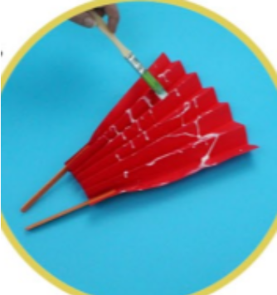  Create paper chain snakes, Chinese lanterns or fans to celebrate Chinese New Year.  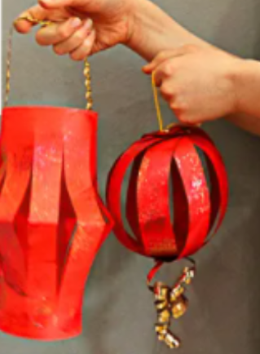  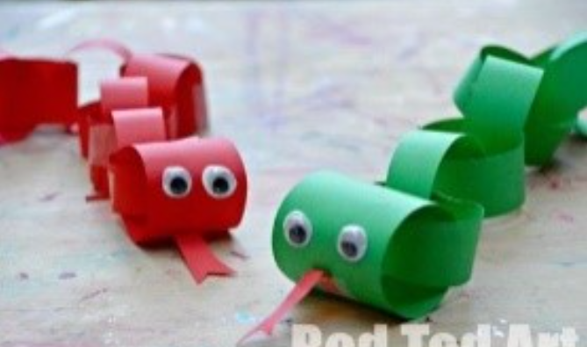
Understanding the world: | We are continuing our learning about Chinese New Year. Please listen to Ruby’s Chinese New Year.  https://video.link/w/ietZc  Can you draw or paint a picture about Chinese New Year.
PSED | Play a turn-taking game with your child (a board game, a card game, dominoes, etc) Focus on taking turns and winning (or losing) gracefully!
PSHE | Talk about different roles that adults do. Ask your child what they would like to be when they grow up? How will they get there? What do they think they will need to do?
Thank you for supporting your child with their learning while they are at home. If you have any questions, please use class dojo and upload any work completed to Tapestry.
We hope to see you soon.

