EYFS Home Learning – 10.2.22
Sorry you can’t be in class with us today.
Below are some activities linked to the learning we will be doing in school.
Phonics: | Please practise previously taught sounds – see Tapestry.  This week we are practising reading and writing words made up of 4 sounds.  We will be building the words clip, grin, skip. Your child is to use the sound  cards you have at home to build these words. Make sure they say the sounds as they build the word. They are then to practise writing these words. Again, encourage your child to say the sounds as they write them.  Challenge: Try and write the caption: He must slip the frogs in to the pink mug.
English: | LO: Connect an idea using the word ‘and’  Listen to the Runaway Wok by Ying Chang Compestine.  https://video.link/w/fQnZc  Reinforce the plot (that Ming is giving to the poor and sharing) and ask your child to think independently about what they would share with Ming. Introduce the connective ‘and’ and model the sentence ‘I would share... and...’ The focus is on using the word ‘and’ to connect two ideas together.
Reading: | Read for at least 10 minutes the decodable book you have been sent home.  Recap words to learn by sight: all, come, some, to
Maths: | Draw around your child’s foot onto a sheet of paper. How can we measure how long your foot is? Encourage them to notice that we can use any non-standard units to measure things, as long as they are all the same, e.g. cubes/ paperclips/pencils/glue sticks. Measure the footprint and write the number of items used next to it. _____’s foot is 12 cubes long. Do the same for yourself and ask your child to estimate whose footprint is longer/shorter and how many cubes/paperclips long they think it might be. What else could we measure at home? Encourage your child to measure and record different objects throughout the day. Model language of long, short, longer, shorter, tall, taller, wider, narrower to make comparisons.
Writing: | See resource to write the captions: Jump went the wok. The wok ran off.  Encourage your child to say the sounds as they write the word.
Expressive art and design: | 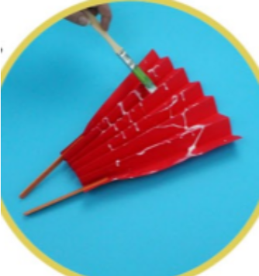  Create paper chain snakes, Chinese lanterns or fans to celebrate Chinese New Year.  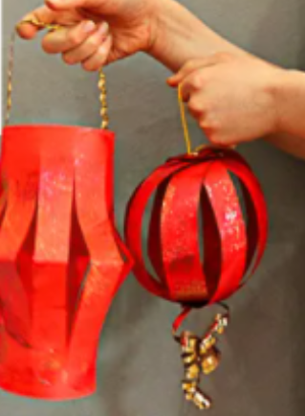  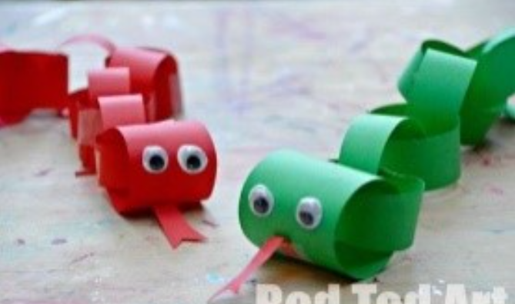
Understanding the world: | We are continuing our learning about Chinese New Year. Please listen to Ruby’s Chinese New Year.  https://video.link/w/ietZc  Can you draw or paint a picture about Chinese New Year.
PSED | Play a turn-taking game with your child (a board game, a card game, dominoes, etc) Focus on taking turns and winning (or losing) gracefully!
Thank you for supporting your child with their learning while they are at home. If you have any questions, please use class dojo and upload any work completed to Tapestry.
We hope to see you soon.

