EYFS Home Learning – 9.2.22
Sorry you can’t be in class with us today.
Below are some activities linked to the learning we will be doing in school.
Phonics: | Please practise previously taught sounds – see Tapestry.  This week we are practising reading and writing words made up of 4 sounds.  We will be building the words sniff, trap, step. Your child is to use the sound  cards you have at home to build these words. Make sure they say the sounds as they build the word. They are then to practise writing these words. Again, encourage your child to say the sounds as they write them.  Challenge: Try and write the caption: Dan must stop the frogs.
English: | LO: To speak in complete sentences.  Listen to the Runaway Wok by Ying Chang Compestine.  https://video.link/w/fQnZc  Ask your child what were the 3 things that the wok brought to the Zhang family (food, toys and money). Introduce the sentence starter ‘I want the wok to bring me....’ Firstly, ask your child to think of their favourite food and then say their sentence ‘I want the wok to bring me a doughnut’. Repeat activity with their favourite toy.
Reading: | Read for at least 10 minutes the decodable book you have been sent home.  Recap words to learn by sight: all, come, some, to
Maths: | Challenge your child to a competition. Explain that you want to see who can throw a ball the furthest distance! Remind your child that we always have to start from the same place to make measuring fair. Ask your child to throw a beanbag as far as they can, and then take giant steps from the starting line and count how many steps it takes for them to get to the ball. Record the score. Take your turn and record the distance in steps. Ask your child, ‘Whose number is the highest? Who threw their beanbag the furthest distance?’
Handwriting: | Practice zigzag monster letter formation. Letters v, w, x, z. See resources from 7.2.22.
Expressive art and design: | 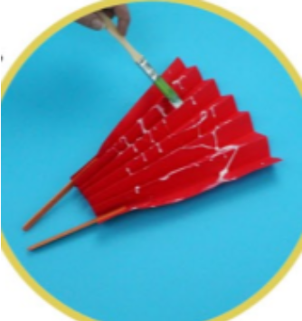  Create paper chain snakes, Chinese lanterns or fans to celebrate Chinese New Year.  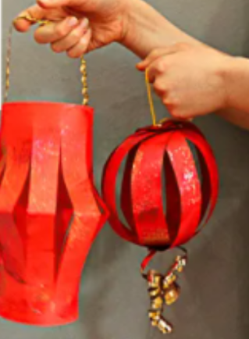  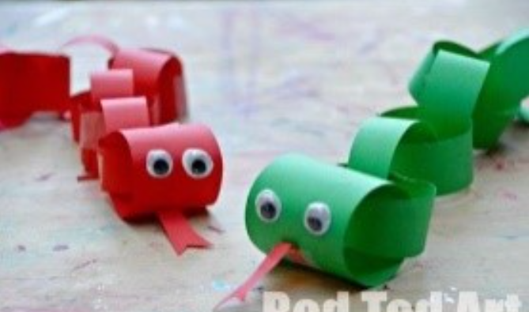
Understanding the world: | We are continuing our learning about Chinese New Year. Please listen to Ruby’s Chinese New Year.  https://video.link/w/ietZc  Can you draw or paint a picture about Chinese New Year.
PSED | Play a turn-taking game with your child (a board game, a card game, dominoes, etc) Focus on taking turns and winning (or losing) gracefully!

Thank you for supporting your child with their learning while they are at home. If you have any questions, please use class dojo and upload any work completed to Tapestry.
We hope to see you soon.

