EYFS Home Learning – 8.2.22
Sorry you can’t be in class with us today.
Below are some activities linked to the learning we will be doing in school.
Phonics: | Please practise previously taught sounds – see Tapestry.  This week we are practising reading and writing words made up of 4 sounds.  We will be building the words plan, slam, smell. Your child is to use the sound  cards you have at home to build these words. Make sure they say the sounds as they build the word. They are then to practise writing these words. Again, encourage your child to say the sounds as they write them.  Challenge: Try and write the caption: The twin frogs swim in the sink.
English: | LO: Use questions to check understanding.  Listen to the Runaway Wok by Ying Chang Compestine.  https://video.link/w/fQnZc  Recap unfamiliar vocabulary. Ask your child the following questions to check understanding of the story.  1) Is the wok good or bad? Why?  2) Why is the wok stealing from the Li family?  3) What did the wok steal?  4) What happened to the Li family?
Reading: | Read for at least 10 minutes the decodable book you have been sent home.  Recap words to learn by sight: all, come, some, to
Maths: | Introduce children to new vocabulary: measure, height, taller, shorter. Use Sophie’s Sunflower resource. If you have lego or duplo at home, use this to measure 5 different objects at home and record the number. Put them in order from shortest to tallest.  Alternatively, use the measuring flowers resource. Cut the flowers out and stick them in the correct order from shortest to tallest.
Handwriting: | Practice zigzag monster letter formation. Letters v, w, x, z. See resources from 7.2.22.
Expressive art and design: | 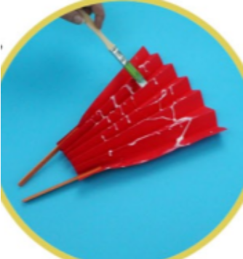  Create paper chain snakes, Chinese lanterns or fans to celebrate Chinese New Year.  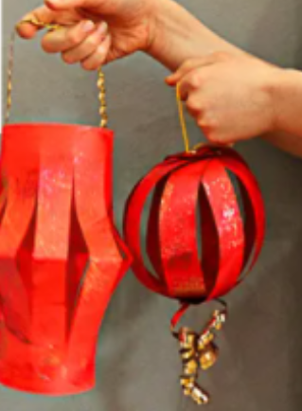  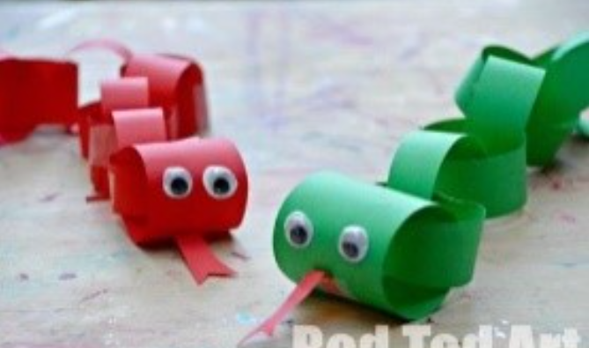
Understanding the world: | We are continuing our learning about Chinese New Year. Please listen to Ruby’s Chinese New Year.  https://video.link/w/ietZc  Can you draw or paint a picture about Chinese New Year.

Thank you for supporting your child with their learning while they are at home.
If you have any questions, please use class dojo and upload any work completed to Tapestry.
We hope to see you soon.

