EYFS Home Learning – 7.2.22
Sorry you can’t be in class with us today.
Below are some activities linked to the learning we will be doing in school.
Phonics: | Please practise previously taught sounds – see Tapestry.  This week we are practising reading and writing words made up of 4 sounds.  We will be building the words crab, grab, gruff . Your child is to use the sound  cards you have at home to build these words. Make sure they say the sounds as they build the word. They are then to practise writing these words. Again, encourage your child to say the sounds as they write them.  Challenge: Try and write the caption: The frogs swim in the sink.
English: | LO: Listen to a traditional story from another culture.  Listen to the Runaway Wok by Ying Chang Compestine.  https://video.link/w/fQnZc  Discuss unfamiliar vocabulary and names (examples: wok, Beijing, rusty, sauntered). Encourage your child to join in with the rhyme ‘skippity, hoppity, ho’ each time. Look at the pictures and discuss cultural differences. Ask your child to tell you what they liked the most about the story.
Reading: | Read for at least 10 minutes the decodable book you have been sent home.  Recap words to learn by sight: all, come, some, to
Maths: | Introduce children to new vocabulary: measure, length, longer, shorter. Using the Connor Caterpillar resource, explore measuring length with your child. Cut the caterpillars out and put them in order from shortest to longest and then longest to shortest. Ask your child to count how many segments are in each caterpillar to check the length (don’t worry about counting the caterpillars that are longer than 10 segments!).
Handwriting: | Practice zigzag monster letter formation. Letters v, w, x, z. See resources.
Expressive art and design: | 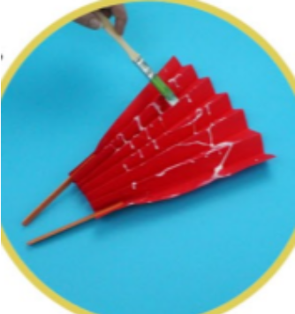  Create paper chain snakes, Chinese lanterns or fans to celebrate Chinese New Year.  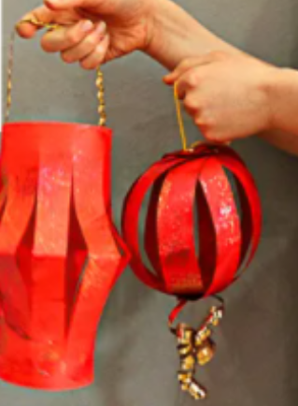  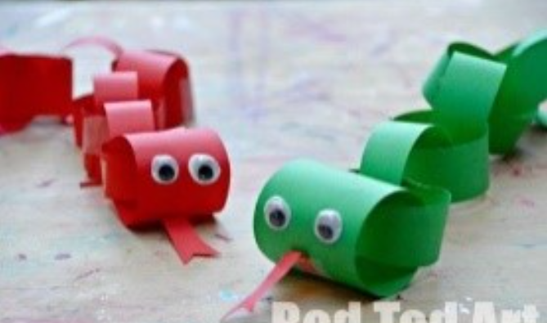

Thank you for supporting your child with their learning while they are at home.
If you have any questions, please use class dojo and upload any work completed to Tapestry.
We hope to see you soon.

