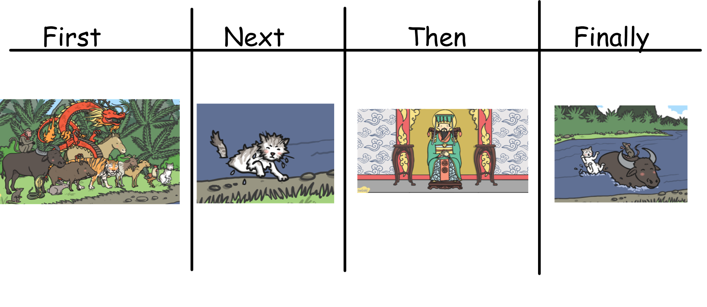
Cut the pictures out and put them in the correct order.

