Self assessment


LO: Understand how to use apostrophes for possession
Apostrophes for possession
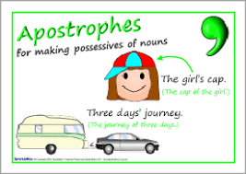
Write a sentence with an apostrophe for each of the
sentences.
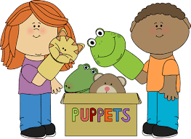
Example

The children’s puppets.



__________________________________________________________________________


________________________________________________________________________


____________________________________________________________________________


_________________________________________________________________________

