Use these things to help you:
- A Number square
- A calculator
- A wipe board

LO: Maths investigation of square numbers:

Hard
If a number is PALINDROMIC, it can be read the same way forwards as backwards e.g. 989 or 1001

Challenge: Can you find the first 3 numbers that are square numbers and are also palindromes?
(CLUE: The answers are more than 100, but less than 1000)

Tricky
Challenge: can you find 2 square numbers that add together to make another square number?

Challenge: can you find 3 square numbers that add together to make another square number?

OK
Find the square numbers by following the pattern.
Use 2 different colours to make the square bigger:
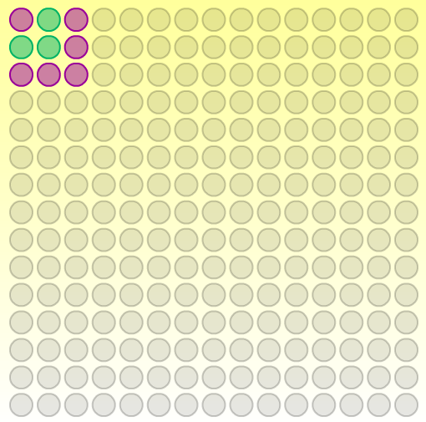
Odd number | Square number | Pattern
+1 | 1 | 1X1=1
+3 | 4 | 2x2=4
+5
+7

http://nrich.maths.org/content/id/2275/SumOddIntegers.swf

Answers

2 square numbers that add to make a square number
- 9 + 16 = 25
- 36 + 64 = 100
- 81 + 144 = 225

Square numbers that are palindromes
- 121
- 484
- 676

3 square numbers that add to make a square number
- 4 + 9 + 36 = 49
- 1 + 16 + 64 = 81
- 16 + 25 + 400 = 441

