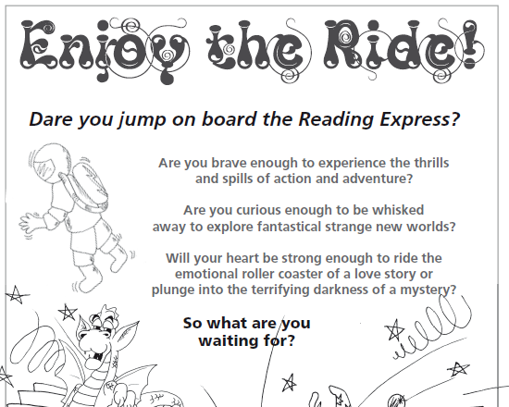
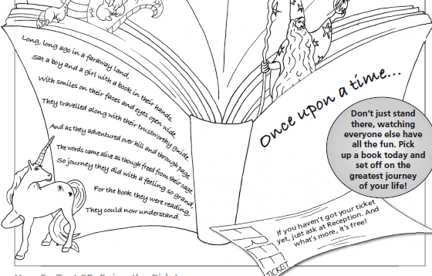

Can you find a word that means 'you want to know more'?

What do you think 'to be whisked away' means?

Which ride does the author use to describe our emotions?
Why do you think the author describes i in this way?

Highlight the word plunge. What does it mean? Why do you think the author chose this word?

