Monday 11th May
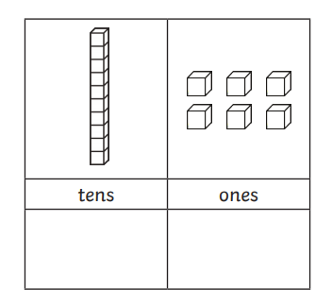
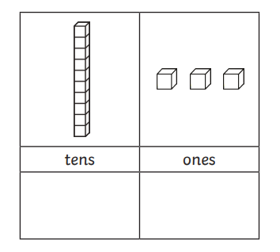
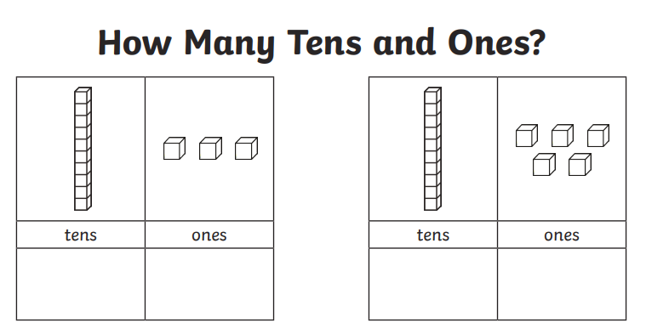
LO: Recognise teen numbers as ten and some more.

Now, can you draw tens and ones for these numbers;
11 17 18 12 14 19

Diving for Depth
Can you work out the missing numbers?

