Tuesday 12th May
LO: Match numbers, images and words for teen numbers

Match the pairs that represent the same number
15
Seventeen

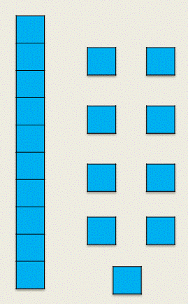

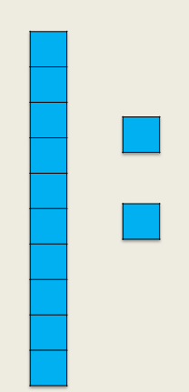

thirteen

fourteen
19

12

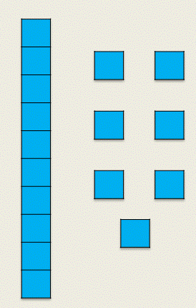

Diving for Depth

Can you write all the teen numbers and write the words to match?

