Thursday 14th May
LO: Partition teen numbers into tens and ones

Using an item you have in your house – such as counters, lego, straws (anything fairly small), make an amount between 11 and 19.
Separate the ten from the one – so create two groups for the number.
Write an equation for the number.
For example
10+2=12

Can you do this for every number between 11 and 19?

Diving for Depth
Teen Numbers  Can you fill in the missing numbers in the equations? |  | 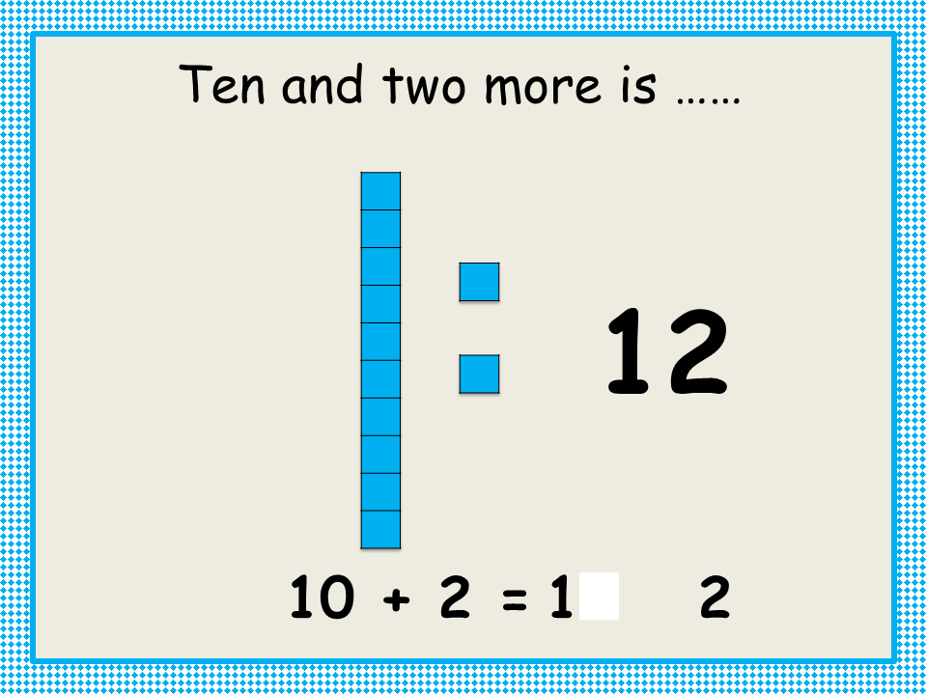 | 10 + = 11
 | 10 + 2 = ____ | 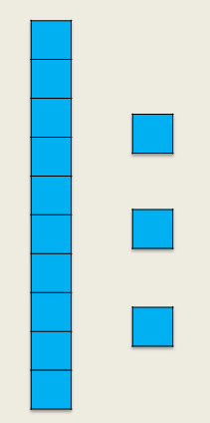 | 10 + 3 = ____
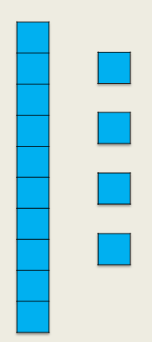 | + 4 = 14 | 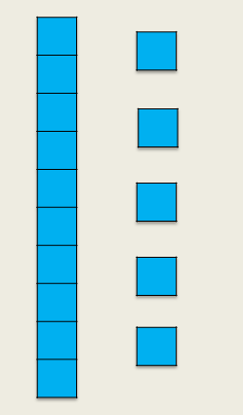 | + 5 = 15
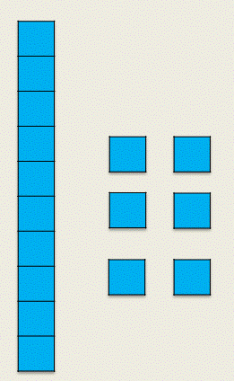 | 10 + 6 = ____ | 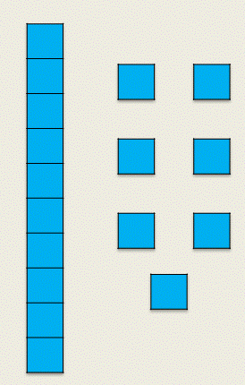 | 10 + 7 = ____
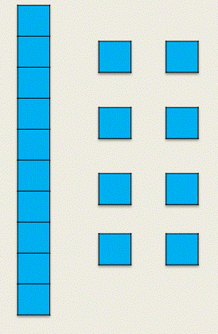 | 10 + = 18 | 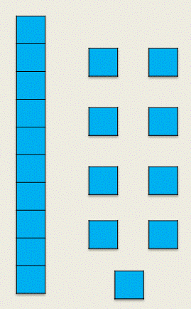 | 10 + = 19

