Wednesday 10th June 2020
Read this explanation with someone at home to find out more about rainbows: You can listen to an audio version of the text below here: https://soundcloud.com/talkforwriting/why-rainbows/s-Ov4K1MVNQjn

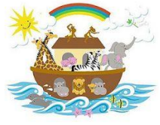
Why is the rainbow an important image? How do you feel when you see a rainbow? Maybe you marvel at the colours. Perhaps you wonder what’s at the end of the rainbow. Rainbows have been important to people from the beginning of time. Read on to find out why. Some people believe that the first time a rainbow was seen was by Noah. In the bible story of Noah’s Ark, a rainbow appeared which showed that the sun was coming out and the terrible storm was over. The rainbow was a sign of hope.

In addition, rainbows are part of the myths of many cultures around the world. In Norse mythology, there is a rainbow bridge that reaches between Earth and the realm of the Gods. Rainbows were bridges in the ancient beliefs of Japan and Gabon, too. Therefore, the rainbow was seen as important to human happiness. There is also a famous Irish legend about a pot of gold at the end of a rainbow that is guarded by a leprechaun. As the pot of gold has never been found, there is the hope that it will be … one day!
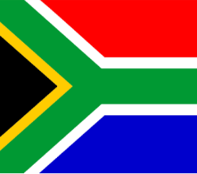
In South Africa, the rainbow was
used as a symbol of hope and peace
after a long period of white and black
people being separated by their skin
colour ended. To encourage everyone to come together, no matter where they were from or what colour their skin was, famous religious leader Archbishop Desmond Tutu called South Africa a ‘rainbow nation’. The South African flag has six colours which is believed to be linked to the ‘rainbow nation’ idea. Today, all over the world, the rainbow is a symbol of hope and peace.
It is believed that the spectrum of colours represents difference and the beauty of everyone being different to one another. Celebrating and enjoying difference leads to peace (no arguments or wars). The rainbow appearing in the sky is a sign that the storm is over which is why people see the rainbow as a sign of hope: hope for a sunny day and better things to happen in our world. 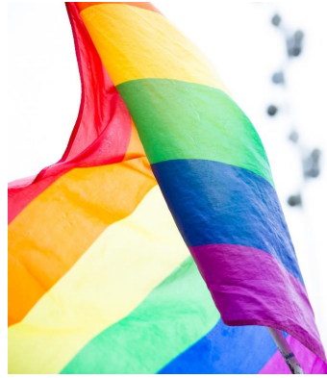

Talk challenge
★Talk to someone at home about the rainbow and why it is important to some people. Here are some ideas of things to talk about:
▪ What ideas do you have about the rainbow as a symbol?
▪ What else have you seen the rainbow or rainbow flag used as a symbol for?
▪ If you were writing this explanation what other information would you have included?
★Have you seen any rainbow pictures in people’s windows? Perhaps you have one in yours! Imagine that an alien has just landed on your street or near your home and has asked you why people are displaying rainbow pictures in their windows.
Think about what you would say and then have a go at explaining why there are rainbow pictures in people’s windows.
You may find these sentence starters help you:
At the moment, there is an illness …
Rainbows represent …
People display rainbow pictures to …
Rainbow pictures make people feel …
When people see the rainbows they …
Talk super-challenge
★When you are happy with your explanation, why don’t you record it? You could use the voice record function on someone’s phone (remember to ask permission).
★Listen to your recording and see if there’s something you could improve. Think about how clearly you are speaking and whether your voice sounds interesting to listen to. If you are allowed to, you could publish your recording on Twitter! Don’t forget to tag us @Talk4Writing.

