13.1.21
LO: Understand the inverse relationship between addition and subtraction using the first, then and now structure

- Act out these First, then and now stories
- Use manipulatives to show these stories
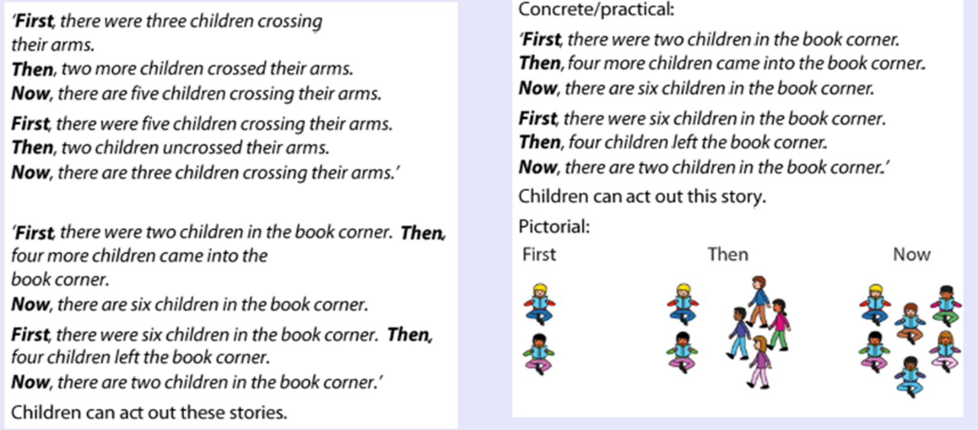
DFD: Write these stories as an equation

