15.1.21
LO: Using skills acquired to answer questions based on augmentation and reduction

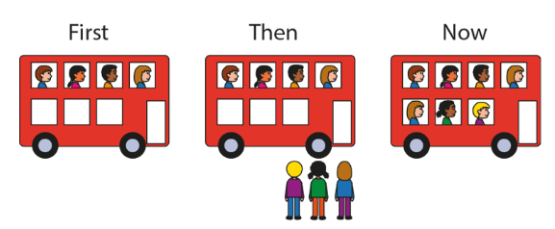
- Write the equation that this story is representing.

- Which equation is correct, circle your answer?
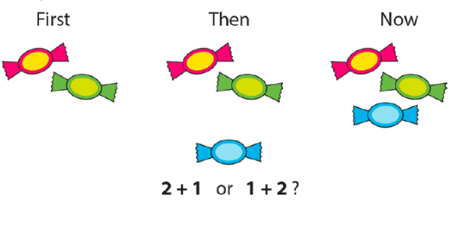

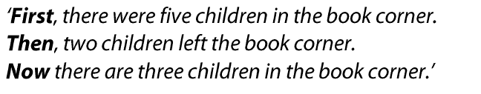
- Write the equation that this story is representing.

- Look at the dogs in this story and fill in the missing part. Write an equation when you have found the missing part.

- Write the inverse equation to this one:

4 + 6 = 10

