25.1.21
LO: To develop an understanding for an addend of one in an equation
Activity: Come up with 6 First, Then and Now stories just adding 1. Write the equation that the story is representing.
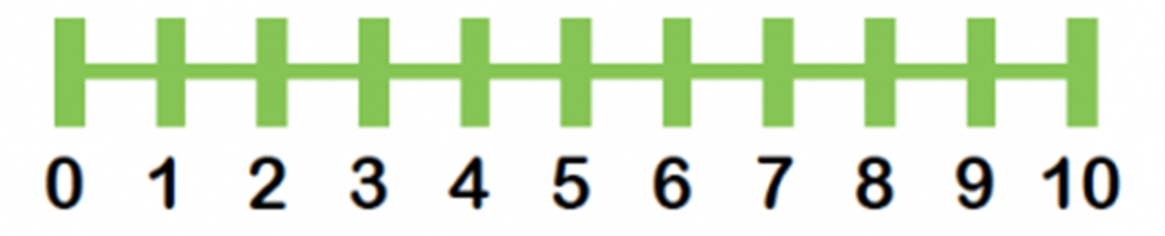
Remember that adding one gives one more. Here is a number line to help you, and a First, Then and Now board, if you would like to print it out.


