26.1.2021
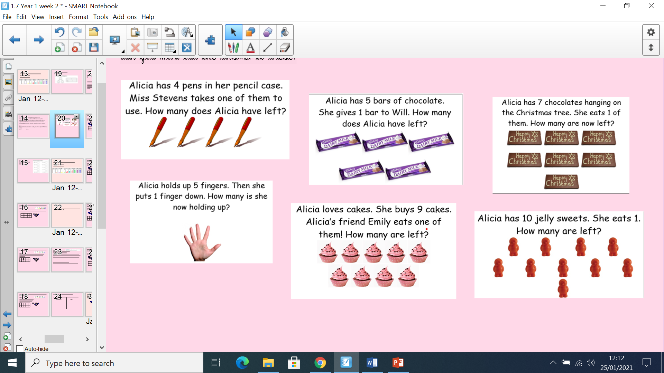
LO: Applying one more, one less knowledge to equations.

