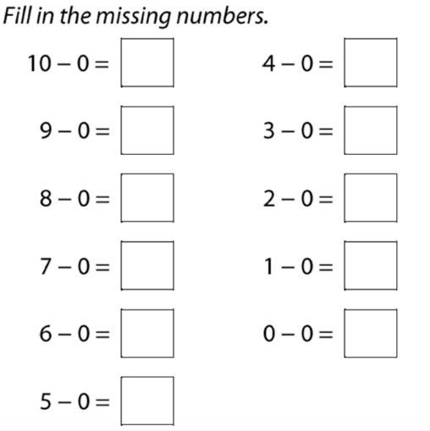
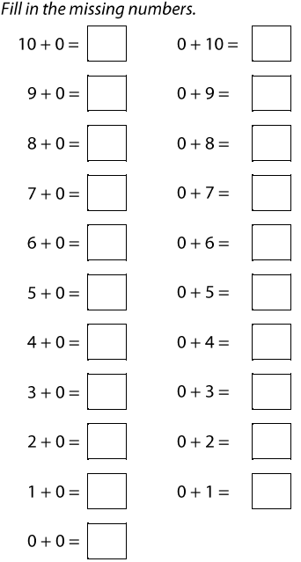
3.2.21
LO: LO: To know that when adding or subtracting 0 the number remains the same.
* Use a first, then and now board to represent an addition and subtraction equation.
** Use a first, then and now board to represent stories with a difference of 0.
*** Complete addition and subtraction equations that show a difference of 0.

