HARVEST FESTIVAL
Thank you for all the generous donations for our Harvest Festival this week. The children enjoyed an assembly with Rev. Simon Atkinson from Brixington Community Church. He explained the importance of the Exmouth Community Larder to many families within our town.
A special thanks to our Ethos Team members, Honey and Ellie H, for helping to collect up and sort all the contributions.
HOME LEARNING
Reading – keep reading regularly, every day if possible.
Spellings – Next week, we will be focusing our spelling work on homophones (words that sound the same but have different spellings / meanings). For home learning this week, the children should write a sentence for each of the words in the list below.
rain rein reign
whose who’s
weather whether
Times tables – Children should continue to practise the times tables (and related division facts). This can be done in lots of different ways – games, quizzes, online activities etc.
TTRockstars is just one way to practise.
Children can log on at https://play.ttrockstars.com
BIKEABILITY
Well done to everyone who took part in the Bikeability sessions today. The instructors were impressed with the children’s skills. Certificates will be given out next week.
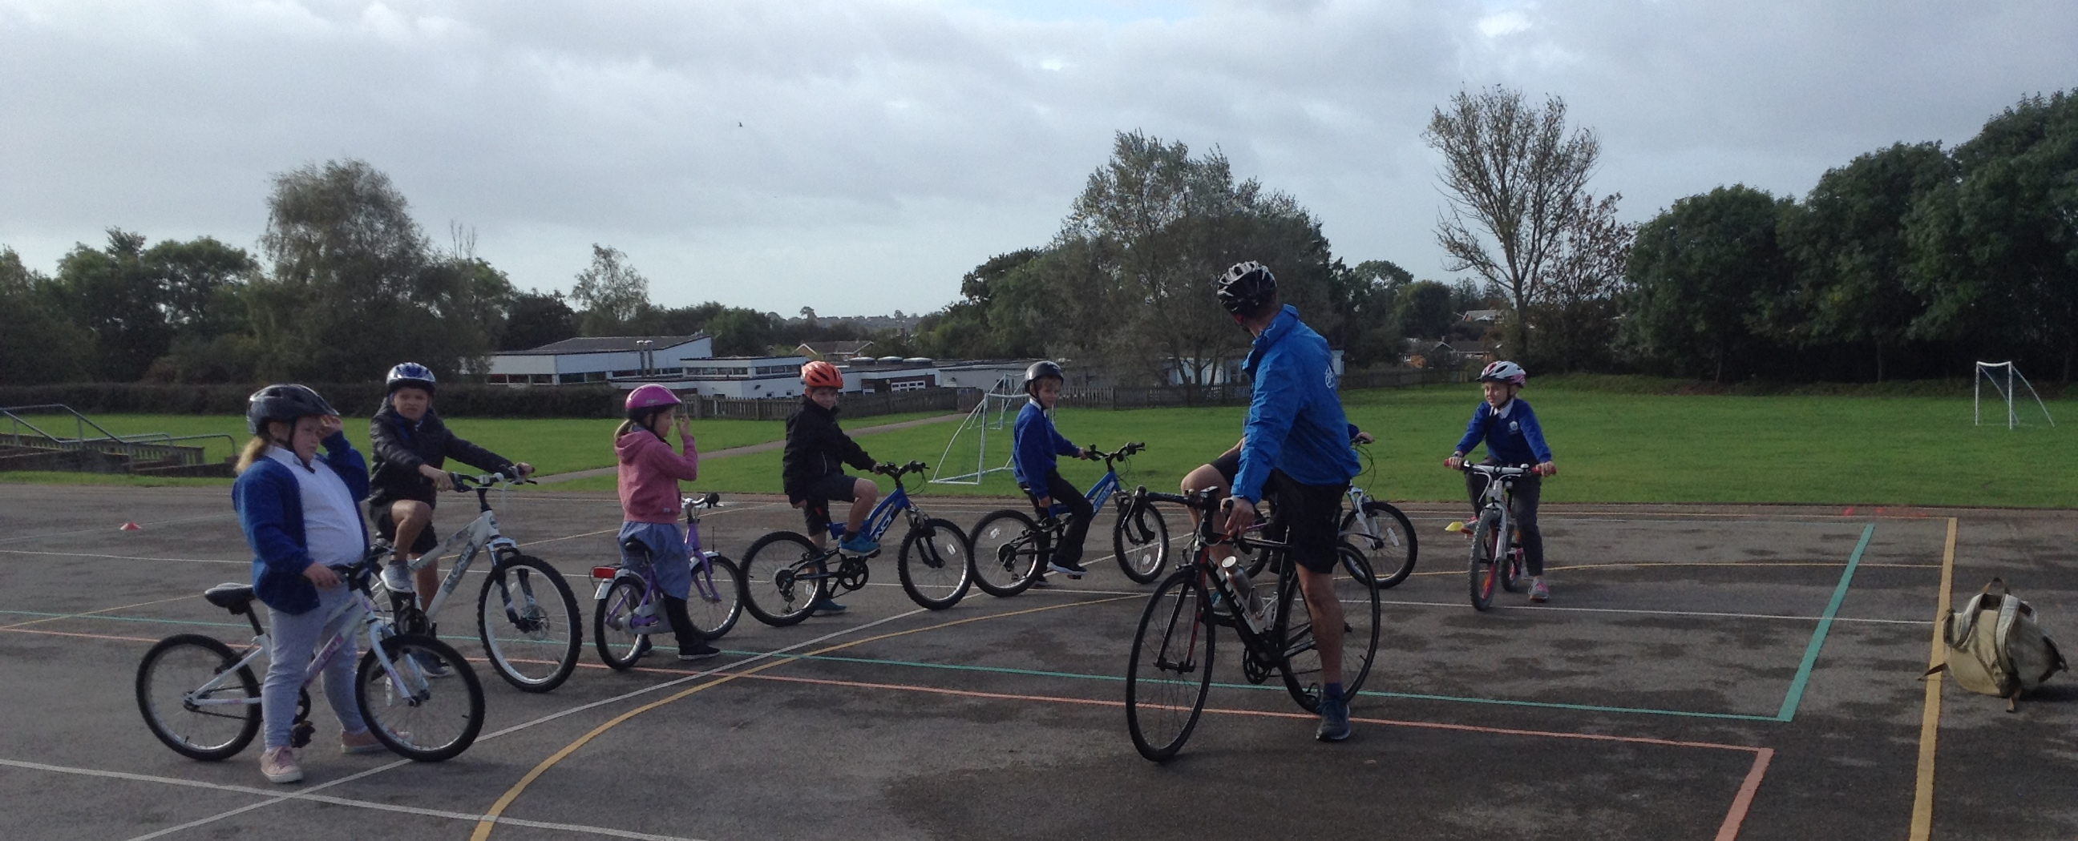

READING
Well done to everyone who has been reading regularly and quizzing on their books this week.
Year 4 Reading Superstars this week are:
Lily P and Sophie M
Well done both, great quizzing!

Year 4 News
Friday 4th October 2019

