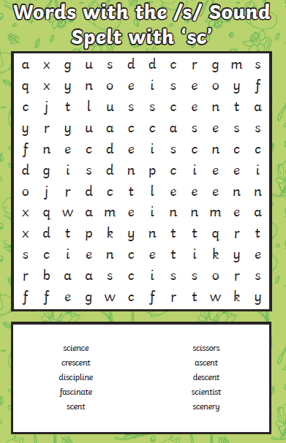
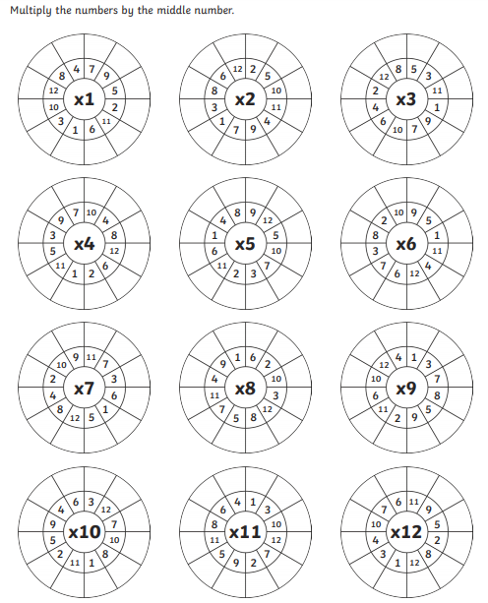

Which times table did you find the trickiest? Spend some time practising – aim to be as speedy as possible!

Year 4 Home Learning – 17th May 2019
Dear Parents and Children,
Tasks for home learning this week are:
- Reading – daily if possible. Please remember to complete the reading record.

- Spellings –This week’s spellings all have ‘sc’ making the s sound. Your child should complete the word search and learn the words ready for our spelling test next Thursday.

- Times Tables – Complete the multiplication wheels and focus your times tables practice on those you find trickiest.
Next week, we will continue to work on biographies, thinking particularly about paragraphs. We will also be watching ‘Mr Stink’ and comparing the film to the book. If you do not wish for your child to watch the film, please contact your child’s class teacher.
In maths, we will be continuing our work on shape. We will be focusing on reflective symmetry.

Are you a Secret Superhero?
As part of our topic, today we have welcomed a member of ‘Exmouth in Bloom’ into school to talk about the work of the group and the contribution they make to our local community.

Thank you for your continued support

Mrs A Walker and Miss K Burnett

