Year 4 Home Learning – 18th January 2019
Dear Parents and Children,
Our spring term topic, The Vikings, has got off to a great start. We hope you found the topic information we sent home last week useful. Please note the slight error with the date for the topic celebration afternoon – it is, of course, 26th March 2019 (rather than 2018 as stated on the topic jigsaw!).
- Reading – children should be reading regularly at home. This might be reading independently, reading aloud or being read to. Whenever possible, we would like parents to talk children about the books they are reading. Questions such as: What do you think might happen next? Who is your favourite character and why? How do you think the character is feeling?

- Spellings – This week we are asking all children to learn to spell the following words:
if since as while although when
after before until because
We will be having our spelling test on Thursday next week.

- Grammar – This week we have been using conjunctions (joining words) when writing sentences with more than one clause. Our spelling words this week are all examples of conjunctions. For our grammar task this week, we would like the children to choose five conjunctions from the list above and write a sentence with more than one clause for each of them.
e.g. The children enjoyed playtime until Mrs Walker blew the whistle.
Ready for an extra challenge? Experiment with the order of the clauses in your sentence.
e.g. Until Mrs Walker blew the whistle, the children enjoyed playtime.

- Times Tables – Please continue with your times tables practice. This will really support our current maths focus on fractions.

Next week, we will be starting an exciting block of work on fantasy stories. We will be using ‘How to Train your Dragon’ as a starting point for our work.
In maths, we will continuing our work on fractions, particularly thinking about hundredths and also equivalent fractions.
Key vocabulary from this week to discuss at home:
Fraction
Denominator – the bottom number of a fraction, this tells us how many equal parts the whole thing has been split into
Numerator – the top number of a fraction, this tells us how many of those equal parts we are looking at / colouring in / eating!
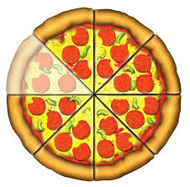
In this picture, the pizza has been split into 8 equal pieces and one has been eaten.
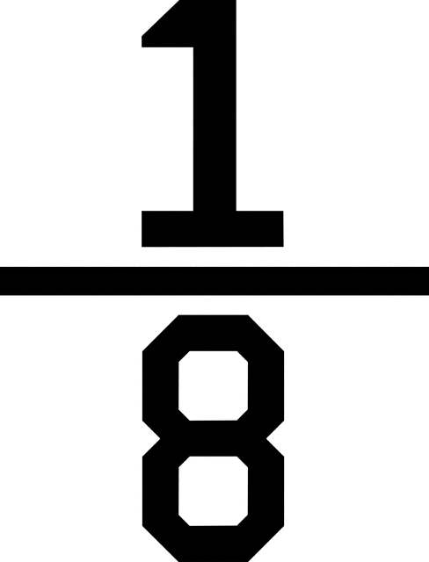
So of the pizza has been eaten.

Please contact your child’s class teacher if you have any queries.

Thank you for your continued support
Mrs A Walker and Miss K Burnett

