+LO: To compare the value of numbers

Fill in the circles with either Croco or Chops to show which number has the larger value.

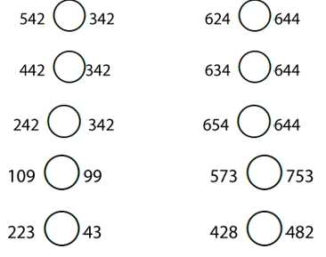

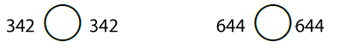
Now fill in these circles with the correct symbol:



