WORD OF THE DAY
Monday astonished
Tuesday petrified
Wednesday curiosity
Thursday overwhelmed
Friday partnership

Year 3 News
Friday 2nd October 2020
Resilient Readers!

Please continue to read with your children at home as much as possible. Please ensure you ask them as many questions as you can about the story.
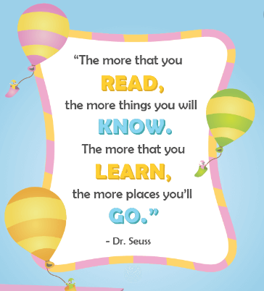
Thank you for your continued support.

Miss Brown and Mrs Rickword

HOME LEARNING

Reading – Children are bringing home reading books. Children should aim to read at home for 15-20mins daily. If you have a query about your child’s reading, please send a DOJO message or use the class email address. Please don’t forget about Bug Club.
Maths –This week, please practice number bonds to make 10 so they are able to be recalled lightening fast! If you can do this, please work on number bonds to make 100. You will find some activates set on my maths this week as an optional extra.
https://www.topmarks.co.uk/maths-games/daily10
You can find number bonds to make 10 and 100 in level 1 and 2 –> addition ->
Children should spend no more than 30mins per week on these tasks.
Times tables – Year 3 are focusing on the 5 times table. If your child is confident in the 5 times tables, try missing number multiplications. 6x?=30 or ? x 5=30
Suggested activities: There is a Rock Out Challenge on TTRS. Where possible we would love children to use the website https://play.ttrockstars.com and challenge themselves to improve their speed.
Optional Extras – There is no requirement to complete these tasks, they are entirely optional. In science we have been looking at healthy eating, muscles and bones. Your child could make a poster or a powerpoint to show everything they know about this topic.

Please do not send in any paperwork- photos can be taken and sent in via DOJO or class email.
3b@brixington.devon.sch.uk 3r@brixington.devon.sch.uk

SUBJECT SPECIFIC VOCABULARY
These words will come up in our learning this week. Please have a conversation at home about these words.
Investigation syllables nouns tradition
Multiples repeated sequence
NOTICES

If your child needs a new reading book, please remind them to pop their name on the class whiteboard.

