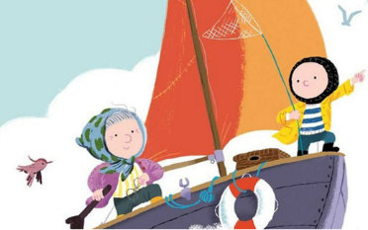
Reminders / messages

Please make sure reading records and books are in everyday as children are read with daily.

Enjoy your bank holiday weekend

Word of the Day
Each day in class, we focus on one ‘Word of the Day’. These words are chosen in order to support children developing a wider vocabulary, help them access a text being used in reading lessons and encourage adventurous word choice when writing.
Next week, year 1/2 will be focusing on the following words:

prefix suffix Sovereign’s orb concentric reign

Perhaps your child will use some of these in conversations at home!

Year 1/2 News
28.4.23
This week…
This week we have started our new learning about the artist Sir Terry Frost. Over the coming weeks, we will be working in the style of him and creating some exciting pieces of work using different medias. The children have enjoyed learning a British folk dance and are looking forward to having an opportunity to learn from a REAL Morris dancer… In English, we have continued exploring our text, Grandma Bird, and have written a letter in the style of a character!

Thank you for your continued support.
Mrs Gerry, Miss Brown and Miss Dowd

PHONICS FOCUS:
Next week, year 1 will be continue to focus on the /ue/ sound. This sound can be spelt at: /ew/ /ue/ /u_e/ /u/ Please find a sound sheet in your child’s bag to use as practise.
Year 2 will be continuing recognising and spelling the year 2 common exception words. It would be great if you could quiz your child at home to see how many they know! If you are unsure on the year 2 common exception words, here is a link to follow: https://cdn.oxfordowl.co.uk/2019/08/29/13/50/37/10bf76a2-c1dd-42e6-88af-0686acd91609/CommonExceptionWords_Y2.pdf
HOME LEARNING

Reading – Children should aim to read at home for 15-20mins daily. This may be reading to an adult or independent reading. Please record reading in the reading record.

Maths –
Year 1 – Please practise subtracting within 10 to support subtracting within 20. For example, if I know 6 – 4 = 2… Then I know 16 – 4 = 12.
Year 2 – We are beginning to look at fractions, please could you support your child in exploring these at home. You could look at folding and cutting shapes, pieces of paper into halves and quarters. You could even treat yourselves with some fractions of cake or pizza! Challenge your children to find halves and quarter of numbers up to 20.

Optional Extras – Sometimes children are keen to do something extra linked to their learning. We will give ideas but there is no requirement to complete these tasks.
Can you write a letter or postcard to Grandma Bird from Noi about when he returns home to his dad?

