Complete the table to show how many of each shape below.
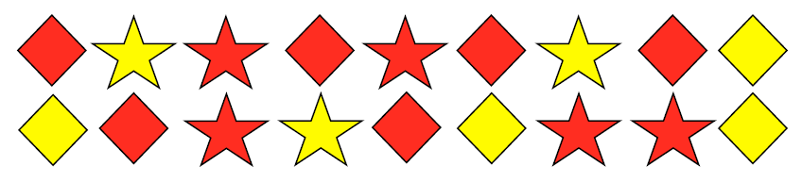
 | square | star | Total
Red
Yellow
total

Fill in the missing inforamtion in this two way chart
 | child | adult | total
Male | 52 |  | 86
Female |  | 43
Total |  |  | 178

This graph show the temperature in our classroom.
What questions could you ask about the graph?
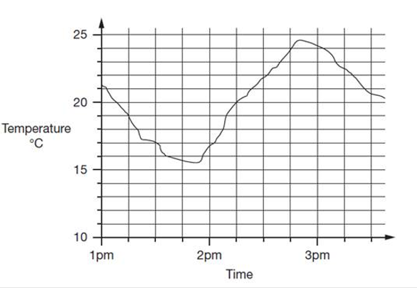

Remember questions starting

How much more…
How much less…
What was the difference between…?
How much more at…….than ….?

Write 10 questions and answer them.

