Spelling test: Friday 20th April 2018
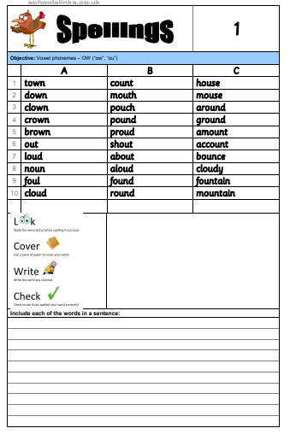

Spelling test: Friday 27th April 2018
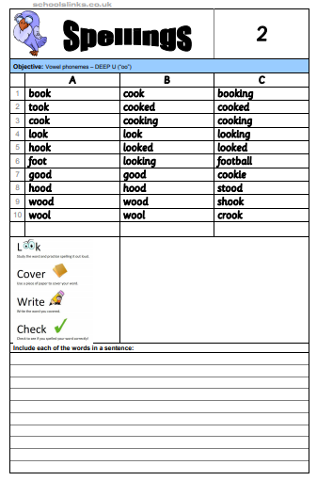
Spelling test: Friday 4th May 2018
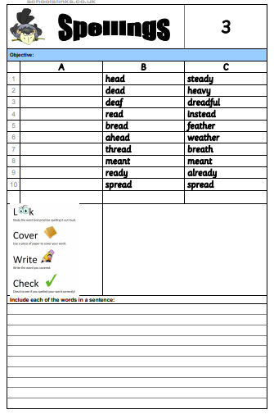

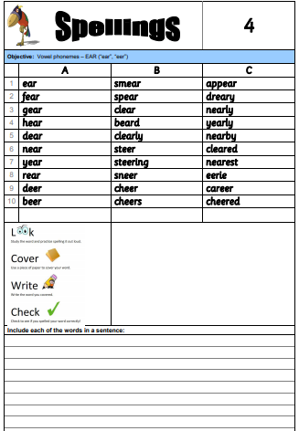
Spelling test: Friday 11th May 2018

(No spelling test on Friday 18th May)
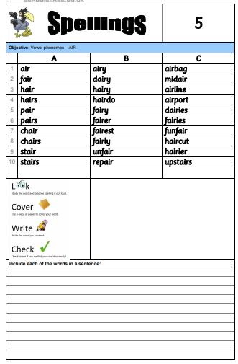
Spelling test: Friday 25th May 2018

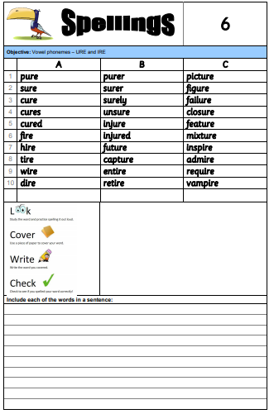
Spelling test: Friday 8th June 2018

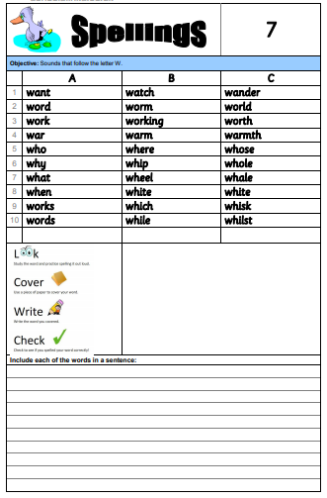
Spelling test: Friday 15th June 2018

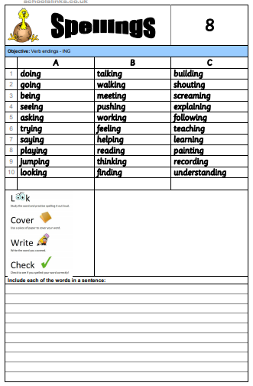
Spelling test: Friday 22nd June 2018

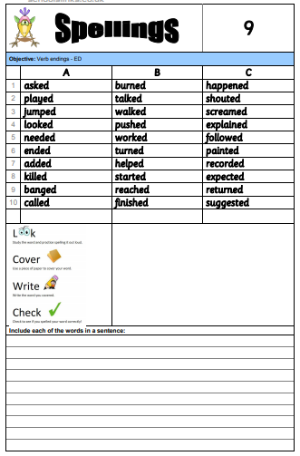
Spelling test: Friday 29th June 2018

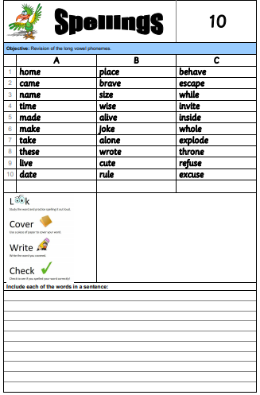
Spelling test: Friday 6th July 2018

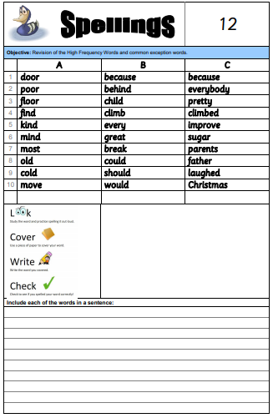
Spelling test: Friday 13th July 2018



