How can you help?
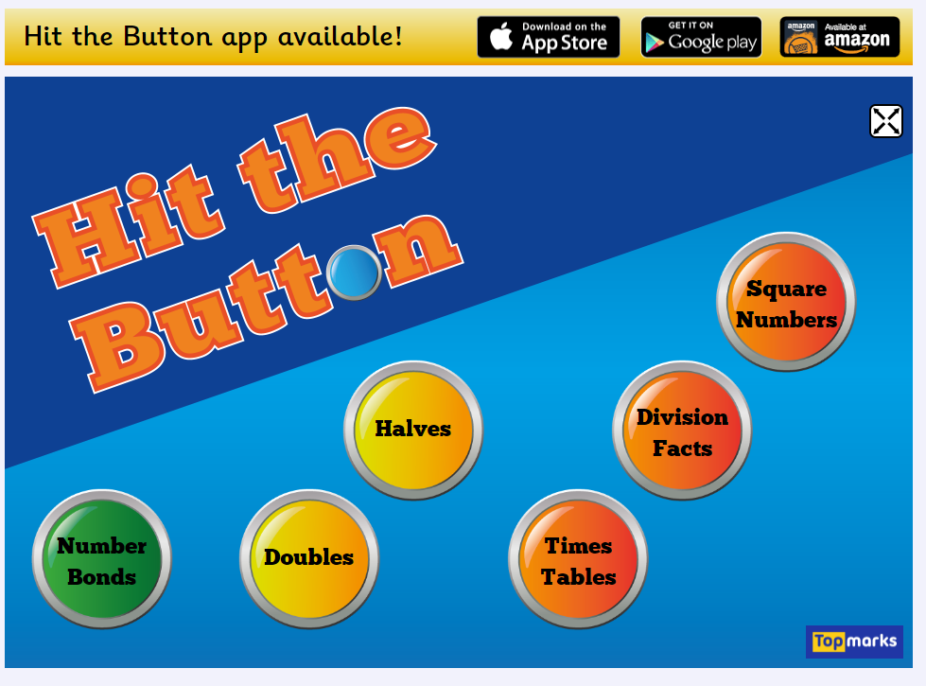
Maths

Topmarks – A great website for maths games, practising number facts and problem solving.
Practise: Addition, subtraction, times tables, time, measure, money etc…

https://www.topmarks.co.uk/Search.aspx?Subject=16
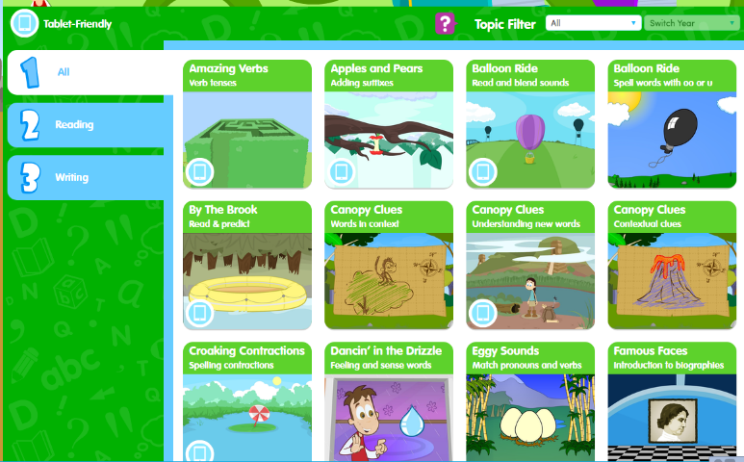
Writing

Education City – There are lots of options to practise spelling patterns, reading challenges and other games with words.

https://ec1.educationcity.com/content_select/index/4/1/1/2#/
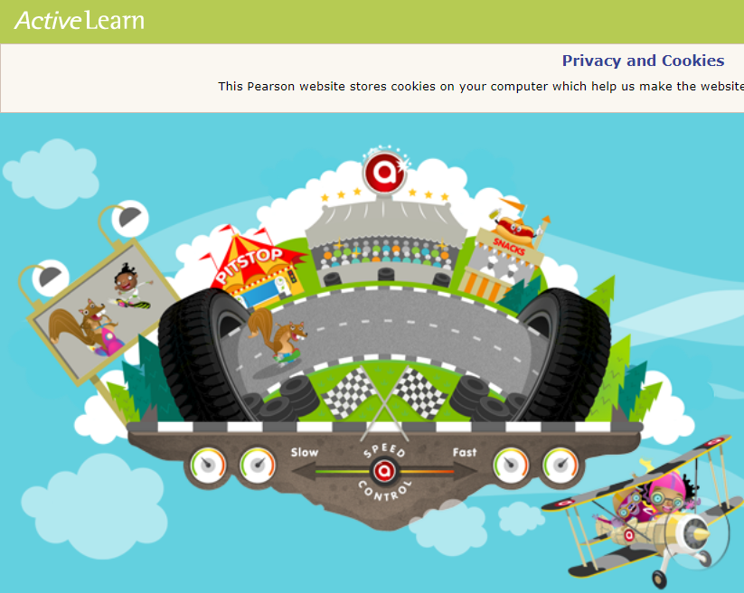
Reading
Bug Club – Your child knows how to access Bug Club and this can be done through the internet on any device. A great tool for reading a variety of texts, playing fun games and answering quizzes.

https://www.activelearnprimary.co.uk/login?c=0

