Maths The children will be focussing on place value and the value of digits during the beginning of the term. Everyday children will experience mental/oral techniques as well as written methods. There will be a strong focus on securing number skills using a variety of concrete materials. Problem solving will be linked to our ‘space’ topic.

Science - Year 2 In the first half term we will be looking at the life cycle of chickens. We will build our understanding that exercise makes the heart work harder and that it is an essential part of a healthy lifestyle. We will find out about healthy lunch box foods before designing and sharing our own snack. After half term we will be thinking about how can we work out what’s alive and what’s not. We will collect specimens, sort them into categories, and investigate habitats and food chains.

Music

The children will be exploring space sounds and creating music patterns to reflect them.

Science - Year 1 In the first half term we will be learning fascinating things about our bodies and senses. We will observe changes over time and think about the question 'how do we change as we get older? After half term we will look carefully at the behaviour and habitats of creatures we find in the school grounds. The children will learn about a variety of common animals with a focus on the pets we keep and how we keep them happy and healthy.
ICT
The children will use iPads to support their learning across all subjects. The children will use ‘Bug club’ to support their reading during guided reading sessions.
We will also discuss the importance of staying safe online.

Geography
In Geography, we will be exploring continents, oceans and countries. We will be learning about the different planets in our solar system. We will also be looking at the phases of the moon and the impact this has to life on Earth.
Religious Education
Year 1 – We will be thinking about all the ways that we are special and how Christianity has special seasons, people, places, music and stories too.
Year 2 – We will be thinking about what is a belief and exploring key beliefs and stories within Christianity and Judaism.
Physical
Education
The children will be developing their balance during our gymnastics lessons. The children will also be focussing on their hand eye coordination through a range of throwing and catching activities.
.
History
The children will be learning about significant events in space history from Neil Armstrong’s walk on the moon to more recent events such as Tim Peake’s journey to the international space station. We will also be learning about the events in the race to space!
Design & Technology
The children will be creating the solar system using papier mache balloons. The children will create a range of space scenes using a range of medium.
Literacy

This term the children will be looking at a range of genres linked to our topic and will have the opportunity to create a range of fiction and non-fiction texts. Year 1 will be developing sentence writing using books linked to space including Whatever Next, Winnie in Space and Aliens love underpants. Year 2 will be writing instructions for making a rocket and writing stories set in space. The children will continue to follow the letters and sounds programme; groups are differentiated by phase ability. The children will practice the skills of decoding, segmenting and blending.
The children will continue to focus on sentence structure and using punctuation.

Computing

Year 1 and 2 Autumn Term topic:  Space  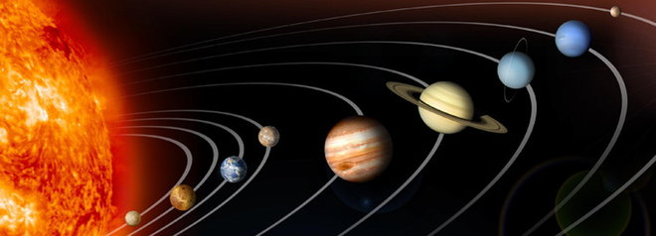 | Art & Design | Computing

