

Strategy for Vocabulary Acquisition: Brixington Primary Academy

The following strategy outlines Brixington’s strategy for developing pupils’ vocabulary and oracy skills. Beneath this strategy, is the First Federation Vocabulary Strategy, which informs the rationale behind our approach and adds detail and context to some of the strategies described.

*denotes that the strategy will also be used in Nursery and Reception classes.

Direct instruction of vocabulary: | The explicit teaching about individual words and their meaning
How words are chosen | - A focus will be on ‘Tier 2’ words – chosen from reading books and upcoming lessons to aid comprehension. https://www.vocabularyninja.co.uk/tier-2-words.html or https://www.tes.com/teaching-resource/year-4-word-of-the-day-11540535 will also be used as guidance for other relevant words for each year group.  - Useful/important/difficult words will also be identified from key texts and upcoming lessons.*  - Teachers will seek to choose words that have high value and high mileage (words which will certainly be useful in future and will unlock understanding of broader concepts).*
Effective teaching strategies | - Each class will have a word of the day that will be discussed briefly. These will be chosen at least a week in advance and made available to parents via the homework slip.  - During regular guided and whole class reading/story sessions, new and important words will be noticed, discussed and sometimes displayed for future reference.*  - One-two times per week, the Frayer model will be used to explore specific words in depth. This will be displayed and referred to.  - When words are identified, the root of the word will always be focused upon (e.g. act rather than action).  - Children will sometimes be encouraged to find their own new words, to challenge themselves at their own level, using reading books matched to their ability.  - In teaching and editing sessions, children’s vocabulary choices will be noticed and alternative choices will be explored – to encourage ambitious choices of vocabulary.  - Curiosity about words will be rewarded by class teachers and encouraged for all.*  - Teachers will share stories with their classes, which exemplify rich and expressive vocabulary.*
Word-learning strategies: | Teaching children to use word parts (morphology) and dictionaries as strategies to increase their vocabularies and their capacity for learning new vocabulary
Teaching of morphology | - Children will be taught what morphemes are and will use these in morpheme matrices, word webs or similar visual representations at least once per week. These will often form part of spelling sessions.  - Prefixes and suffixes will be identified frequently, whenever new words are discussed.  Explicit teaching of spelling strategies involving - s/-es/-ing/-ed/-ful/-ly will take place in KS1.  - In KS2, pupils will learn to modify words on the Y3/4 and Y5/6 word lists by using morphemes.
Strategies for clarifying | - With their teacher, children will look for context cues to help them identify words’ meanings. This will often take place during reading and comprehension activities.  - Teachers and children will also use clues from morphology and sensory webs (what does it make us think/feel) to identify a word’s meaning.  - Children will be encouraged to try new words in their writing, and misuse of ambitious word choices will be clarified verbally*.  - Dictionaries and online materials will occasionally be used to find a word’s etymology to help with spelling and comprehension of a word’s meaning.
Creating a language-rich culture | Children learning and expanding on vocabulary choices through discussions, from being read to and from developing their word-consciousness
Providing rich and frequent  language experiences | - Teachers will read to children each day, from a range of quality example texts*.  - Staff aim to be role models of good vocabulary for young people*.
Reading to and with children | - Teachers will choose reading books based on the following reasons:  -children’s interests  -links to other subjects  -link to PSHE theme  -social/emotional learning  -acclaimed/classic books  -to add variety/breadth to children’s exposure to literature



First Federation Trust Vocabulary strategy

Rationale:
“ If we teach students the words, we give them the world”.
Stahl& Kapinus

Language opens doors. It unlocks the world of reading and the imagination, the excitement of writing, the capacity to explore new subjects and releases our potential to learn and grow as an individual. In schools, it underpins progress, impacts on attainment throughout primary and secondary years, affects self-esteem and behaviour and plays a huge role in a child’s future life chances. Without enough language – a word gap – a child is seriously limited in their enjoyment of school and success beyond.

Vision and aims:
The teaching of vocabulary and the acquisition of language is a whole Trust priority as we recognise that pupils acquisition and command of vocabulary are key to their learning and progress, across the curriculum.
In developing this strategy, it is our aim that:
- Teachers will develop vocabulary actively, building systematically on children’s current knowledge
- Children will increase their store of words and make links between new and known vocabulary
- Children will discuss the shades of meaning in similar words
- When writing, children will expand the vocabulary choices that they draw upon
- Children will understand the meanings of words they meet in reading across subjects
- Children will understand and use language which defines certain subjects, as with mathematical and scientific vocabulary
- Children will be interested, motivated and confident in vocabulary learning and develop a curiosity about words
- Every child will have opportunities to access high level vocabulary from ambitious texts, with reading not being a barrier to learning

Implementation:
First Federation Trust have identified three key elements to the teaching of vocabulary which will be implemented in all of our schools to provide a systematic and strategic approach to the teaching of vocabulary. These elements are :
- Direct instruction
- Word learning strategies
- Creating a language-rich culture
These three elements are intertwined; one cannot work without the other.

- Direct instruction

Direct instruction (the explicit teaching about specific words and their meaning) of vocabulary takes place through:

- Word choice

- Effective teaching strategies

Word choice:

If we are going to teach vocabulary, then we need to decide how to identify the words that we want to teach and whether we want breadth of knowledge or depth of knowledge. The words chosen need to have high value and high mileage.

Many activities in the classroom focus on breadth of knowledge, e.g. word walls where vocabulary is collected around a topic or the use of the themed pages in a thesaurus. We cannot teach every word that a child does not know, so we need some method of identifying the most valuable words to teach.

As a Trust we have identified 2 ways in which we will identify the words that we wish to teach the children.

  - Tier 2 words: Beck et al classify words into three tiers, with Tier 2 being the most appropriate for direct instruction.
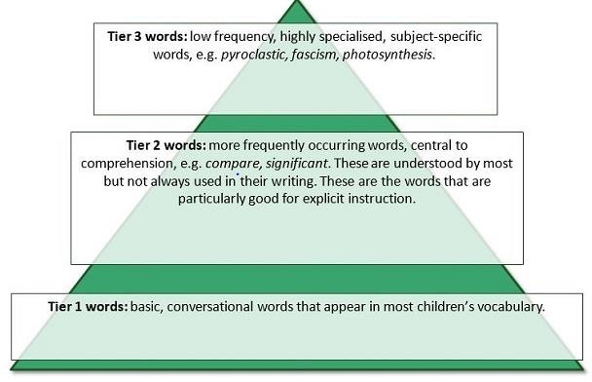

In Key Stage 1 and 2, Tier 2 words will be selected from the texts that are being read to the children. These will either be from the text being used as part of an English sequence or from the Reading spine that class readers are chosen from. Teachers should aim to explicitly teach, through direct instruction, 1 or 2 words a week. These should be displayed in the classroom on a Frayer model and then kept as a word bank (displayed in classroom).

(See Appendix 3 in the FFT Reading strategy which identifies the range of texts
that should feature in a teacher’s reading spine across an academic year. Tier 2
words should be chosen from these texts for direct instruction).

  - Difficult/Important/ Useful: Teachers may also look at a text or poem and identify these words which are ‘useful’ and ‘important’. These are the words to be taught through direct instruction. Several teachers, when considering the same text, may well identify different words that they feel are useful/important. The process that a teacher has undertaken in identifying these words is the key focus. Choices made will reflect the needs and prior knowledge of the children within their individual classes.

There are also a range of other strategies available that staff may choose to consider which would support them in selecting which words to teach children and why. Individual schools will decide on whether they wish to include any further strategies from those listed below, which exceed the 2 required strategies above.
These include:

  - Words from texts that will be met in class
  - Grammatical function words
  - Academic words (e.g Averil Coxhead)
  - Topic/ Key concept words
  - Incidental words from misconceptions
  - Current limitations e.g happy/sad.

Effective teaching strategies:

Once the words, for direct instruction, have been chosen, teachers will utilise the following model to teach these words.

The Frayer Model Link
The Frayer Model involves pupils in defining new vocabulary and thinking about examples and non-examples: a form of deep processing. A PDF version is available to download on the FFT Leadership Sharepoint. A completed example is shown below.

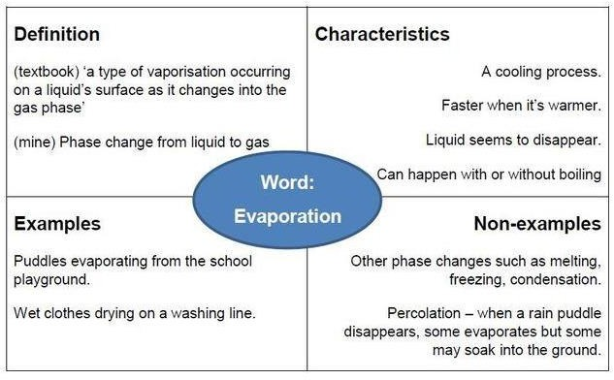

In this example, the text book definition and one that the teacher has crafted (alongside the children) have both been included. This is a good example of the
‘traditional’ definition being as, or more, complicated than the word itself. To have the greatest impact this chart would be completed with the pupils – definition first, followed by characteristics. The teacher can then provide a mix of examples and non-examples and pupils can discuss which ones go where on the chart, or pupils could generate their own examples/non-examples.

Appendix 1 contains further information about the Frayer model and provides further examples.

Word learning strategies:

We can teach children to use word parts (morphology) and dictionaries as strategies to learn individual words, and therefore increase their vocabularies and capacity for learning new vocabulary. Word learning strategies are for children to use independently to work out the meaning of words.

Teaching morphology:

Morphology is the study of parts of words that carry meaning and morphemes are the smallest units of meaning. For example, the morpheme ‘s’ on the end of ‘cats’ tells us that there is more than one cat. The prefix ‘un-‘ means ‘not’ so we know the
word unhappy means not happy. If we understand morphemes and how they work, we can use this knowledge to work out the meanings of new words.

A key element that makes morphology such high-value in terms of increasing vocabulary, as well as spelling, is the idea that we can teach morphology using a limited number of words. But these generate knowledge about a much larger group of words.

In Key Stage 1, as outlined in the National Curriculum, children will begin with the exploration of morphemic elements with base words and suffixes such as adding - s/-es/-ing/-ed/-ful/-ly.

In Key Stage 2, we will use the Year 3 and 4 and Year 5 and 6 spelling lists to teach morphology. Virtually all of these words can be modified by using morphemes. If pupils learn 100 words on the list, they will be able to read, spell and understand each.

There are two key strategies that can be used as a basis for teaching morphology for meaning and they are morpheme matrices and word families.

Morpheme matrices are a key tool in looking at the meaning and spellings of words. At the very start of using morpheme matrices, you might want to limit the prefixes to just one, e.g. un- so that you can discuss the difference the prefix makes to a word.

A simple grid might look like this:

 | well
 | able
un | luck | y
 | friend | ly

Pupils can work from left to right, joining morphemes together to create words.

One of the challenges of working with morphemes is enabling pupils to understand where the morphemes are in a word. The above matrix will support that development as will putting morphemes onto cards that pupils then put together to make words.

Once the children understand the meaning of some prefixes and suffixes, matrices which involve adding a range of both a root or base element can be used, discussing each morpheme’s meaning.

Whether simple or complex, pupils can make words from these matrices, discuss their
meaning (and spelling) and make up ‘unreal’ or ‘silly’ words sharing what they mean. For example, from the more complex ‘act’ matrix, if it contained the prefix ‘de-‘ you could create the word ‘deacting’. Children could then enhance their learning by writing a dictionary definition of the created word.

Wordwebs A word family web is slightly different to a word matrix in that it allows pupils to group or categorise words in a way that makes sense to them.
The web starts with a base or element which might be a word, such as hear, in the middle and then a list of other words is created that contains the same morpheme. Pupils then group the words around the web according to their own categories. A simple word web might look like this.

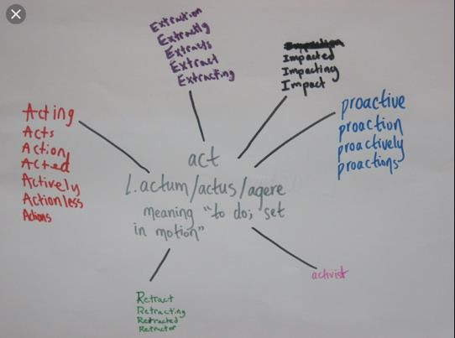

Within Appendix 2, there are a range of additional strategies that staff may wish to use in order to support the teaching of vocabulary and word learning strategies.

Clarifying:

Clarifying is a key reading skill and is one of the four strategies (predicting, clarifying, questioning and summarising) developed through a Reciprocal Reading approach (Palincsar and Brown, 1986)

Having a focus in clarifying for reading will in turn have an impact on writing in the long term.

Clarifying is a strategy which involves looking ‘outside’ a word or looking around the word for clues to meaning.

There are a range of strategies that can be used to clarify words. These include:

    - context cues;
    - sensory webs;
    - think aloud/zooming in and out;
    - teacher modelling (guided reading).

Clarifying does not always mean that the word can be defined exactly. Sometimes, a reader just gathers a sense of a word e.g whether it is positive or negative.
Sometimes the misconceptions children encounter in their reading relate not to particularly complex vocabulary but to usual words being used in unusual combinations or challenging contexts. Generally, when readers come to something that needs to be clarified, they consider its context. Although context clues can be useful, they can also be problematic.

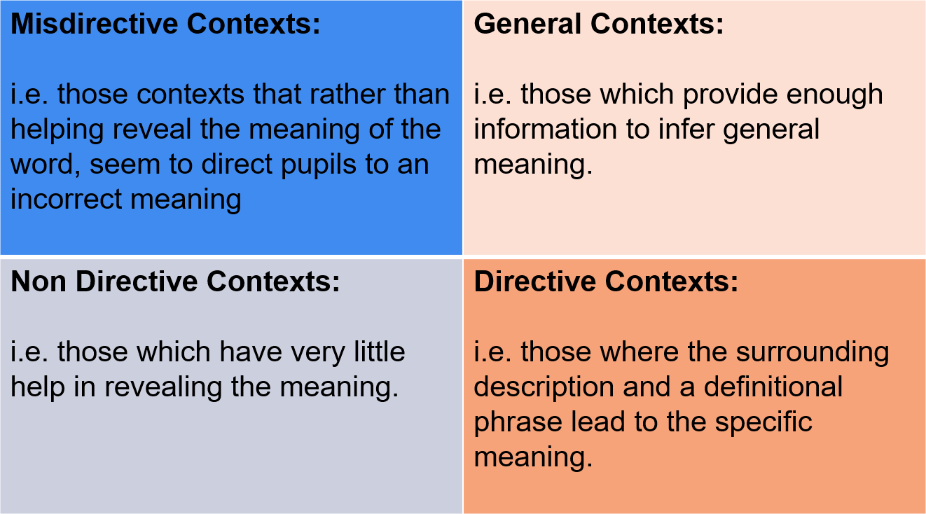
Examples of some of these are:
  - Misdirective context- The prince was tall, strong and petrified (child is expecting this word to link to strong and powerful but in fact the author has done the opposite)
  - Non directive context- The prince was abject(Here, there is not enough information to infer meaning of the complex word)

When clarifying a word, we need to:
- Read and reread
- Read it aloud
- Read more slowly
- Look at the morphemes in the word
- Think about other words that are like it
- Act it out
- Use the word class or position of the word in the sentence

This metacognition of clarifying is a crucial part of developing independence with the strategy.

- Creating a language rich culture
When children enter school, they have much larger oral vocabularies than that which they use for reading and writing. Most words that they read independently are already in their oral vocabularies so younger children will not learn many new words from their own reading. Children will learn and expand on their vocabulary choices through discussions, being read to and from having their attention focused directly on words. Language rich experiences are planned for in order to support children with the acquisition of vocabulary. Our aim is to support children to foster word consciousness- an awareness of and enjoyment of word play and exploration of language.
These opportunities need to be planned for through:
  - Consideration of the vocabulary that all adults use within the school
  - Reading to and with children often, using a wide variety of quality texts. Text should be chosen as they build on children’s experiences of the world and provide ambitious content with opportunities to discuss the content.
  - Gathering words to use in writing
(See FFT Reading Strategy Appendix 3 which identifies the quantity and quality of the texts that are read to children linked to opportunity number 2 above).
Appendix 3 identifies ways in which words can be gathered for use in writing. These could be linked to the topic words that children will need to use in a sequence of learning, for example, in History and Science.

Effective strategies for creating a language rich culture
- Reading the text more than once to the pupils. This is more difficult with older pupils but could work with parts of a longer text. Three to four repeat readings are generally suggested. Some researchers suggest using the pictures as you go through the reading, Beck and Mckeown suggest showing the picture after you have read a section because not all images support the meaning of the written text.
- Defining unknown words for pupils. Some researchers argue for this during the reading, others at the end of the reading.
- Interacting with the text through open-ended questions that require description and explanation where the answers are often followed up with another question.
- Using background knowledge to support meaning and context. Doug Lemov et al in Reading Reconsidered argues for reading linked fiction and non- fiction text in order to support meaning and context. For example, when reading Blackberries and Bombs by Julia Donaldson, a play about

evacuation during World War 2, you might also read a non-fiction text which provides more information about the process of evacuation.
- Relating the text to the pupils’ lives. Depending upon the familiarity of the book, some work with pupils may have to be undertaken to link their lives and experiences with events in the text. Often with young children we use books that have familiar settings and branch out from this as they get older.

Please see Appendix 4 which includes further information about the individual schools specific criteria about the consistent approach to the teaching of vocabulary.

Appendix 1
Purpose of the Frayer Model:
The purpose of the Frayer Model (Frayer, 1969; Buehl, 2001) is to identify and define unfamiliar concepts and vocabulary. Students define a concept/word/term, describe its essential characteristics, provide examples of the idea and suggest non examples of the idea (knowing what a concept isn’t helps define what it is). This information is placed on a chart that is divided into four sections to provide a visual representation for students. The model prompts students to understand words within the larger context of a reading selection, as it asks students to analyse the concept/word (definition and characteristics) and then synthesise or apply this information by thinking of examples and non-examples. It also activates prior knowledge of a topic and builds connections.
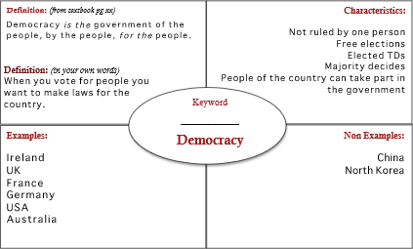
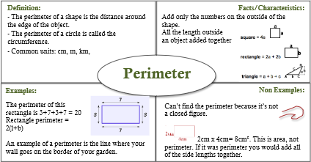

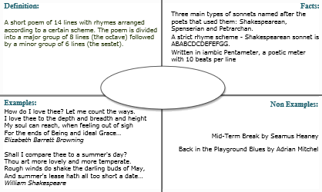

Sonnet

Appendix 2:

Other strategies that could be used to develop vocabulary teaching include:

Paint charts:

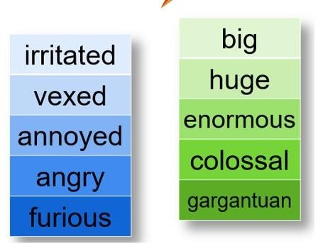

Meaning lines:

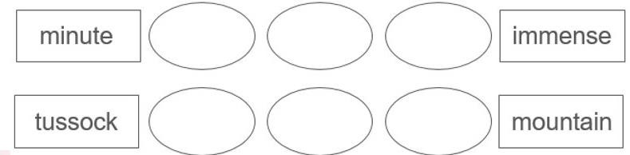

Menu of instructional activities:

Example/Non example Word associations
Generating situations, contexts and examples Word relationships
Writing- applying sentence stems Returning to the story context Puzzles.

Appendix 3
The use of word banks or word walls is a strategy that scaffolds pupils’ use of rich language related to an area of learning. They:
- are easily accessible and semi-permanent, providing a reference point for talk and writing.
- are most powerful when their use is modelled
- are a visual support for all pupils
- can be organised in many ways; alphabetically, categorised by pupils, according to tiers or by word class
- support long-term retention of words
Word walls are often developed alongside the pupils but can also be created by the teacher, prior to a writing task. The aim is to generate vocabulary that may be in their spoken vocabulary but is not in their written vocabulary.

The following activities based on Word Wall Activities by Jasmine and Schiesl could be used to explore words on the word wall to ensure that their meanings are developed.

  - Define the words and then ask pupils a series of questions about them, e.g. disquiet means to feel worried or uneasy. Why might a child feel disquiet in a cemetery? Can you feel disquiet in a brightly-lit room?

  - Pupils describe a word or the context it might be used in and a partner says a word that would fit the situation and explains why it is that word.

  - Pupils take on the role of teacher by making up a quiz for a partner about the words on the wall, e.g. Which words might be synonyms for scary?

  - Make up sentences with as many of the words in as possible.

  - Make up a story using as many of the words as possible. This could be orally and then might be written.

