

Strategy for Reading: Brixington Primary Academy

The following outlines Brixington’s strategy for developing reading. It is followed by the First Federation’s agreed approach, which provides context for the school’s decision-making for these strategies.
Early Reading: | Early reading is developed through both language comprehension and decoding.
Reading is celebrated throughout the Foundation Stage Unit, by regularly sharing stories and bringing them to life through chosen learning activities. Books are the starting point for much of the staff’s planning and children are praised and rewarded for accessing reading activities during continuous provisions. The staff understand the importance of making effective book choices that align to pupils’ interests and offer good learning opportunities and are a role model for learning English, and this is a significant discussion point in planning meetings. The EYFS lead is also on the school and Trust English network groups to ensure subject knowledge is relevant and up to date in order to support her team and pupils.

Parents are supported and encouraged through invitations to attend the learning with the children and information events, as well as through meetings with staff where necessary. Children have a specific book in school that is matched closely to their current phonics level and take another one home to read with their families. They also take a second book home that is led by the pupil’s own interest. Children visit the library with staff once per week and read 1:1 and in small groups at several points during the week – some children will read more often than others if this is necessary to ensure progress.

The environment celebrates reading, with current focus books brought to life through drama, role-play and small world activities. Each class has a specific area for reading where children can read, talk about, share and listen to books.

The school has established a local toddler group where teachers share stories ad books with young children, and Brixington leads a network group for local EYFS providers to ensure best practice and up-to-date subject knowledge are shared.

Phonics for reading: | The diligent, concentrated and systematic teaching of phonics is central to the development of early reading.
The Letters and Sounds phonics scheme is followed and pupils’ progress is assessed in line with the program’s overview for the year. Ongoing assessment of pupils’ phonics progress is sufficiently frequent and detailed to identify any pupil who is falling behind the programme’s pace. If they do fall behind, targeted support is given immediately to help them keep up, but if this persists then more frequent intervention occurs (such as smaller group teaching or 1:1 sessions) and support will be provided by SENDCO or other professionals where necessary.

In EYFS and Year 1, phonics sessions take place for all pupils each day. These make use of suggested Letters and Sounds strategies as well as the Phonics Play programme and those developed by teachers.
Sessions are short and feature significant pace and always include an opportunity to read tricky words, to blend and segment, to identify and use a new or revised sound, and to write. At times, children will be grouped with peers who are working at the same specific stage as them to help ensure progress is sequential and lessons are focused upon relevant next steps. Pupils with the least confidence will sometimes be taught in smaller groups, by a class teacher or experienced TA with relevant training.

To ensure all children learn sounds in a sequential way, in EYFS, continuous provision will include opportunities to use the sounds in context and some pupils throughout EYFS and KS1 will have significant additional opportunities to practice the sounds with an adult, on their own and in small groups.

The overwhelming majority of pupils achieve the phonics mark at the end of Year 1. Pupils who do not, receive additional phonics teaching in Year 2 and their book choices are closely monitored as they move up through the school, to ensure that reading supports phonetic development.

Phonics lessons are delivered by teachers and experienced TAs, and CPD is delivered by experienced school staff each term. Volunteers sometimes help children with reading.

Developing a whole-school reading culture | Reading is shown to be valued and important throughout the school.
The enjoyment of reading is given significant prominence throughout the school. It is the priority for home-learning in all year groups and is rewarded in assemblies and with prizes and recognition. Each class includes a reading area which celebrates reading achievement, and children are read with every day. New book releases are shared with children in assembly each week.

School libraries for older and younger children are currently being redeveloped in order to ensure that book choices can be made easily, and that all pupils can access books that match their ability closely, in terms of phonics and comprehension. Libraries use Bug Club and Accelerated Reader, and these programmes have shown evidence of motivating pupils and of supporting families with making good reading choices.

All teachers read to their class each day, and choose books for a number of reasons (see reading for pleasure strategy).
Progression of reading skills | Teaching of reading skills is sequential and carefully planned for.
Our curriculum is designed to meet these aims:
- ensuring children master word reading skills- both phonic decoding skills and the quick recognition of ‘common exception words’ (tricky words)
- fully developing children’s skills of comprehension- including retrieving information, summarising, making inferences and using evidence from the text to justify these.
- fostering an enjoyment of and enthusiasm for reading that will last beyond pupils’ primary years.

Brixington’s progressive curriculum has been refined in 2019/20, based on work with the Trust’s English Network Group and the research that has informed the Trust’s strategy for reading. Updated plans outline year groups’ specific objectives for decoding, reading for pleasure, and comprehension, in a way that builds each year. Assessment targets are set to measure pupils’ progress against these objectives, and reading sessions are mapped out by teachers with specific focuses aligned to the year group’s goals.

Children whose progress in reading does not keep up with the curriculum are identified through termly standard assessments for comprehension (Year 2 onwards), weekly guided reading sessions (KS1), and reading age standardised scores measured through short assessments. Formative judgements are also made when reading with pupils. Once identified, these pupils are discussed with senior leaders in pupil progress meetings and a best-suited support is arranged. This might include significantly increasing the amount of time spent reading with an adult in school, or some targeted intervention work with a specific focus. Wherever possible, families will also be asked for further support.

To asses reading, teachers use summative and formative approaches, including notes taken during reading sessions with pupils, supported by @reading Behaviours Guidance’ from Herts for Learning.

Listening to pupils read / Guided reading
Children throughout the school are heard read regularly, and discussions about books and words happen in whole-class and small-group reading sessions, 3-5 times each week. In key stage one, guided reading allows pupils to develop confidence reading allowed in small groups and to discuss themes and words in detail. In key stage two, whole class reading is also used, to allow whole-class discussion of the text as pupils work towards common goals in line with their curriculum targets.

Pupils’ reading choices are supported through guided visits to the library once per week in Key Stage 1, and the Accelerated Reader programme is used in Key Stage 2 to identify a specific level of challenge that the children can choose books from. Reading Records allow teachers to observe the ag e-appropriateness, quality and variety of choices being made.

Staff have received training around hearing pupils read, and the how to ensure this has impact on reading confidence, word-reading, comprehension and vocabulary acquisition. Sentence stems are used to support staff and volunteers with asking appropriate questions.

Quality of resources | Resources are provided or created to best support the reading curriculum.
A commitment from staff and parents has allowed significant investment in quality reading resources, though this has initially focused upon new material for developing early reading and quality phonics provision. Investment in reading resources for older pupils, including non-fiction, is still required and is taking place throughout 2019/20. 2-3 Book Fairs each year allow parents an opportunity to also make appropriate purchases for home reading, and displays talks in assembly offer recommendations to support these choices.

Books for confident readers are organised in line with the Accelerated Reader band, to make choosing appropriate books in terms of ability more easy. For early reading, books are organised in line with the phonics sounds that they develop, which are displayed easily for pupils, parents and staff. Coloured reading levels on the side of books help parents and children recognise their progress and ability, though the specific match to relevant phonics sounds is prioritised.

English series of learning always include high-quality texts as models, and are sometimes designed entirely around one text, which is celebrated as a high-quality example and something to aspire to.
Parental engagement | High expectations regarding the reading culture within the school and the value of reading are passed on to parents.
Teachers use reading records to monitor home reading and meet with parents promptly if the number of reading sessions per week is low (fewer than 3 over time). Children who read frequently at home are rewarded with praise from the teacher and also with prizes and acknowledgement in assembly.

Working closely with the PTA, the priority of the school’s library resources has been shared with parents, who have supported through fundraising events.

The school offers information evenings to parents to support with early reading in EYFS and KS1 and, at Parents Evening twice per year, teachers offer advice on choosing books and how to talk about them with children. The libraries are open before and after school for reading, and parents are invited in to work with the teacher if it is felt this will benefit the child’s reading at home.

An annual Brixington Book Week celebrates reading and offers families the opportunity to join in with reading activities such as challenges, sponsored reading and dressing up.
Pupil voice | Pupils are encouraged to develop positive attitudes towards reading.
Leaders monitor pupils’ attitudes to reading by speaking with them about their books, taking guided reading sessions, and monitoring usage of applications such as Bug Club and Accelerated Reader. As children’s ability to read improves in KS1 and lower KS2, we are mindful that some children can be discouraged by their peers’ ability to access more challenging or ‘grown-up’ books than they can, and the school provides specific high-interest/low-challenge books for these pupils.

Choices for new books are driven by what is popular with the children. For example, the popularity of David Walliams led to investment in other authors from similar genres.
The books that teachers share with their classes are sometimes chosen by class vote or pupil recommendation.



First Federation Trust Reading strategy

Rationale:
The First Federation Trust and each individual school within the Trust
believes that all children have the right to be fluent and confident readers as this helps to unlock the doors to future success, for enjoyment and for academic and professional attainment.

Teachers have high aspirations of children and this is demonstrated through the school’s ethos of consistently striving for excellent teaching and outcomes for children in reading.

We believe in both the importance of developing children’s discrete word- reading skills and comprehension, and the need to engender a love of books and reading.
Aims:

As a collective, we are determined that every child will learn to read. Our approach to the teaching of reading will encompass the key competencies in reading:
- word reading skills- both phonic decoding skills and the quick recognition of
‘common exception words’ (tricky words)
- comprehension- including retrieving information, summarising, making inferences and using evidence from the text to justify these.

This Simple View of Reading, highlighted in the Rose Review of early reading forms the backbone of provision for reading (Appendix A). Developing both of these competencies through high quality teaching is a priority for our schools. Children are taught to apply these skills to read for meaning across a wide range of genres.

The first two dimensions constitute being able to read, but a further essential dimension is about ‘being a reader’. Our schools use every opportunity to support children’s discrete reading skills and comprehension and teach them to develop a love of reading, through the following:
- knowledge about authors and books
- the language of books
- reading stamina
- choosing books- encouraging children to choose to read and enable them to choose something they might enjoy.

Children’s love of reading and reading for pleasure is ignited through the passion displayed for reading by staff and the wide range of high quality texts available to them.

Early reading
Early reading is developed through a balanced approach between language comprehension and decoding.
In order to support language comprehension, children should be exposed to a range of complementary activities including vocabulary development, language structures and the development of background knowledge.
Children’s language comprehension skills will be developed through storytelling and shared reading activities. In order to support shared reading, we use the PEER framework as described in Appendix B.
Phonological awareness is a necessary, but not sufficient, component of reading. It provides one of the best predictors of early reading difficulties. Children with underdeveloped phonological awareness will benefit from small group or one to one support.
Singing and rhyming activities help children develop phonological awareness. As phonological awareness develops, children become increasingly able to hear and manipulate smaller units of sound. For example, children can spot and suggest rhymes, count or clap the number of syllables in a words and recognise words with the same initial sound.

Phonics for reading
The diligent, concentrated and systematic teaching of phonics is central to the teaching of early reading in all our schools. This requires high-quality teaching that follows a carefully planned and tightly structured approach to teaching phonic knowledge and skills. Pupils are given opportunities to apply what they have learnt through reading – including time to read aloud to adults to practise their decoding skills – writing and comprehension of what they are reading.
The key features of teaching phonics to beginner readers are:
- grapheme/phoneme (letter/sound) correspondences (the alphabetic principle) in a clearly defined incremental sequence
- to apply the highly important skill of blending (synthesising) phonemes in order, all through a word, to read it
- to apply the skills of segmenting words into their constituent phonemes to spell
- that blending and segmenting are reversible processes.

Schools with Nursery classes begin such teaching early on. The curriculum gives children rich opportunities to talk and listen in a wide range of texts. This contributes to developing their familiarity with books and stories and their knowledge of the
meanings of words. There is a strong focus on developing the children’s capacity to
listen, concentrate on and discriminate between sounds.

In lessons, in EYFS and Key Stage 1, teachers should support pupils to practise by providing them with texts containing words that can be decoded using the letter- sound patterns they have already been taught, or by having children write their own stories using the letter-sound combinations taught and then reading their own and
others’ stories. The goal is to improve the fluency (speed) as well as accuracy of pupils’ decoding to the point that it becomes automatic and does not require conscious effort.
Each school has a clear programme of phonics expectations, based on the needs of their cohorts, which identifies which phonemes will be taught at certain stages
throughout a child’s journey through EYFS and Year 1.

Progression of reading skills
Dependence to Independence
Different children will have a varied and broad range of starting points and experience and the route of their individual progress will very much depend on this prior experience. Learning to read is a complex process and one that places great demands on a child’s cognitive ability to draw on their prior learning and emotional willingness to take visible risks.
Develop pupils’ speaking and listening skills and wider understanding of language
The ﬁrst and most important resource that young readers have is a strong foundation of spoken language.
Speaking and listening skills are at the heart of language, not only as foundations for reading and writing, but also as essential skills for thinking and communication.
Evidence suggests that reading comprehension can be improved with targeted
teaching that improves pupils’ speaking and listening skills.
In Key Stage 1, teachers will use these approaches:
- pupils reading books and stories aloud and being encouraged to have conversations about them with their teacher and peers;
- the teacher modelling the process of making inferences (using information in a text to arrive at another piece of information that is implicit) by asking relevant questions aloud and answering them themselves;
- pupils engaging in paired or group work so they can share the thought processes that lead them to make inferences; and
- activities that extend pupils’ spoken and receptive vocabulary (approaches that explicitly aim to develop vocabulary work best when they are related to current topics in the curriculum and there are opportunities to practise using new vocabulary).
In Key Stage 2, teachers will use these approaches:
- reading books aloud and discussing them;
- activities that extend pupils’ expressive and receptive vocabulary;
- collaborative learning activities where pupils can share their thought processes;
- structured questioning to develop reading comprehension;

- teachers modelling inference-making by thinking aloud.

Children will also need to have experience of sharing reading for pleasure and purpose and opportunities to play an increasingly participatory role in reading alongside adults. They need to have knowledge of the conventions of reading, and understanding of the large and small shapes in texts. Children will beneﬁt from a repertoire of core texts which broadens as reading material becomes increasingly complex and wide ranging and will be able to respond to texts with increasing
inference, long before they can decode ﬂuently. A diet of high quality texts, rich in vocabulary with supportive features including strong shapes and tunes will enable children to learn how to co-ordinate the use of phonic, semantic and syntactic cues as they become increasingly mature, independent readers.
Vocabulary
Within our EYFS settings, we prioritise the development of communication and language (See First Federation Trust Vocabulary strategy). Focussing on language and communication is especially important for young children and will support the development of a range of early literacy skills as well as their wider knowledge and understanding. A wide range of activities can be used to develop communication and language including shared reading, storytelling and explicitly extending
children’s vocabulary.
Developing vocabulary should form part of a broad approach to improving communication, language and literacy. The following should be considered:
  - providing children with a rich language environment (implicit approaches) as
well as directly extending children’s vocabulary (explicit approaches)
  - carefully selecting high frequency words for explicit teaching (Tier 2 words)
  - developing the number of words that children know (breadth) and their understanding of relationships between words and the contexts in which words can be used (depth)
  - providing multiple opportunities to hear and use new vocabulary
Teachers are explicit in using and explaining the vocabulary within these texts and ensuring children’s full comprehension.

As children mature as readers, they begin to engage with a greater selection of books and texts. It is crucial that they are supported in their endeavours to take on the multi-faceted reading demands of the curriculum. In assessing children’s progress and development as readers, there is consideration for a widening of reading horizons. The notion of range and variety play an increasingly important part in interactions with texts in addition to a growing ability to read silently, ﬂuently and with ease. Children may not read equally across the range of text types but at different times will need to read more in one area than another, as well as developing preferences and special interests within the range.

Comprehension
Comprehension requires an understanding of the form of the language, which is composed of morphology and syntax, the meaning of relevant vocabulary and the context to the text. Morphology refers to the arrangement of the smallest units of words that contain meaning, such as the ‘root’ word, ‘child’, and the affix, ‘-ish’, which in combination make the new word, ‘childish’. Syntax refers to how words are combined and organised into phrases and sentences. (See FFT Vocabulary strategy for further information and approaches to teaching morphology)
Reading comprehension can be improved by teaching pupils specific strategies that they can apply both to monitor and overcome barriers to comprehension.
Within our schools we use the following strategies:
- Prediction—pupils predict what might happen as a text is read. This causes them to pay close attention to the text, which means they can closely monitor their own comprehension.
- Questioning—pupils generate their own questions about a text in order to check their comprehension.
- Clarifying—pupils identify areas of uncertainty, which may be individual words or phrases, and seek information to clarify meaning.
- Summarising—pupils succinctly describe the meaning of sections of the text. This causes pupils to focus on the key content, which in turn supports comprehension monitoring. This can be attempted using graphic organisers that illustrate concepts and the relationships between them using diagrams.
- Inference—pupils infer the meaning of sentences from their context, and the meaning of words from spelling patterns.
- Activating prior knowledge—pupils think about what they already know about a topic, from reading or other experiences, and try to make links. This helps pupils to infer and elaborate, fill in missing or incomplete information and use existing mental structures to support recall.
The strategies should be modelled and practised to ensure that they become embedded. For example, a teacher could model how they would attempt to understand a text using questioning. Children will then practise these skills in collaborative groups, with support and feedback from their teacher decreasing as pupils become increasingly effective at using each strategy.
The strategies can be introduced individually, but pupils should also be taught how to combine strategies.

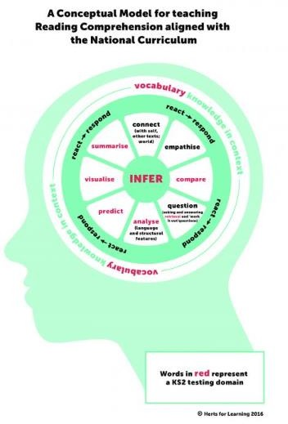
Developing fluent readers in Key Stage 2

Scarborough’s Reading Rope (Appendix C) provides a useful model for reading by likening it to a rope comprised of multiple strands. The two main strands, word recognition and language comprehension, are supported by a broad academic consensus and underpinned by research evidence. These two main strands are composed of sub-strands that need to ‘become entwined’ as pupils learn to co- ordinate the different components of reading.

The model can be used as a diagnostic tool to identify areas to focus effort. Although all of the strands represent an important component of reading this does not mean that they require equal curriculum time. For example, most pupils will require a greater focus on their language capability (language structures and vocabulary) and reading fluency, but some will still need a focus on more basic skills,

such as decoding. Therefore, it is important to understand pupils’ current capabilities and focus effort appropriately.
Fluent readers can read quickly, accurately, and with appropriate stress and
intonation. A fluent reading style supports comprehension because pupils’ limited cognitive resources are freed from focusing on word recognition and can be redirected towards comprehending the text. There are no quick ways to develop reading fluency and most pupils will benefit from being explicitly taught rather than just being encouraged to practise individually.
The following approaches are well supported by evidence:
- guided oral reading instruction—fluent reading of a text is modelled by an adult or peer. Pupils then read the same text aloud with appropriate feedback; and
- repeated reading—pupils re-read a short and meaningful passage a set number of times or until they reach a suitable level of fluency.

Teaching reading in English lessons

In order to develop children’s love of reading, units of learning will be based around motivating books and texts. A good quality text will provide opportunities for children to be engaged in learning across the National Curriculum programmes of study for English. The texts will include a specific book, a play or poem, or for Key Stage 2 children, a specific genre. Text based, whole class teaching provides opportunities for learning and reinforcing:
  - word reading- as children encounter unfamiliar words
  - grammar and punctuation- through seeing them in context and considering how they are employed for effect
  - comprehension- through listening to, reading, and discussing challenging texts
  - vocabulary and spelling- by encountering new language
  - spoken language through participating in discussions about books, learning from specific language modelled by the teacher and peers
  - writing (both transcription and composition).

Studying whole texts in lessons can also develop children’s love of reading by providing the opportunity to read and listen to texts and authors that they may not choose to read. Opportunities should also be planned for children to encounter new or unfamiliar genres.

There is not just one way of structuring an effective English lesson; the teaching should be driven by what is to be learned.

Developing a whole school reading culture
Children will develop as readers if they experience personal involvement in reading. Reading for pleasure often begins as shared pleasures and emotional satisfaction arising from reading with an adult or experienced reader. Provision of a rich reading programme that enables shared experiences and the opportunity to encounter a wide variety of books will ensure the range of personal reading choice grows.
Observation of both silent reading and reading aloud will reveal strategies used in

approaching the task and enable next steps to be developed. Children will need to talk about books in order to clarify ideas, relate reading to experience and to reﬂect on what they have read. This is the real meaning of comprehension. They need to understand that readers respond differently to the same book, and explore the idea that texts or illustrations might be biased, inaccurate or inadequate. If children are well read, they are better able to evaluate what is read and to make informed choices.

- Hearing books being read aloud
It is the school’s responsibility to make sure that children hear books read aloud.
Learning to love books begins when children first start school. In Nursery and EYFS classes, in order to help children become life-long readers, they should interact with books. This should be through listening to books and stories that develop their comprehension, making links between books and their developing knowledge of the world.
As well as being read to and sharing books within a group/ class situation, young children should have the opportunity to browse through books on their own. This will provide them with the skill of handling books independently.
Developing a love of reading in younger children requires a wide, language-rich curriculum and classroom environments that immerse children in books and stories. In EYFS settings, good quality books support the development of spoken language and can be the driver for activities and learning opportunities across the curriculum ( including drama and imaginative play, art and music).
Opportunities to share a novel or non-fiction text with a class forms an important part of the reading curriculum in Key Stage 2 as well as Key Stage 1. Listening to longer and more complex texts than children may access independently increases
children’s knowledge and understanding. They will also encounter rich vocabulary which develops their reading comprehension. When a teacher reads aloud, it makes literary language accessible and provides a model of expressive reading.
Each teacher will plan a reading spine across the year linked to the 5 plagues of reading (D.Lemov) to extend children’s familiarity with a range of text types and introduce them to specific characteristics of such texts. (See Appendix D)

- Independent reading
Reading independently for sustained periods in order to develop children as self- reliant readers is important. Teachers will provide time for independent reading which is equitable for all children, including those that do not read at home.
Alongside quiet reading time, children will also be given opportunities to talk about and celebrate the books they are reading. During independent reading, teachers will support children to choose new books, answer questions about the texts and engage children in discussion.

During independent reading sessions, children should choose their own reading material. We recognise that children may not always make the right choice, but by making mistakes, they will learn to make correct judgements. Teachers will be able to guide children’s choices, where necessary.
- Reading with others
Parents and volunteers can be a useful resource in supporting children’s reading. They may support individual and group reading, or provide children with a valuable model of adults reading for pleasure.
It may also be useful to pair older and younger children for reading activities. Older children may enjoy mentoring younger readers, and younger readers may benefit from reading alongside a more fluent reader.
- Developing the reading environment
Libraries, book areas and displays play an important part in building a reading culture in schools. Reading environments should appeal to all ages and abilities, and to boys and girls. Libraries and book areas should be welcoming spaces where children visit, read, choose and talk about books.
Reading areas should be accessible before school, during break times and after school so that parents and children can visit together.
Schools will plan for whole classes to visit the school library. This will provide opportunities for children to choose books to read at school or to take home. From Foundation stage, children will be helped to become familiar with using the library and given regular opportunities to visit, both for structured activities and to choose books freely.
Libraries and book areas will be well-stocked with engaging books from a wide variety of types and genres: poetry, fiction and non-fiction, picture books and non- book materials such as magazines, newspapers, comics and graphic novels.
- Celebrating reading
At every opportunity, teachers should talk with enthusiasm about reading, sharing examples of good books. Children should also be provided with opportunities to recommend books to their peers.
Books can be promoted within classes on a daily basis through:
  - promoting a range of books by one author
  - offering a range of books on a similar theme or genre
  - reading opening paragraphs of several books and leaving them as cliff- hangers
  - reading a key incident from part-way through a book
  - reading up to a cliff-hanger and then stopping
  - showing children the covers of a whole set of new books and asking them what they think the books are about
  - sharing pictures from books and asking children to make predictions
  - asking children for their top reads

  - presenting books that have won book competitions *
  - assemblies and special events such as National Poetry Day and key writers’
birthdays

(* staff can access winners on internet searches including the Carnegie and Greenaway Medals, the Blue Peter Book Award, the Waterstones Children’s book prize, The Nestle Children’s Book Prize)

Parental engagement
High expectations regarding the reading culture within a school and the value of reading are passed on to parents with the aim that reading is subsequently well supported at home.
A variety of strategies will be employed by our schools to ensure that effective links with parents extend the culture of reading into the home.
These include:
  - Inviting families to school to talk about the importance of reading
  - Volunteers in school will include parents
  - Setting reading as homework
  - Celebrate children’s reading successes in school with parents
  - Author visits with parents invited to a session
Our schools promote and encourage parents to undertake shared reading with their children. This starts with the parents reading to children initially before they are able to read to themselves and when they do begin to read, continuing with parents reading to their children. (See Appendix E for shared reading tips which can be shared with parents).

Quality of resources
For all lessons where reading is being taught, texts should be carefully selected to ensure that they are both motivating and challenging. School may be the only opportunity that children have to explore such texts. Children should be provided with access to great literature as a way of accessing a world beyond their immediate experiences. Well planned, engaging lessons, with time to talk and discuss the ideas in such texts supports and enhances children’s love of reading.
Quality levelled reading schemes help to build the fluency, stamina, confidence and the important reading skills that children need before they move to a wider range of books.

Assessment of reading
Teaching every child to become a reader comes about as a result of effective formative assessment, in part. Teachers need to have a strong grasp of where children are as readers, both their strengths and areas to develop. Teachers need to use the Simple view of reading (Appendix A) to assess children’s skills and apply this understanding to their planning in order to close gaps and move children’s reading forwards.
The assessment of individual pupils’ progress, phonic knowledge and skills is undertaken frequently in order to identify quickly the pupils who are failing, or in danger of failing, to keep up with their peers. Effective provision for them to catch up is put in place early and there are high expectations of what all pupils should achieve.
Phonological awareness can be assessed by focusing on the following: Words- ask the child to count the number of words in a sentence you say Syllables- ask the child to count the number of syllables in a word Rhyming- ask children to create a rhyming string based on a prompt
Phoneme blending- sound out the phonemes (s-o-ck) and ask what it means Segmentation- check if a child can identify the start, middle and, end of words.

Reading interventions
Schools should focus first on developing core classroom teaching strategies that improve the literacy capabilities of the whole class. Nevertheless, it is likely that a small number of pupils will require additional support—in the form of high-quality, structured, targeted interventions—to make progress.
High quality initial teaching is supplemented by small group support and individualised support as necessary. Where staff identify that a child is falling behind with either their phonics or comprehension skills, there will be rapid intervention.
Targeted interventions involve a teacher, teaching assistant or other adult providing intensive individual or small-group support. This may take place outside of normal lessons as additional teaching, or as a replacement for other lessons. If pupils are withdrawn from normal classroom activity it is important that the alternative support is more effective than the teaching they would normally receive.

Pupil voice
Listening to children’s views about reading and involving them in selecting books and resources is hugely motivating for them. Involving children also plays a part in strengthening the school’s reading culture.

Appendix A
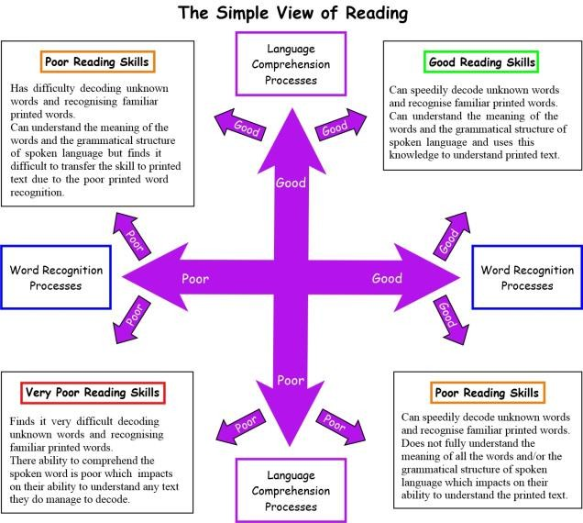

Appendix B
The PEER framework
This is a simple sequence that can be used to support shared, or ‘dialogic’ reading.
When reading together adults can pause and:
Prompt the child to say something about the book;
Evaluate their response
Expand their response by rephrasing or adding information to it: and
Repeat the prompt to help them learn from the expansion.
For example, if an adult and child were looking in a book about a zoo, the adult
might point at the picture and say, “What is that?” (PROMPT). The child replies,
“zebra”, and the adult responds, “That’s right (EVALUATION)- it’s a black and white
stripy zebra (EXPANSION): can you say, ‘stripy zebra’”.(REPETITION)

There are 5 main types of prompts that can be used as part of the PEER sequence. The prompts can be remembered using the acronym CROWD:
Completion- leave a blank at the end of a sentence for children to complete (this works well with rhymes and repetitive phrases)
Recall- ask children about something they have already read )these prompts support children to understand the story plot)
Open-ended- often with a focus on picture books (works well with illustrations and encourages children to express their ideas)
Wh-prompts that begin with who/what/where/why and when (These can be used to develop vocabulary)
Distancing- connects the book to children’s own life experiences and provides an
opportunity for high quality discussion

Appendix C
The main strands that are interwoven into a fluent reader
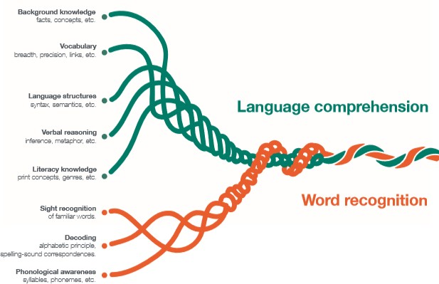

Appendix D
Based on the The 5 plagues of the developing reader (Doug Lemov, ‘Teach like a champion’)
Five particular challenges (or plagues) are important to plan into a whole school reading approach to both reading and vocabulary ensure that teachers identify and teach the challenges presented by complex texts. These books should form part of the reading spine across the whole school. On subsequent pages we have provided a breakdown of the 5 plagues and suggested texts for KS1, Lower Key stage 2 and Upper key stage 2.
- Archaic texts- Archaic texts are older texts, those written when authors used different words, in different sequences, within different syntactical structures. With each passing year, archaic texts become a little less familiar and a little more distant from the way we write and talk today. Accessing these texts is integral to becoming an engaged citizen of the world. Teachers can help prepare their students for archaic texts by encouraging them to read pre-complex texts, like the ones listed below for primary school, which provide simpler and more manageable versions of archaic structures.

- Nonlinear texts challenge a reader’s expectation that time elapses in a linear and even manner. These texts force readers to contend with confusing moments when time, or the rate at which it appears to be passing, shifts suddenly and without
explanation. Storytelling, in short, doesn’t obey any rules in terms of how time elapses. The manipulation of time is one of the primary tools authors use to shape a reader’s perception of events—and can be a primary source of confusion for students.
Teachers can help prepare students for nonlinear narratives by training them to spot and analyse sequence, unclear timing, shifts in fixity and rate of time, layered memories, and recurring events.

- Complexity of narrator-A text’s narrative voice can add to its complexity. It can have multiple narrators, nonhuman narrators, or even unreliable and deceitful narrators. It can have narrators whose role or identity is unclear—is the narrator the author? The challenge that such a book poses should not be underestimated: these texts are
tricky and can result in failed comprehension regardless of the degree of a student’s skills. Encouraging new readers to familiarize themselves with all different kinds of narrators early on keeps them from getting disoriented and discouraged when they encounter unreliable or multiple narrators as their reading becomes more complex.

- Complex stories are disorienting for even advanced readers, as they force the reader to hold a story together even as different plotlines swerve off in different, seemingly unrelated directions. To point out the obvious, following multiple plots and multiple, interwoven plots is harder than following a single plot. To prepare students to read successfully, teachers must also expose them to texts with complex plot structures. Making sense of a flurry of contradicting plot points requires deep analysis of a text, a powerful tool for readers to leverage throughout their reading career. Teachers should be very clear and rigorous about untangling plot.

- Resistant texts-When authors write resistant texts, they mean for the material to be difficult to understand. To cause a reader to struggle to make sense of a story is to

communicate the struggle of making sense of it as a writer. Oftentimes with these texts, gaps in meaning are part of the meaning-making. Reading resistant texts can be a huge challenge—but an important one. Three key actions can prepare students to read resistant text successfully: exposure to extremely dense (plague-ridden) texts, reading poetry to get a grip on non-logical prose, and closely reading short examples to give students frequent manageable exposure.

Not every text you read with your students needs to specifically address these plagues. Lots of exposure spread out over the year in small bursts is likely to help quite a bit.

The aim of the lists below is to provide schools with an extensive list of books which they can apply to their own long-term plans.

- These are books to use as whole class reads or extracts taken from them to look at in
greater detail.
- The idea is that in each year, a child will cover all 5 plagues of reading so that, by the time they reach year 6 and beyond, they have a good understanding of all of them and are able to access the more complex books expected of them in secondary schools.
- This only takes into account narratives and poems so a good balance of topic appropriate non-fiction should also be read to help further develop children’s background knowledge of the subject they are studying.

Year 1 and 2 Archaic texts
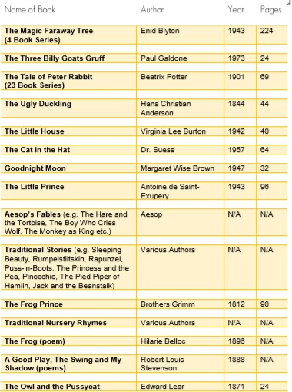
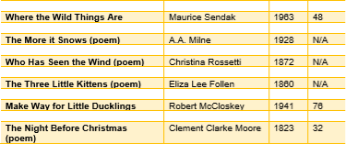

Nonlinear time sequences

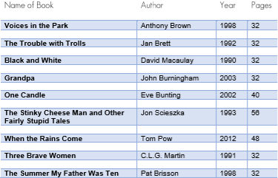
Complexity of the narrator
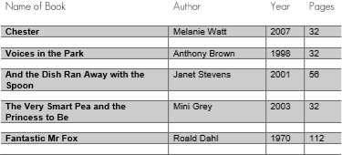

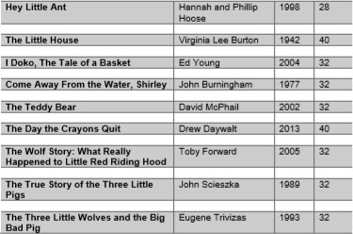

Complexity of the plot
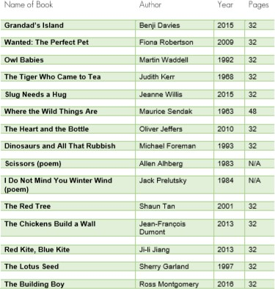

Resistant texts
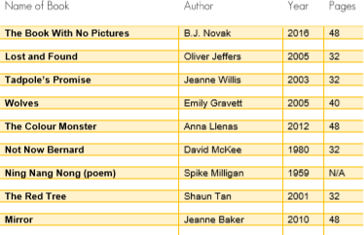

Year 3 and 4 Archaic texts
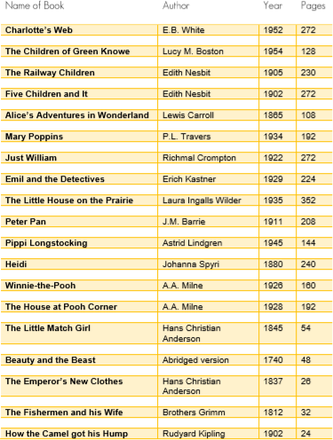
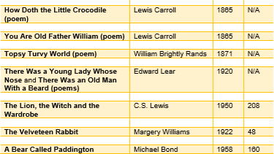

Nonlinear texts
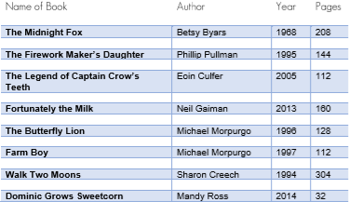
Complexity of the narrator
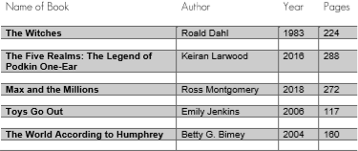

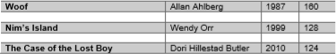

Complexity of plot
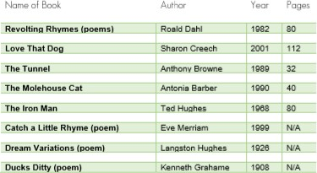
Resistant texts
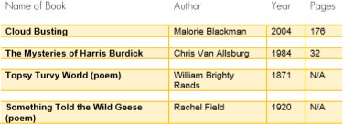

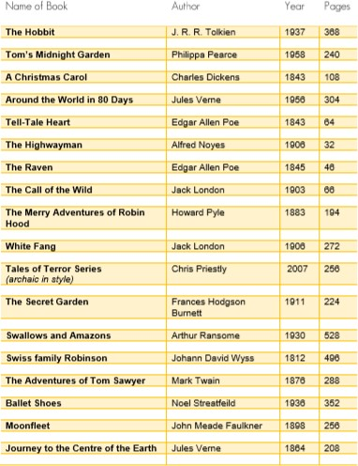
Year 5 and 6 Archaic Texts

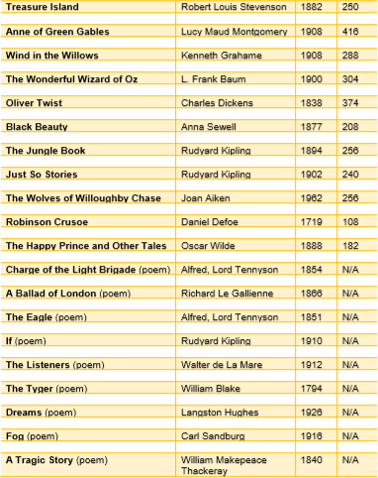

Nonlinear Texts
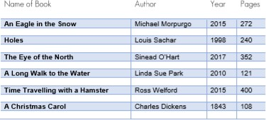



Complexity of the narrator
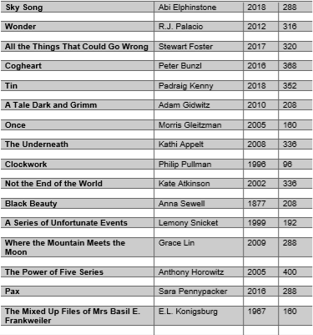



Complexity of plot
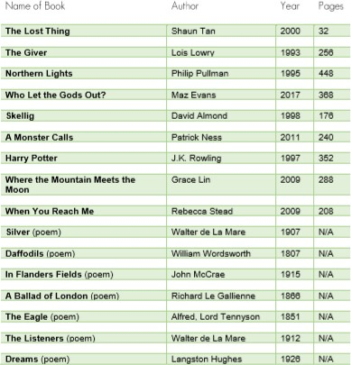
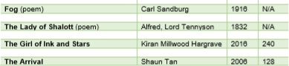

Resistant texts
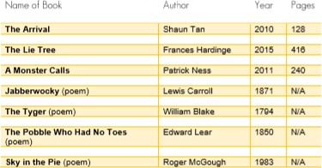

Appendix E
Shared reading tips
Tip 1: Ask questions about the book

Parents can support their child by asking a range of questions about the book they are reading together.
  - The ‘Five W’s’- who/what/ where/when/why can provide useful stems for parents
  - Parents should use a mixture of closed questions (which can be answered with a single word, or a small number of words) and open questions (which require a fuller response)
  - Children might also be asked to summarise what has happened in the book or story so far, and to predict what will happen next.
Tip 2: Link reading to the real world

By talking about links between the book and real life, parents can make the story more interesting and help children to develop their understanding of ideas in the book. For example, while reading about Cinderella going to the ball, a parent might discuss the similarities between a ball and a birthday party.

