Bonjour!
Last week we learnt ‘grand’ and ‘petit’ and used these to describe masculine nouns, e.g. un grand lion. Remember, we can spot a masculine noun as ‘un’ or ‘le’ is used.
Today we are looking again at ‘grande’ and ‘petite’ but this time for feminine nouns. What have you already noticed about the spelling of ‘grande’ and ‘petite’ now we are using them for feminine nouns?
I’m sure you have spotted the e on the end! This is similar to the e that appears on the end of ‘une’ for feminine nouns, e.g. une petite souris.
And that is our focus for today.
LO: understand and use ‘grande’ and ‘petite’
Here are the nouns we looked at last term when we first started learning about masculine and feminine nouns.
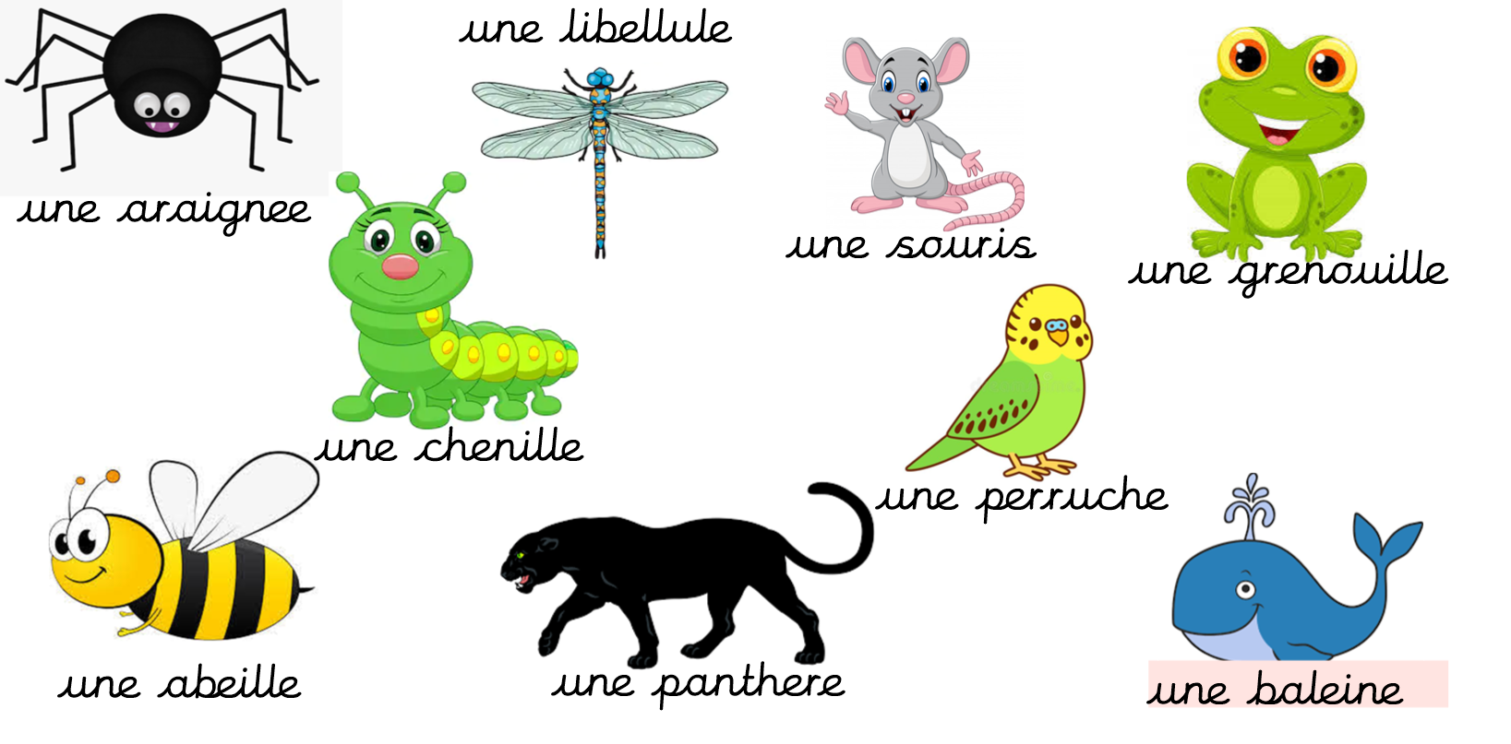
TASK:
Split or fold your paper into two. Label one side with ‘grande’ and the other with ‘petite’. Use each of the creatures above and write or draw them in the correct section of your paper, depending on whether they are a ‘grande’ or ‘petite’ creature in real life.
grande  une grande panthere | petite  une petite abeille

