8.1.21
L.O. I can add and subtract numbers with decimals

Loom Link: https://www.loom.com/share/f599a653ccc64a3280336aedb6733419

Math Antic links:
Adding and Subtracting Decimals - https://www.youtube.com/watch?v=I4Xt136E1ZQ
Column Subtraction - https://www.youtube.com/watch?v=Y6M89-6106I
Column Addition - https://www.youtube.com/watch?v=mAvuom42NyY

Activity 1

For this activity, choose your challenge that you want to start with. They get harder as they go along. If you start on A or B, I would like you to do 5 then self-mark them. If you have go them all correct you can then move onto the next challenge. If you have got some wrong, can you find out where you made some mistakes? Then continue with that challenge.

A | B | C
- 56.2 + 23.5 =  - 74.8 – 32.6 =  - 28.1 + 61.4 =  - 83.7 – 12.4 =  - 34.63 + 23.34 =  - 79.45 – 35.22 =  - 34.03 + 18.41 =  - 167.72 – 52.31 =  - 236.92 + 452.03 =  - 627.341 + 123.458 = | - 56.42 + 23.55 =  - 74.84 – 32.06 =  - 28.18 + 61.42 =  - 83.76 – 12.41 =  - 314.63 + 23.304 =  - 709.45 – 350.202 =  - 34.003 + 18.041 =  - 167.712 – 52.301 =  - 236.902 + 452.003 =  - 697.361 + 123.458 = | - 516.022 + 213.765 =  - 704.8 – 312.006 =  - 268.081 + 661.498 =  - 823.177 – 122.864 =  - 324.603 + 293.034 =  - 709.045 – 35.22 =  - 304.103 + 18.401 =  - 167.22 – 152.31 =  - 236.902 + 452.039 =  - 897.341 + 129.908 =

Activity 2
When you have completed the first activity, move onto the reasoning and problem solving questions. Complete these in the time you have left in the lesson. You can complete them in any order that you wish.

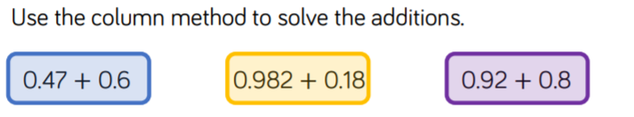


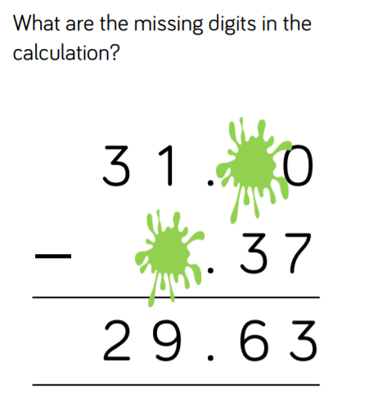 | 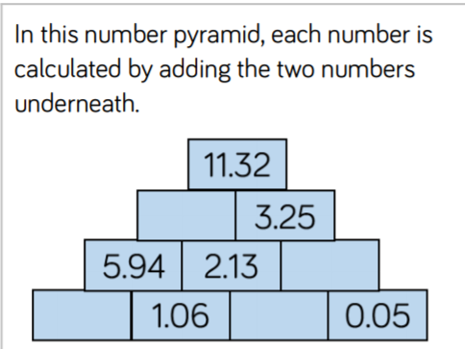
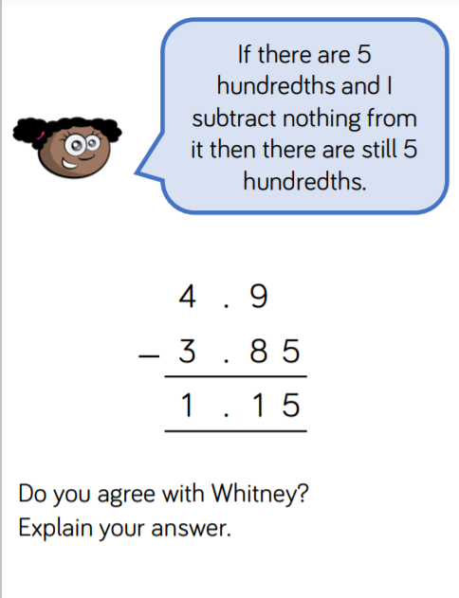 |  | 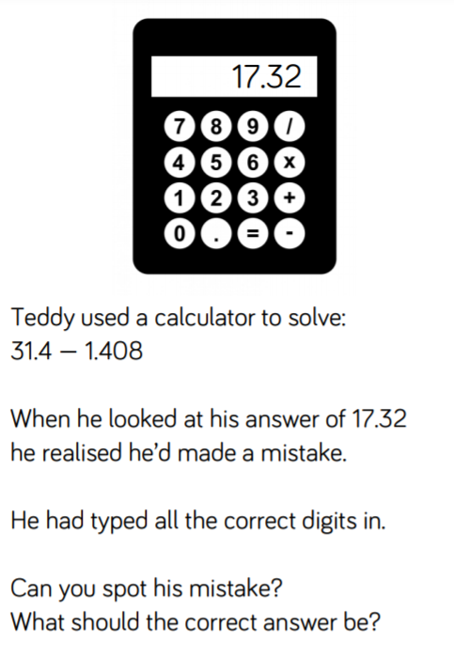
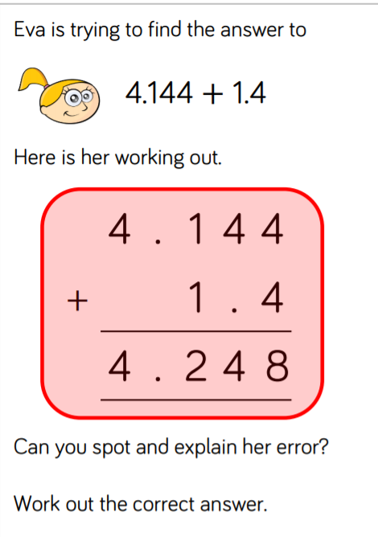 |  | 

