Thursday 27th January
Good morning!

Today’s learning will be……..
Today in school we have our Edukid day.
Have a go at some of these activities.
- How many different languages can you greet another person? Find at least 10 ways to say hello. Patricia speaks Acholi. Watch this video. How might Patricia say hello to us?
https://www.youtube.com/watch?v=WK8LlgtXhJc
- Build a banda (house). Can you make a model of a traditional banda? The pictures below show how they are made. Find out about bandas and what they are like inside.
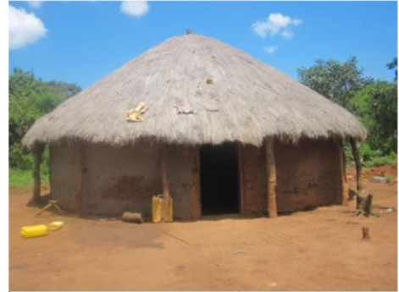

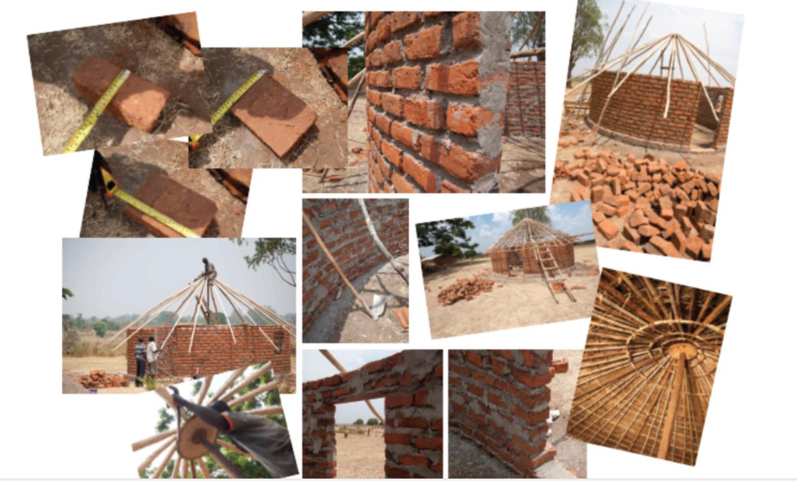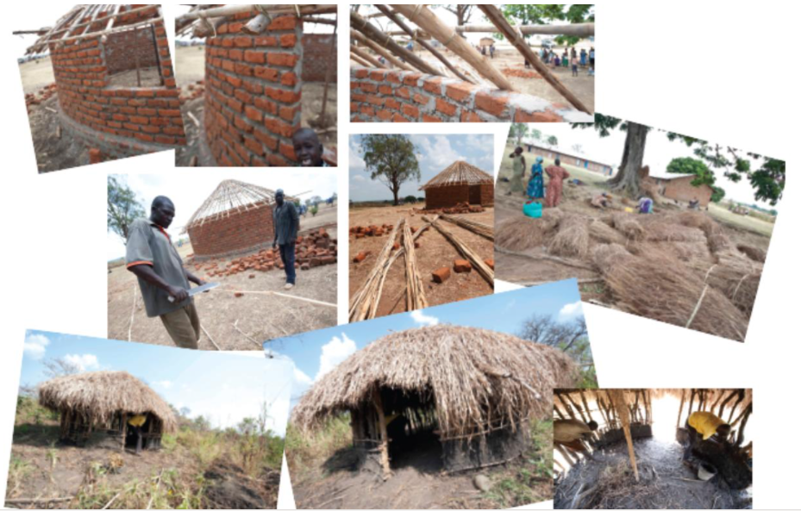
- Use the link below to learn about African Djembe drumming. Can you copy the rhythms he is playing?
https://www.youtube.com/watch?v=q5U8md4rZS8
- In Uganda, the children play football on the playground just like we do. But they make their footballs out of plastic bags. Can you make a football from plastic bags?
- Make a poster that compares aspects of life in Uganda and the UK.

5B@brixington.devon.sch.uk
5H@brixington.devon.sch.uk

