7.1.21
L.O. I can read, write, order and compare numbers up to 3 d.p

Loom Link : https://www.loom.com/share/e793fe90655e4dc1bafe3da10d977dc8

Activity

Order these numbers from smallest to biggest

- 5.345 , 7.28 , 3.283 , 4.932

- 432.2 , 832.493 , 482.893 , 833.3

- 172.74 , 923.621 , 623.201 , 213.9

- 63.2 , 632.3 , 63.23 , 622.322

- 802.374 , 80.734 , 8.032 , 807.702

Challenge
If you completed the questions above, move onto the challenge questions below. Have a go at many as you can in time you have left in the lesson.

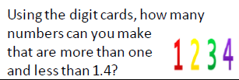 | 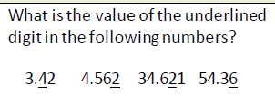
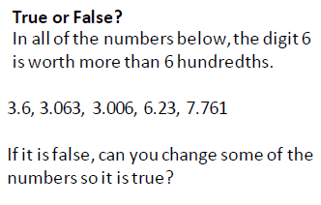 | 

