12.1.21
L.O. I can multiply decimals with integers

Loom Link: https://www.loom.com/share/a055811cb37e4f979cb1fd5c8f700dc0

Helpful Links:
Math Antics – Column Multiplication: https://www.youtube.com/watch?v=FJ5qLWP3Fqo

Activity

Choose you challenge from the ones below. These challenges start at A (easiest) and progress to C. Once you have completed one of the challenges, self-mark to see how you have got on (answers are in the folder on the website).

REMEMBER: If you have chosen B or C and are finding it difficult, go back to challenge A.
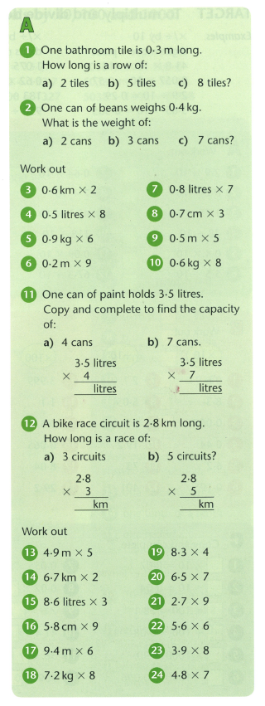
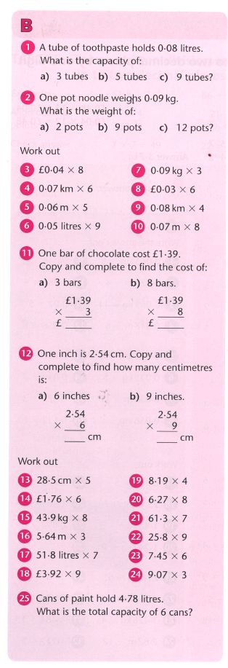
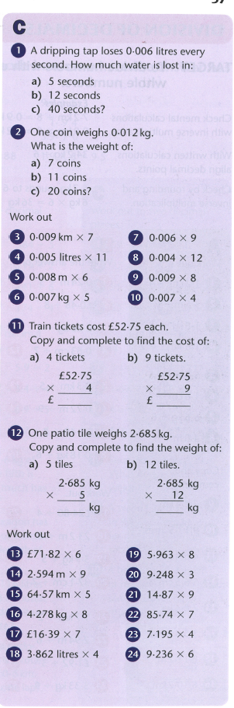

CHALLENGE

