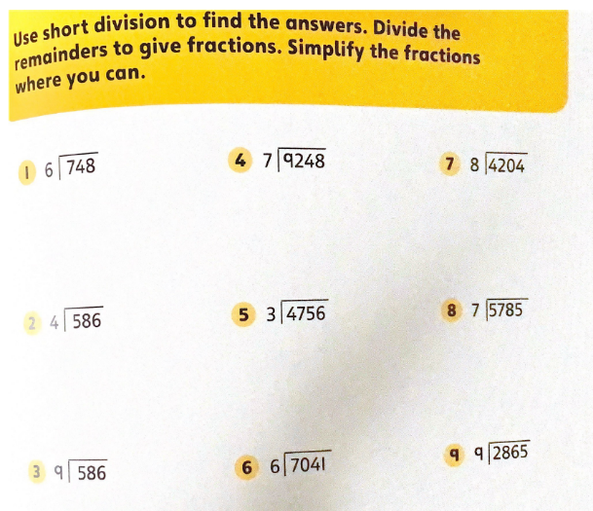
13/1/21
LO: to divide decimals by an integer

Task 1:

Complete the short division revision questions on the PDF on the website. Use the following YouTube clip to help you remember how to do this: www.youtube.com/watch?v=SLze82Zcc4Y

Task 2:

Loom Link:

https://www.loom.com/share/62af3f69492c446a9cea02b9e04b9cfe

Task 3:

Complete the VARIED FLUENCY and REASONING AND PROBLEM SOLVING questions according to your understanding. Level 1 is the easiest and level 3 is the hardest. You can use a combination of mental or written methods.

