Thursday 14th January 2021
LO: to write a tourist guide script for Ghastly-Gorm Hall.

Zoom Link for Live Lesson: 09:15-10:15 (SENT THROUGH DOJO)

Watch this YouTube video showing a tour guide of a $17 million mansion in LA. Inside a $17 Million Fully Customized Bel Air MEGA MANSION - YouTube

Today’s task is to write a tour guide for Ghastly-Gorm Hall. Your plan will look like the following:

- Introduction
- Room 1 (all children will achieve this)
- Room 2 (most children will achieve this)
- Room 3 (some children will achieve this)
- Summary

To be successful:
- I will write descriptively.
- I will use adverbs of possibility to give opinions and to speculate.
- I will use a register which suits the context (Hard).

Use the following information to help you write your script:

Settings in Goth Girl
In the House – Upstairs

Ada’s room
Lucy Borgia’s room
The Long Gallery – where Ada takes tea with L. Goth
The Attic
The roof
The Study
In the House – Downstairs

The kitchen
The Broken Wing (various tumble-down rooms, incl. Bathroom of Zeus,)
The Dining room
The Short Gallery – where Ada has breakfast
The Chinese Drawing room

The Grounds
The Secret Garden
The Even-More-Secret Garden – incl. Greenhouse of Harmony (containing Wildman & Wife)
The Hobby Horse Stables
The Unstable Stables – where Hamish (Shetland Centaur) & Mr Omalus (faun) incarcerated
The Old Ice House – where the Polar Explorer is

Ground Level
Ada’s Room
The Long Gallery
Lucy Borgia’s Room
The Attic
The Roof
The Kitchens
Bathroom of Zeus
The Dome
&
Grand Staircase
Chinese Drawing room
Library
Hobby horse stables
Unstable Stables
The broken Wing
The Secret Garden
The Even-More Secret Garden
The Old Ice House
The Short Gallery
Goth’s Study
The Sensible Folly
Upstairs

Example opening

Welcome to Ghastly-Gorm Hall. I will be your guide today. The hall was built 400 years ago, by the first Lord Goth and has been improved by each Lord. The current Lord Goth commissioned the marvellous Metaphorical Smith to landscape the gardens, which are both magnificent and somewhat confusing. Please follow me to our first point of interest. Take care not to stare for too long at the ghosts. It hurts their feelings... etc.

Tourist Guide Prompt
- Choose a room to describe – you can choose another if you have time
- Read your writing aloud to check it sounds descriptive and interesting
- Use the appropriate register (descriptive, speaking to the audience, speculative (adverbs), enthusiastic, friendly)
Structure of Guide
- Introduction
(what, where, when)
- Room 1
- Room 2?
- Summing up

Introduction – key phrases
Welcome to… I will be your guide today so…
If you have any questions… Please take care when…
Ghastly-Gorm Hall was built in… The first Lord Goth… If you would like to follow me to…
Describing the rooms – key phrases
If you look up, you will notice… The furniture was designed…
The ghosts are harmless… Some people think that…
Imagine you lived in… The family use this room for… Guests often enjoy... I shouldn’t tell you this but…
Summing up – key phrases
I hope you have enjoyed… That is the end of… Next time you visit you may… Tips are welcome…
Adverbs of possibility: perhaps
maybe
possibly
probably
surely
definitely
certainly
The Chinese Drawing room surely is the most beautiful room in the house.

Perhaps, the kitchens in Ghastly-Gorm Hall are the busiest rooms of the house.
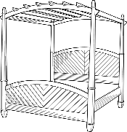
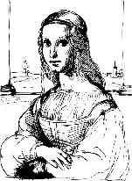
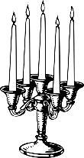
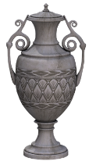
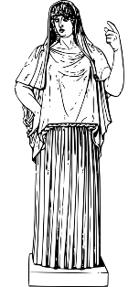
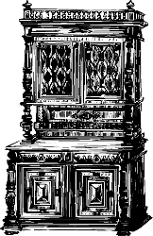
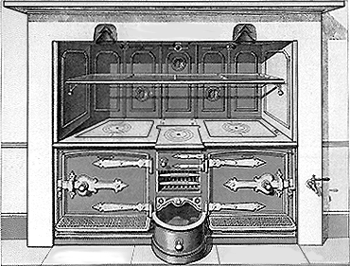
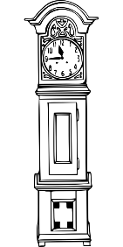
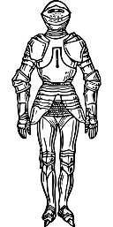
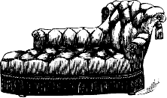
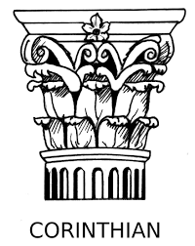
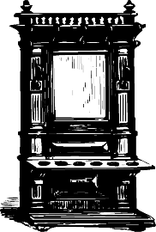
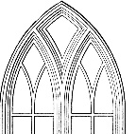
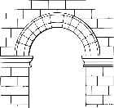
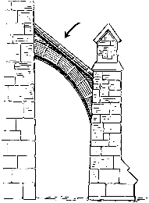
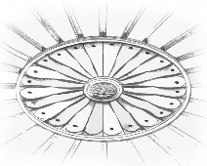

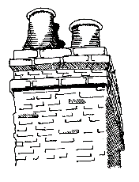
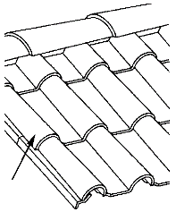
Vocabulary of Large Houses
Four-poster bed
portrait
candlestick/ candelabra
Rooms
Drawing room – a smart sitting room
Dressing room – small room next to a bedroom, for keeping clothes and dressing in
Gallery – A wide corridor, wide enough for furniture (a breakfast table etc.)
Kitchens – Several rooms for different types of cooking
Library – A room where lots of books are kept
Pantry – Cool room for food storage/ preparation
Stable – Place to keep horses
Study – A room with a desk for writing and thinking
Wing – a long section of a building
ornate vase
statue
Jacobean sideboard
kitchen range
grandfather clock
suit of armour
divan chair
mantelpiece
fireplace
hearth

Gothic
window

Corinthian
column

Roman arch

magnificent plaster ceiling
dome

chimney pot
chimney stack
brickwork

roof ridge
tiles

buttress

Unit 2 Day 3

