PE Challenge – Joe Wicks (The Body Coach)

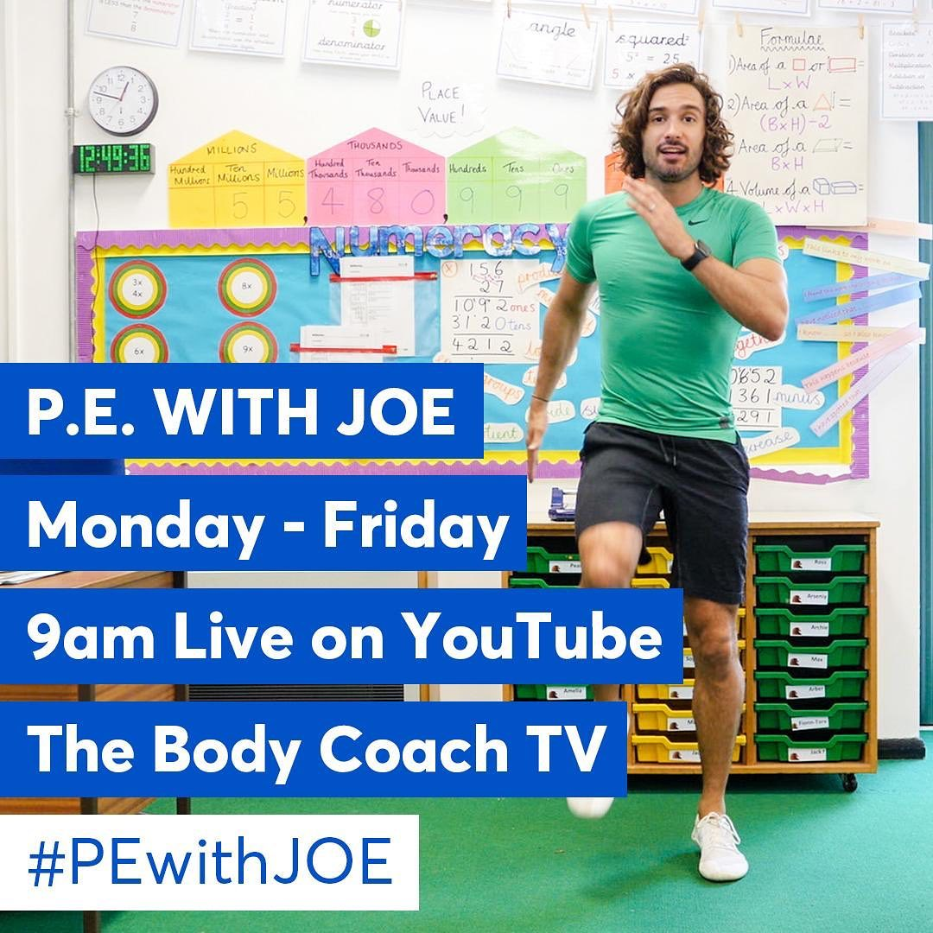

Joe Wicks is starting his daily workouts again on YouTube.

Can you create your own Joe Wicks workout? You need to write down 10 exercises with the amount of time you need to do them for and the amount of time you need to rest for (E.g. 30 seconds of lunges, 30 seconds rest).

Once you have written your workout out, send it to your class email, and we will share them with the rest of year 6 so they can have a go themselves.

If you wanted to, you could film yourself doing your workout.

