Maths Puzzles

Below are a series of puzzles. Each row has to total the number in the yellow box at the end of the row and each column has to total the number in the yellow box at the end of that column.

There are two challenge levels for each set.

Set 1
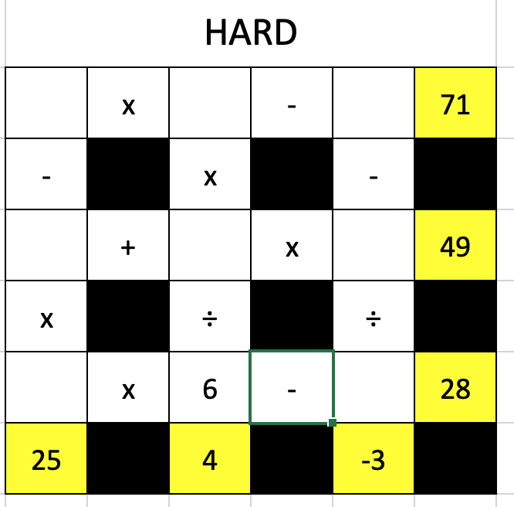
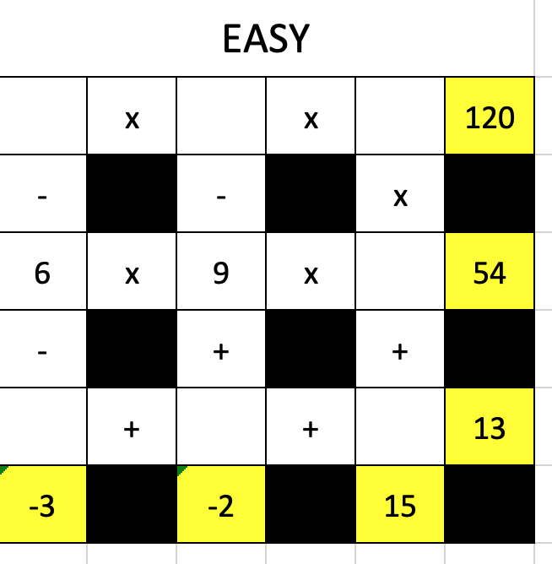

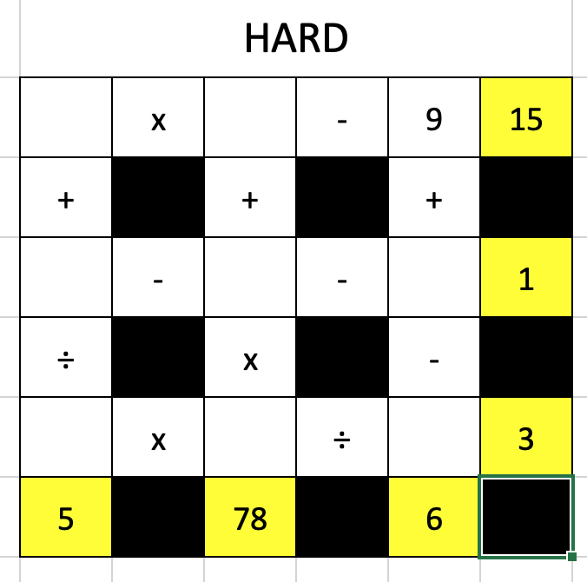
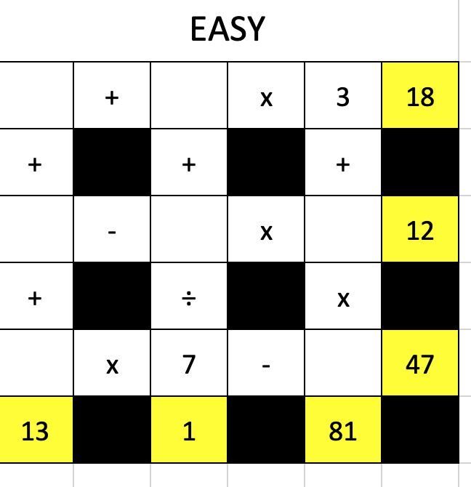
Set 2

