Tuesday 7th July 2020

★ Reading Challenge 2
Now read some more verses:
The Quangle Wangle said
To himself on the Crumpetty Tree:
“Jam; and jelly; and bread;
Are the best of food for me!
But the longer I live on this Crumpetty Tree
The plainer than ever it seems to me
That very few people come this way
And that life on the whole is far from gay!”
Said the Quangle Wangle Quee.
But there came to the Crumpetty Tree,
Mr. and Mrs. Canary;
And they said, — “Did ever you see
Any spot so charmingly airy?
May we build a nest on your lovely Hat?
Mr. Quangle Wangle, grant us that!
O please let us come and build a nest
Of whatever material suits you best,
Mr. Quangle Wangle Quee!”
And besides, to the Crumpetty Tree
Came the Stork, the Duck, and the Owl;
The Snail, and the Bumble-Bee,
The Frog, and the Fimble Fowl;
(The Fimble Fowl, with a corkscrew leg;)
And all of them said: “We humbly beg,
We may build our homes on your lovely Hat:
Mr. Quangle Wangle, grant us that!
Mr. Quangle Wangle Quee!”

★ Thinking Challenge
Put a circle around the 7 animals or birds that are in the poem and write their name. The first one has been done for you.
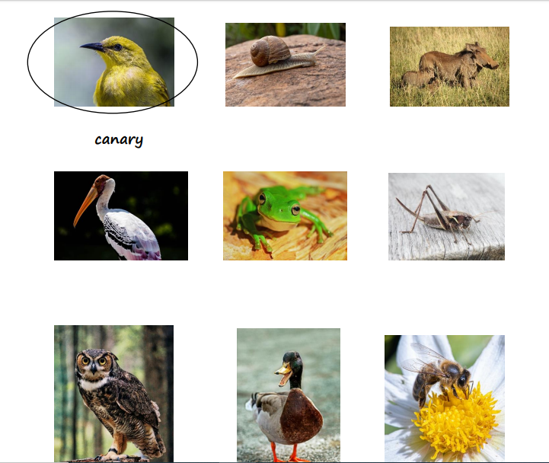

★ Reading Challenge 3
Now read the last two verses:
And the Golden Grouse came there,
And the Pobble who has no toes,
And the small Olympian bear,
And the Dong with a luminous nose.
And the Blue Baboon, who played the flute,
And the Orient Calf from the Land of Tute,
And the Attery Squash, and the Bisky Bat,
All came and built on the lovely Hat
Of the Quangle Wangle Quee.
And the Quangle Wangle said
To himself on the Crumpetty Tree:
“When all these creatures move
What a wonderful noise there’ll be!”
And at night by the light of the Mulberry moon
They danced to the Flute of the Blue Baboon,
On the broad green leaves of the Crumpetty Tree,
And all were as happy as happy could be,
With the Quangle Wangle Quee.
By Edward Lear
★ Talk Challenge
Talk to someone at home about the poem the The Quangle Wangle’s Hat. Write your ideas down below: Do you like the poem? What do you like about it?

Is there anything you don’t like or don’t understand?

If you could ask the poet Edward Lear questions about this poem, what would they be?

