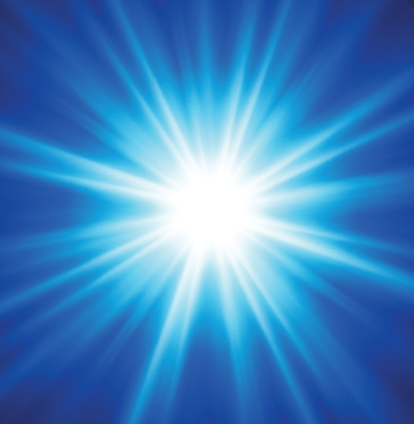
How does light travel?
Can you explain what these key words mean?
Reflection
Periscope
Opaque
Transparent

Light
How do we see?
What would you like to find out about Light? Think scientifically!
What is a shadow? Draw or describe how one is formed.

How do we see? Draw or describe the process.

Where does light come from?

