Measurement
Level 3/4 Questions 1 – 23
Level 4 Questions 24 – 45
Level 4/5 Questions 46 – 67
Level 6 Questions 68 – 78

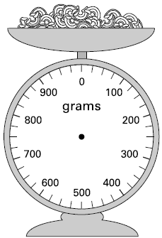
1 Jamie is cooking pasta.
He weighs 350 grams of pasta.
Draw an arrow on the scale to show 350 grams.

1 mark
2.3a

2 Here is a semi-circle.

Measure accurately the length of the straight edge.
Give your answer in centimetres.

cm
1 mark
2.12b

3 Measure accurately the length of the diagonal of this square.
Give your answer in centimetres.

cm
1 mark
4.4a

4 Measure accurately the length of the shortest side of this triangle.
Write your answer in centimetres.

cm
1 mark
4.7b

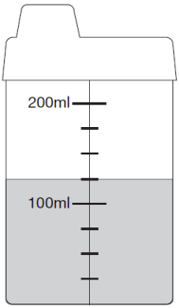
5 Here is a baby’s drinking cup.
How many millilitres of water are in the cup?

ml
1 mark
5.6b

6 Here are four lines: A, B, C and D.

A

B

C

D

Which two lines have a total length of 18cm? and
Draw a straight line that is 3 centimetres longer than line B.
Use a ruler.

2 marks
6.13b

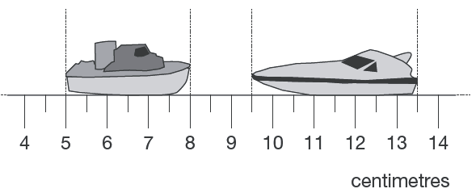
7 Here are two model boats on a centimetre scale.
How far apart are the boats?

cm

What is the difference in the lengths of the two boats? cm
2 marks
7.11b

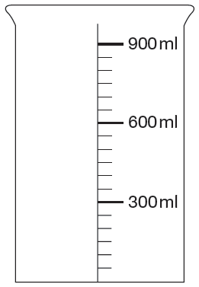
8 Mina has two cartons of juice.
Each carton contains 220ml.

She empties them both into this jug.
Draw an arrow ( ) to show the level of the juice in the jug.

1 mark
7.2b

9 The diagram shows distances on a train journey from Exeter to York.
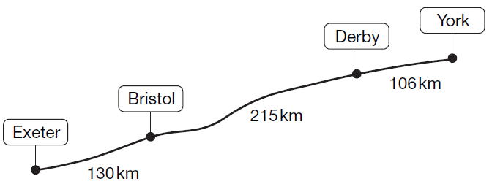

How many kilometres is it altogether from Exeter to York?
km

What is the distance from Derby to York rounded to the nearest 10 km?

km
2 marks
8.6a

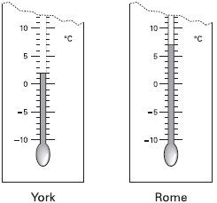
10 These are the temperatures in York and Rome on a day in winter.
How many degrees colder is it in York than in Rome?

ºC

On another day, the temperature in York is 4ºC
Rome is 7 degrees colder than York.
What is the temperature in Rome?
ºC
2 marks
8.0a

11 This piece of cheese has a mass of 350 grams.
Mark an arrow (↓) on the scale to show the reading for 350 g.
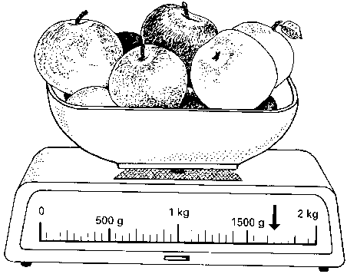

Here are some apples.
What is the total mass of these apples?

2 marks
8.97b

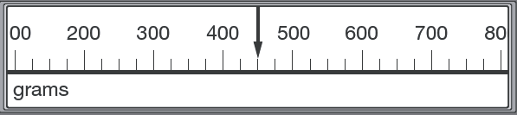
12 This scale shows the mass of Amy’s kitten when it was one month old.

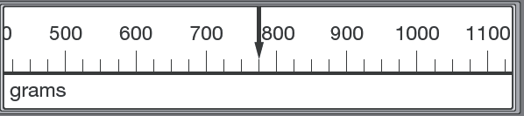
This scale shows the mass of the kitten when it was two months old.

What is the increase in mass? g
1 mark
10.10b

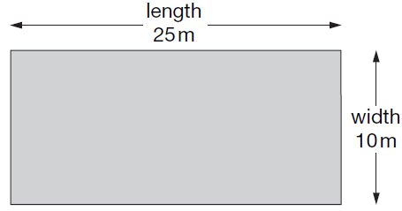
13 A rectangular swimming pool is 25 metres long and 10 metres wide.

David swims 5 lengths. Rosie swims 12 widths.
How much further does David swim than Rosie?
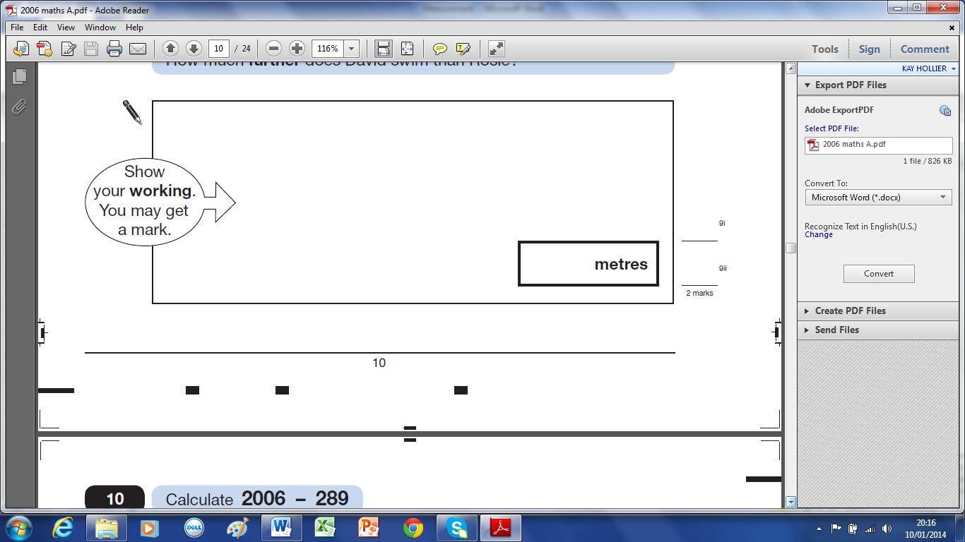

2 marks
9.6a

14 Abbie takes the temperature outside at midday on the first day of each month.
The graph shows her results from January to December.
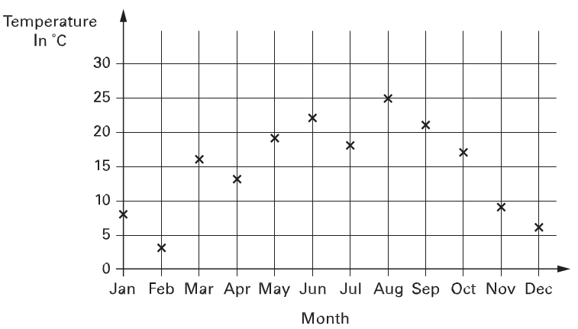
How many months on the graph show a temperature between 10°C and 20°C?

Find the difference in temperature shown on the graph between July and August.

degrees
2 marks
9.4a

15 The temperature inside an aeroplane is 20°C.
The temperature outside the aeroplane is – 30°C.
What is the difference between these temperatures?
degrees
1 mark
11.3b

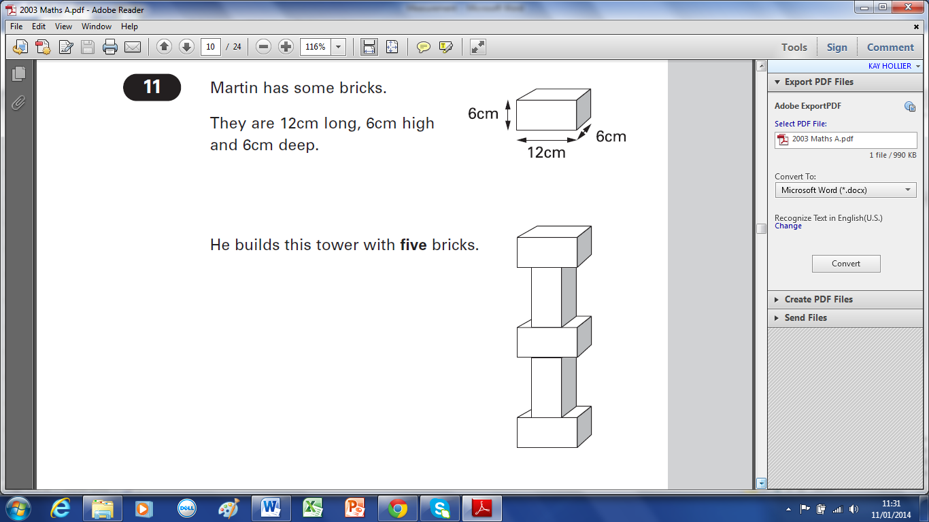
16 Martin has some bricks.
They are 12cm long, 6cm high and 6cm deep.

He builds this tower with five bricks.
How tall is the tower?

cm

Each brick is 12cm long.
Martin makes a line of bricks 132cm long.
How many bricks does he use?
2 marks
11.3a

17 This diagram shows the distances of different towns from Birmingham.
Write the name of a town which is between 30 and 50 miles from Birmingham.
…………………………..……..
1 mark
Use the diagram to estimate the distance in miles from Birmingham to Mansfield.

miles
2 marks
10.99b

18 Seb made a jump of two and a half metres.
Kirsty’s jump was 10 centimetres longer.
How long was Kirsty’s jump?
cm
1 mark
12.12b

19 A bottle holds 1 litre of lemonade.
Rachel fills 5 glasses with lemonade. She puts 150 millilitres in each glass.
How much lemonade is left in the bottle?
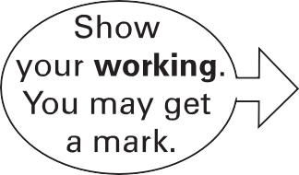
ml

„

2 marks
12.3a

20 Here are the ingredients for fish pie for two people.
Fish Pie
(for 2 people)
250g fish
400g potato
25g butter

Omar makes fish pie for 3 people.
How many grams of fish should he use?
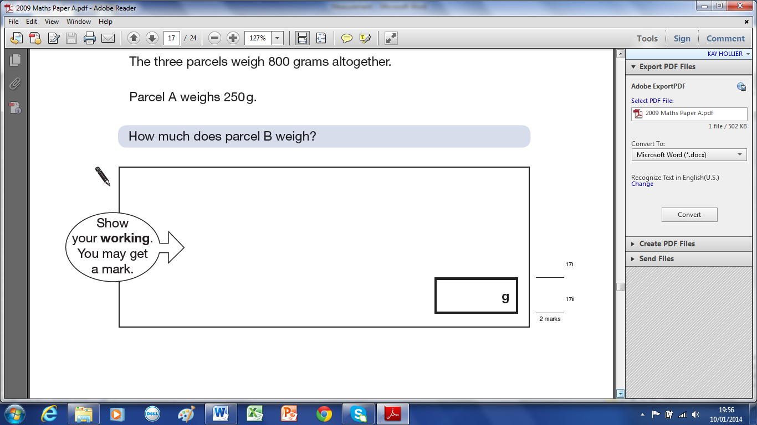

2 marks
14.97b

21 This table shows the distance in kilometres between five towns.
Birmingham
Cardiff
London
Manchester
Newcastle

Birmingham 179 188 127 334
Cardiff 179 269 278 489
London 188 269 298 441
Manchester 127 278 298 212
Newcastle 334 489 441 212

Use the table to find the distance from London to Manchester.

km
James goes from Newcastle to Birmingham, and then on to Cardiff.
How many kilometres does he travel?

Show
your
working
out
km
2 marks
12.97b

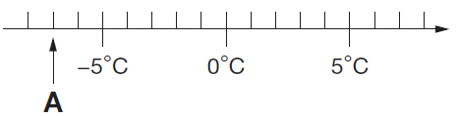
22 Here is part of a temperature scale.

What is the temperature shown at A?
ºC
What temperature is 20 degrees higher than A?
ºC
2 marks
13.13b

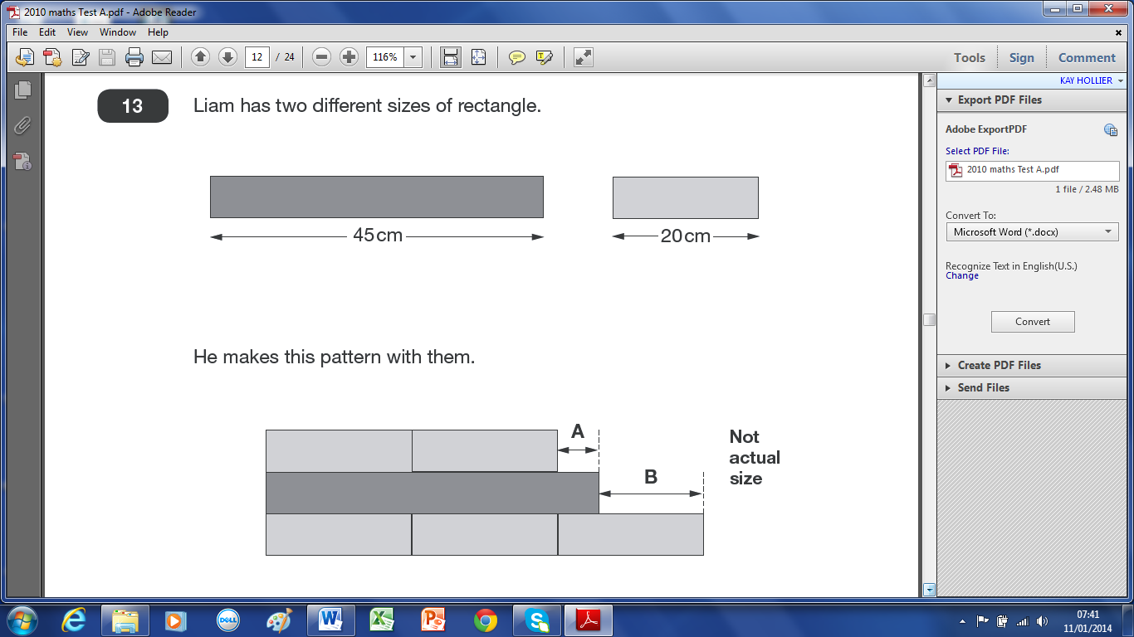
23 Liam has two different sizes of rectangle.

He makes this pattern with them.

Calculate the lengths of A and B.

A = cm B = cm
2 marks
13.10a

24 Joe places some apples on a weighing scale. He takes away one apple.
The pointer shows the mass of the apples. The mass goes down by 120 grams.
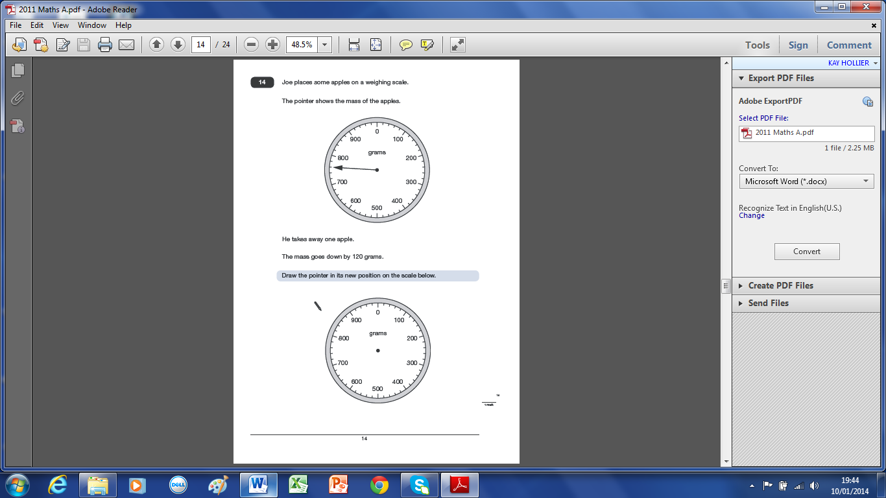
Draw the pointer in its new position on the scale below.

1 mark
14.11a
25 Megan wants to fill a bucket with water.
A bucket holds 6 litres.
A jug holds 500 millilitres.
How many jugs of water does Megan need to fill an empty bucket?
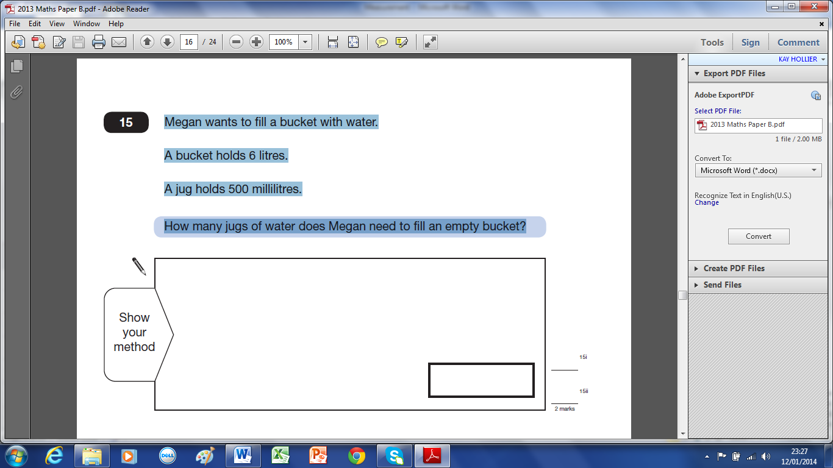

2 marks
15.13b

26 Four children are in a race.
Chen is 2 metres ahead of Alfie.
Nina is 5 metres behind Megan.
Alfie is 3 metres behind Megan.
Write the names of the runners in order, starting with the child who is furthest ahead.

furthest ahead
1 mark
15.13a

27 This scale shows the weight of Fred’s cat.

What is the weight of Fred’s cat?

kg

This scale shows the weight of Fred’s dog.
How much more does Fred’s dog weigh than his cat?

kg
2 marks
15.4b
28 This table shows the weight of some fruits and vegetables.
Complete the table.

2 marks
15.2a

29 Write these lengths in order, starting with the shortest.
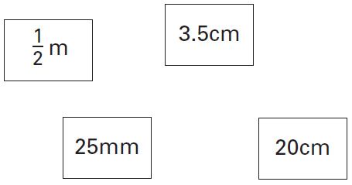

shortest
1 mark
15.3b
30 Here are four masses.
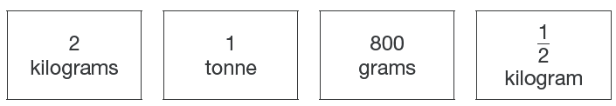

Write the masses in order, starting with the lightest.

1 mark
16.11b

lightest

31 This container has 900 millilitres Lara pours out some water
of water in it. so that it looks like this.
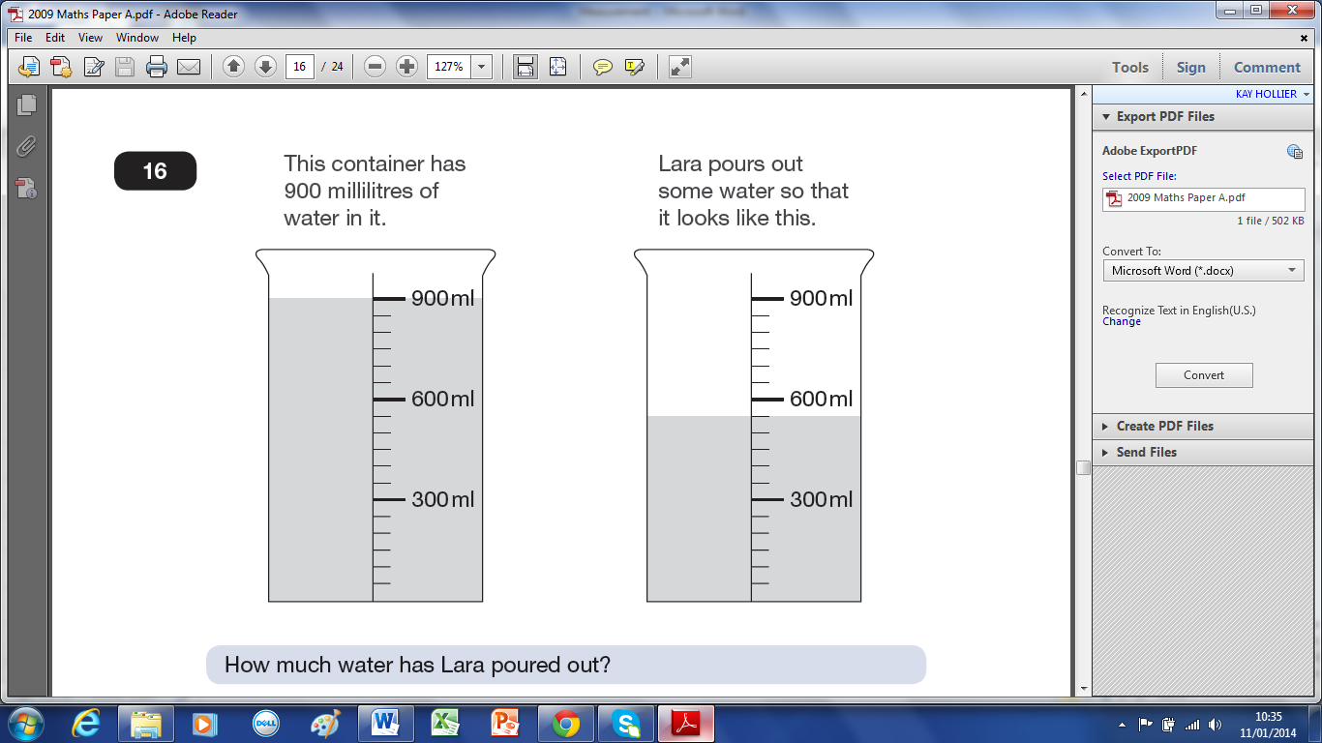

How much water has Lara poured out? ml

Then she pours out another 150ml of water.
Draw an arrow ( ) to show the new level of the water.

2 marks
16.9a

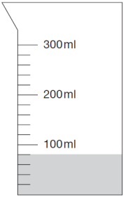
32 Hassan has a jug with some water in it.
He adds another 140 millilitres of water.
Draw a line to show the new level of water.

1 mark
16.7b
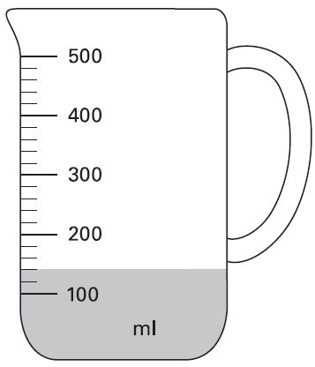
33 Mr Khan makes a blackcurrant drink for a party.
He pours blackcurrant squash into a jug.

How much water must he add to make 500 millilitres
of drink?

ml
1 mark
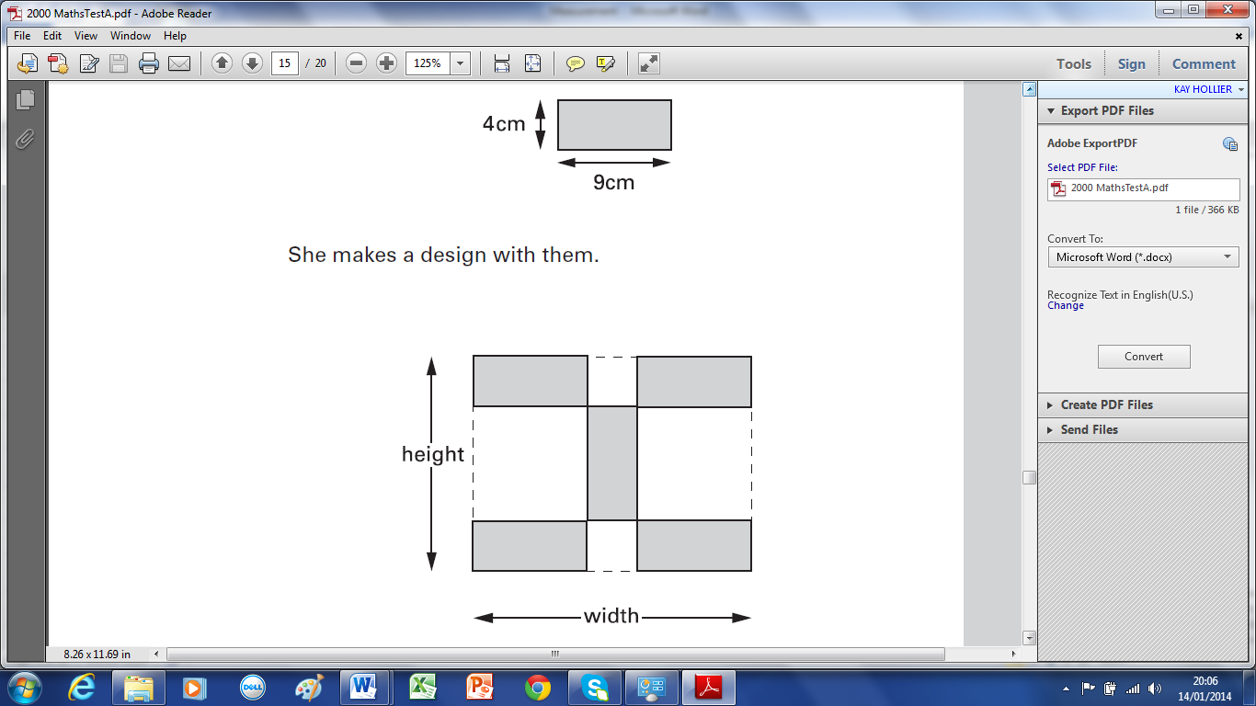
16.4a
34 Kim has some rectangular tiles.
Each one is 4 centimetres by 9 centimetres.

She makes a design with them.

Calculate the width and height of her design.

width = cm height = cm
2 marks
16.0a

35 Julie is 92cm tall. Tom is 184cm tall.
Lisa’s height is half-way between Julie’s height and Tom’s height.
Calculate Lisa’s height.
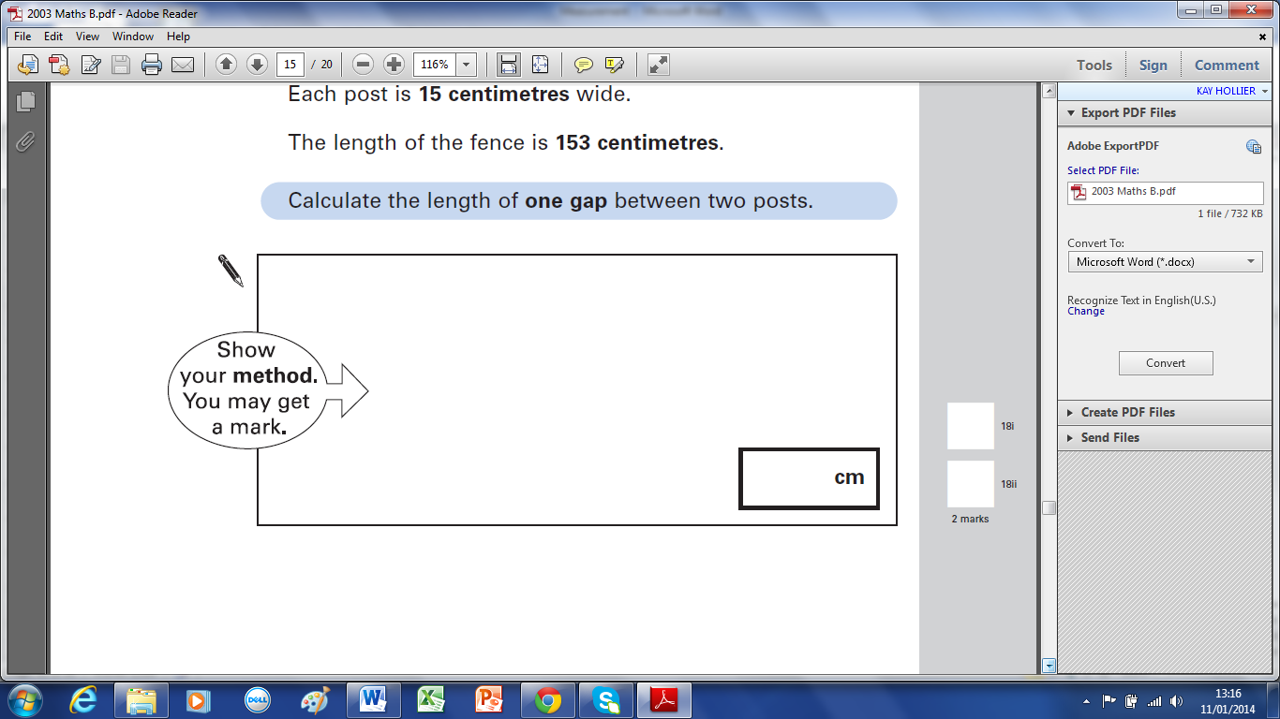

2 marks
16.98b

36 Vicki puts 10 books on a shelf.
The 10 books take up 28 centimetres.
What is mean (average) thickness of her books?

The shelf is 120 centimetres long.
Vicki fills the shelf with a mixture of books like the first ten books.
Estimate how many books she can get on the 120cm shelf.

4 marks
16.96a

37 Freddie is half as tall as his mother.
Freddie is one metre shorter than his father.
Freddie’s father is 180 centimetres tall.
How many centimetres tall is Freddie’s mother?
cm
1 mark
17.12a
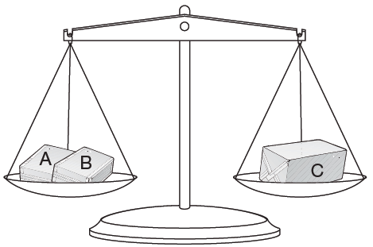
38 Amir has three parcels.

Parcels A and B together weigh the same as parcel C.
The three parcels weigh 800 grams altogether.
Parcel A weighs 250g.

How much does parcel B weigh?

2 marks
17.9a

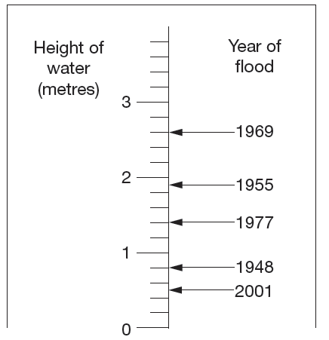
39 This scale shows the dates of floods and the height of the water in the floods.
How high was the water in the 1955 flood?

m

How much higher was the water in the 1969 flood than in the 1948 flood?

m
2 marks
17.8b

40 Lin has five books which are all the same.
She balances them on the scale with two weights.

Calculate the weight of one block.
500grams 800 grams

2 marks
17.6b

41 On this scale, the arrow (↑) shows the weight of this pineapple.
Here is a different scale.
Mark with an arrow (↑) the weight of the same pineapple.

1 mark
17.1b
42 This graph shows the outside temperature from 4 pm to 10 pm on a day in winter.
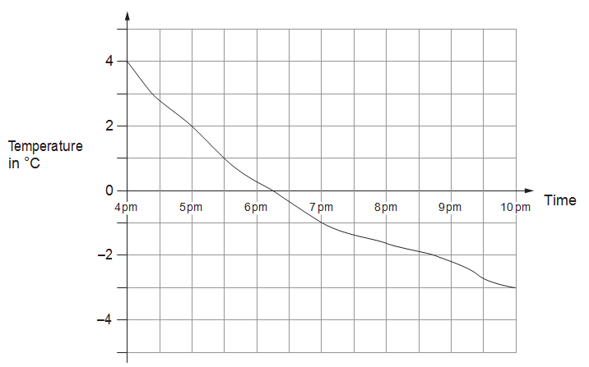
At what time was the temperature –2°C?

How many degrees did the temperature drop from 5 pm to 7pm?

degrees

2 marks
17.10b

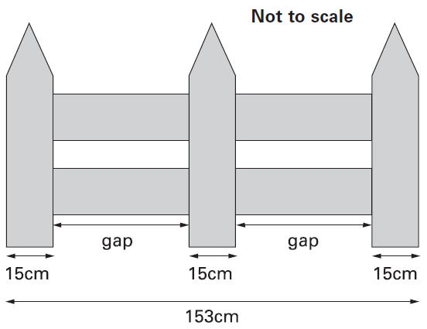
43 This fence has three posts, equally spaced.

Each post is 15 centimetres wide.
The length of the fence is 153 centimetres.

Calculate the length of one gap between two posts.

2 marks
18.3b

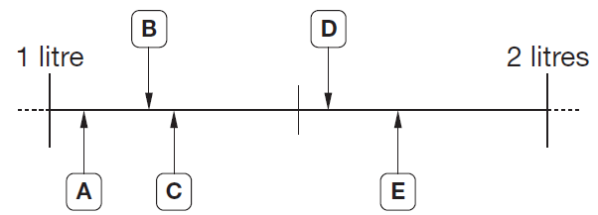
44 Here are five letters on a scale.

Match each letter to one of the capacities in the list below.
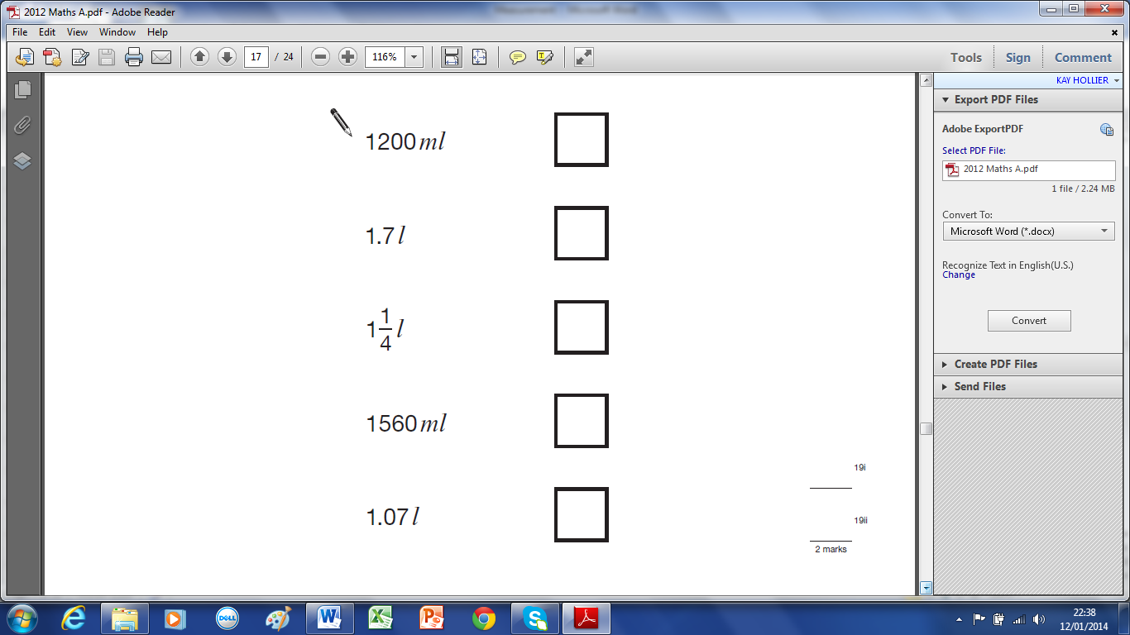

2 marks
19.12a

45 A packet contains 1.5 kilograms of guinea pig food.
Remi feeds her guinea pig 30 grams of food each day.
How many days does the packet of food last?
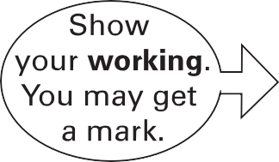

2 marks
19.3a

46 Here is a recipe for raspberry ice cream.
This recipe is for 8 people.
Josie makes enough raspberry ice cream for 12 people.
How much cream does she use?

litres

Fred makes raspberry ice cream in the same way.
He uses 2½ kg of raspberries.
How much sugar does he use?

3 marks
19.1b

47 Chen and Megan each have a parcel.
Chen’s parcel weighs 112kg.
Megan’s parcel weighs 1.2kg.
How many more grams does Chen’s parcel weigh than Megan’s parcel?

grams
2 marks
20.13a

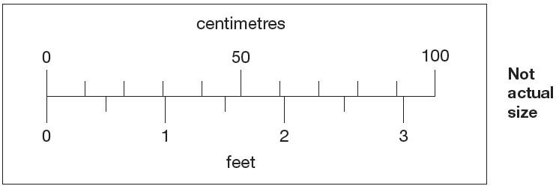
48 This scale shows length measurements in centimetres and feet.

Look at the scale.

Estimate the number of centimetres that are equal to 2$\frac{1}{2}$ feet.
cm
Estimate the difference in centimetres between 50 cm and 1$\frac{1}{2}$ feet.
cm
2 marks
20.9b
49 Here are four pairs of measurements.
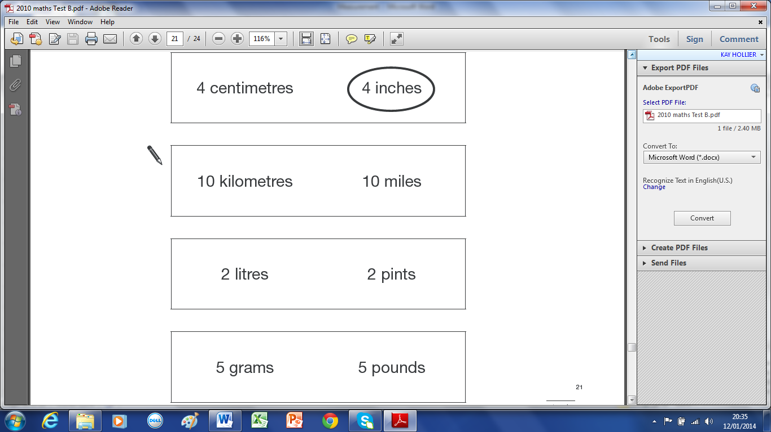
For each pair, put a ring around the larger measurement. One has been done for you.

1 mark
21.10b

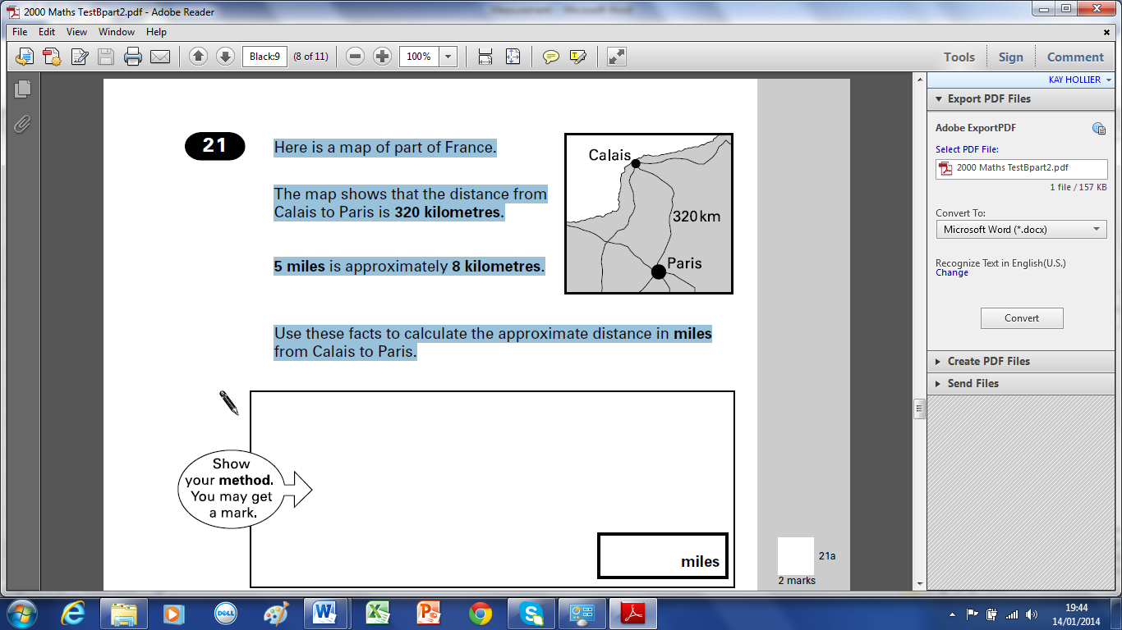
50 Here is a map of part of France.
The map shows that the distance from
Calais to Paris is 320 kilometres.
5 miles is approximately 8 kilometres.
Use these facts to calculate the approximate distance in miles
from Calais to Paris.

2 marks
21.0b

A
60cm
C
B
51 The distance from A to B is three times as far as from B to C.
The distance from A to C is 60 centimetres.
Calculate the distance from A to B.

2 marks
21.2b

52 Mr Jones has two sizes of square paving stones.
1.4m
3m
He uses them to make a path.

The path measures 3 metres by 1.4 metres.
Calculate the width of a small paving stone.
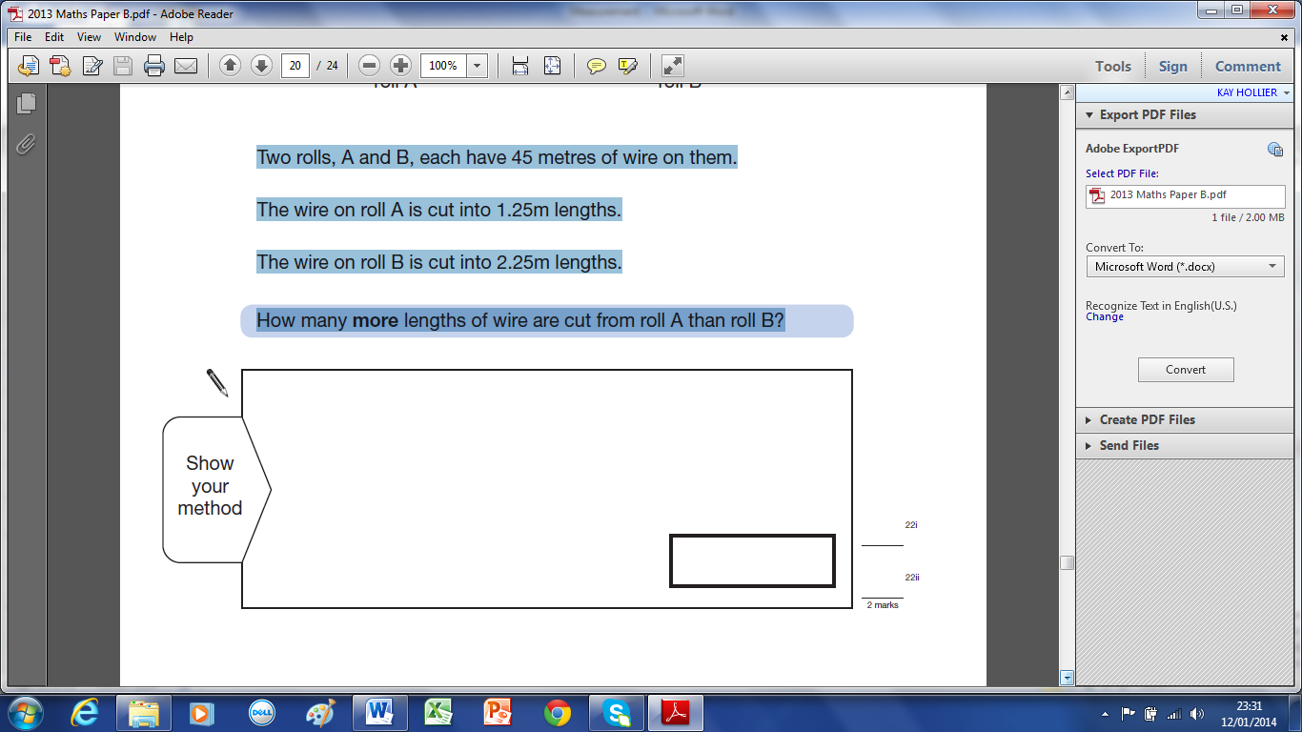

2 marks
21.99b
53 A shop sells rolls of wire.
Two rolls, A and B, each have 45 metres of wire on them.
The wire on roll A is cut into 1.25m lengths.
The wire on roll B is cut into 2.25m lengths.
How many more lengths of wire are cut from roll A than roll B?

2 marks
22.13b
54 Strips of paper are 30 centimetres long.
30cm
Steve joins strips of paper together to make a streamer.
30cm
30cm
5cm
5cm

The strips overlap by 5cm.
How long is a streamer made from only 2 strips? cm

Sunita makes a streamer that is 280cm long.
How many strips does she use?

3 marks
22.97a

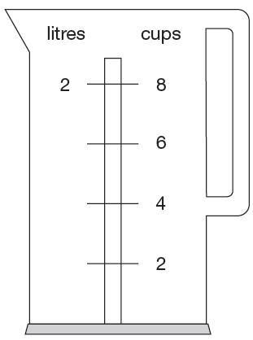
55 Nisha’s kettle holds 2 litres of water.

How many millilitres are equal to 1 cup?

ml
1 mark
22.8a

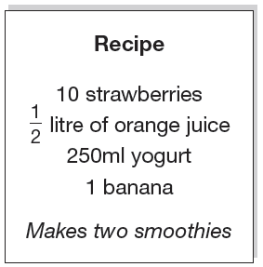
56 Here is a recipe for fruit smoothies.
Stefan uses the recipe to make smoothies.
He uses 1 litre of yogurt.
How many strawberries does he use?

Amir uses the same recipe.
He wants to make 5 smoothies.
He has 1 litre of orange juice.
How many more millilitres of orange juice does he need?
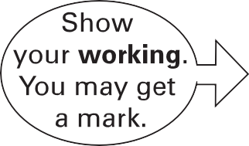

ml
2 marks
22.9b

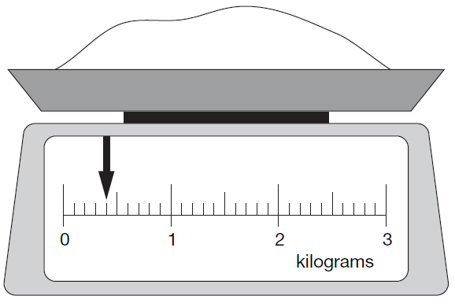
57 Here is some flour on a weighing scale.
How many grams of flour are on the scale?

grams

How much more flour must be added to the scale to make 1.6 kg?

2 marks
22.6b
7.2cm
58 Here is a rectangle with six identical shaded squares inside it.
The width of the rectangle is 7.2 centimetres.
Calculate the length of the rectangle.
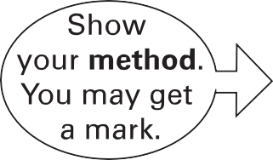

cm
2 marks
22.4b

59 Each paper clip is made from a 9.2 centimetres of wire.
What is the greatest number of paper clips that can be made from 10 metres of wire?

2 marks
22.98b

60 Josh has some tiles.
Each tile is 10cm long. Two tiles fitted together are 18cm long.
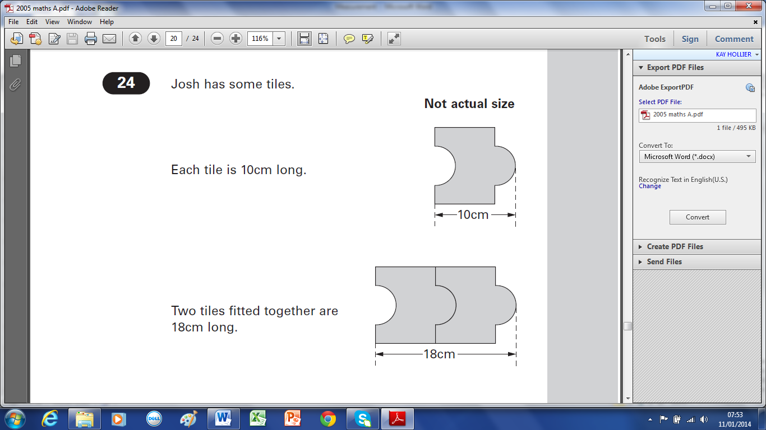

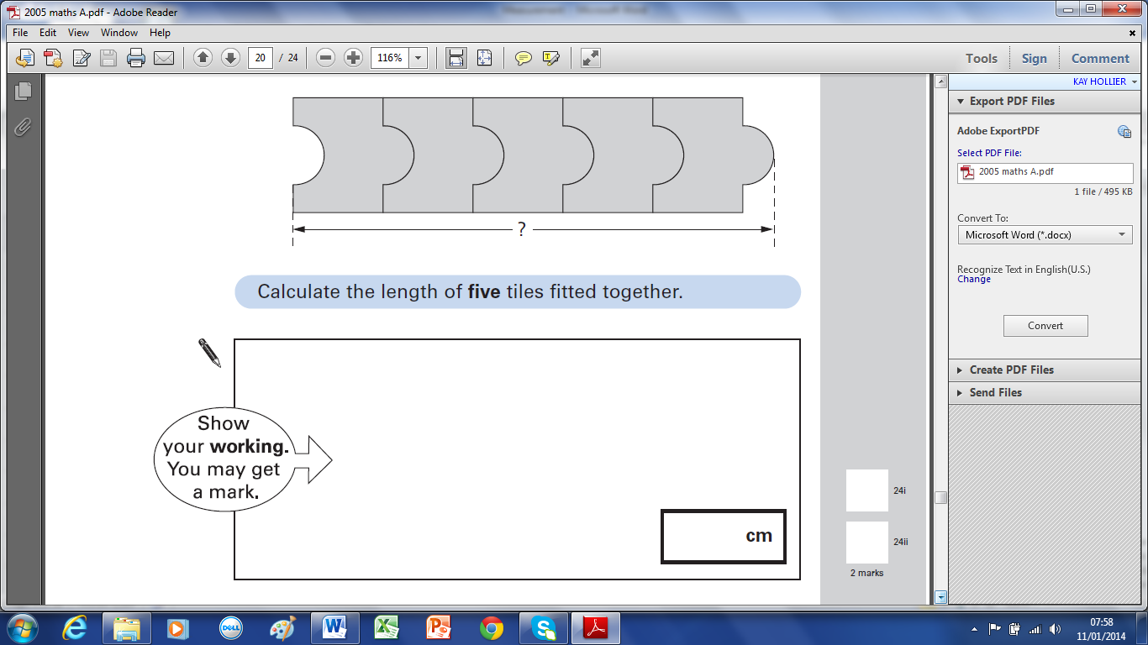
Calculate the length of five tiles fitted together.

2 marks
24.5a

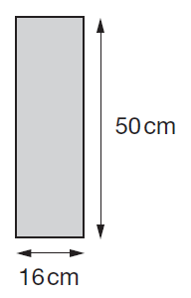
61 Kate has some rectangles.
They each measure 16 centimetres by 50 centimetres.
She makes this design with four of the rectangles.
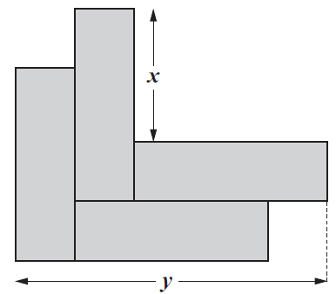

Work out the lengths x and y.
x = cm
y = cm
2 marks
23.7b
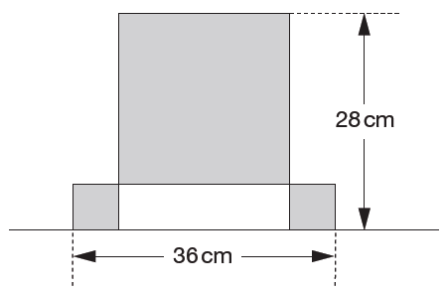
62 This design has one large square and two identical small squares.
The design measures 36 centimetres by 28 centimetres.

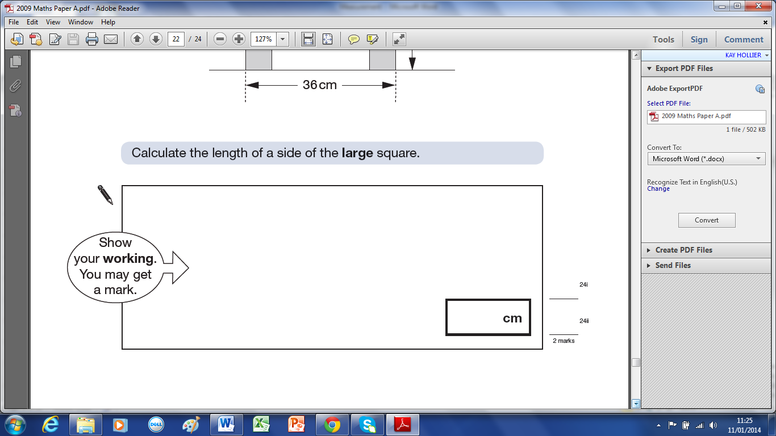
Calculate the length of a side of the large square.

2 marks
24.9a

63 Every 100g of brown bread contains 6g of fibre.
B
D
N
SLICE
RO
A loaf of bread weighs 800g and has 20 equal slices.
How much fibre is there in one slice?
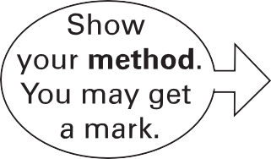

g
2 marks
24.4b

64 A box contains 220 matches and weighs 45 grams. The empty box weighs 12 grams.
Calculate the weight of one match.
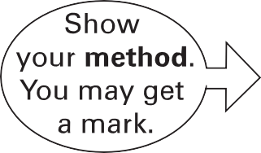

g
2marks
25.5b

65 Four large circles and five small circles fit exactly inside this rectangle.
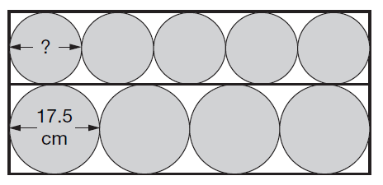

The diameter of a large circle is 17.5 centimetres.

Calculate the diameter of a small circle.

cm
2 marks
25.6b

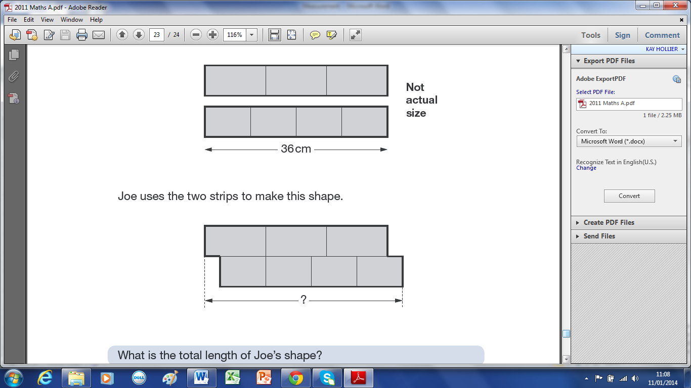
66 Joe has two strips of card.
Each strip is 36 centimetres long.
One strip is divided into three equal parts.
The other strip is divided into four equal parts.

Joe uses the two strips to make this shape.
What is the total length of Joe’s shape?

cm
2 marks
25.11a

67 A 5p coin has a diameter of 1.8 centimetres. Holly makes a straight line of 5p coins worth £10
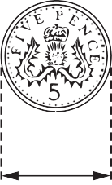
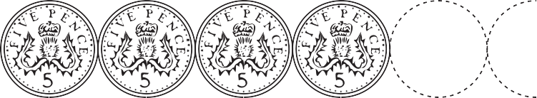

£10
1.8 cm
How long is Holly’s line? Give your answer in metres.

m
2 marks
26.11b

68 In a zoo, the adult polar bear weighs three times more than the baby elephant.
Together they weigh 700 kilograms.
How much does the polar bear weigh?
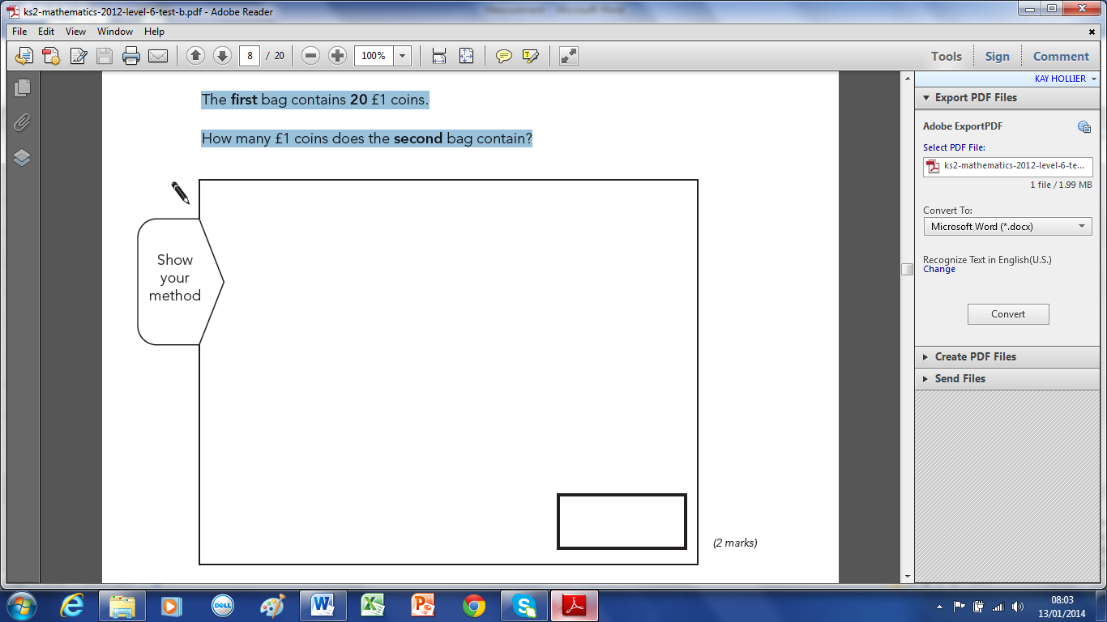

2 marks
2.13b

69 Megan goes on a walking holiday for five days.
The table shows how far she walked on the first four days.
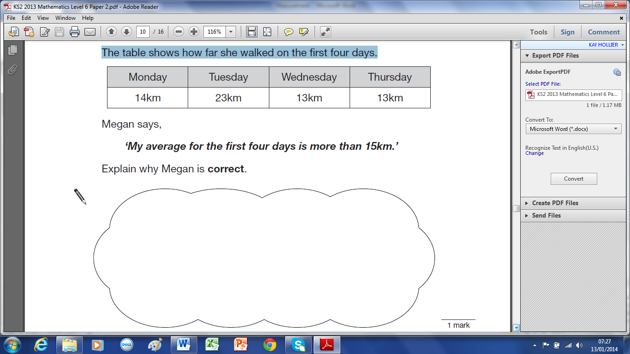

Megan says,
‘My average for the first four days is more than 15km.’
Explain why Megan is correct.

2 marks
7.13b

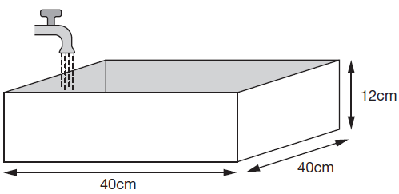
70 Every second, 300cm3 of water comes out of a tap into a cuboid tank.

The base of the tank is 40cm by 40cm
The height is 12cm
How many seconds does it take to fill the tank?
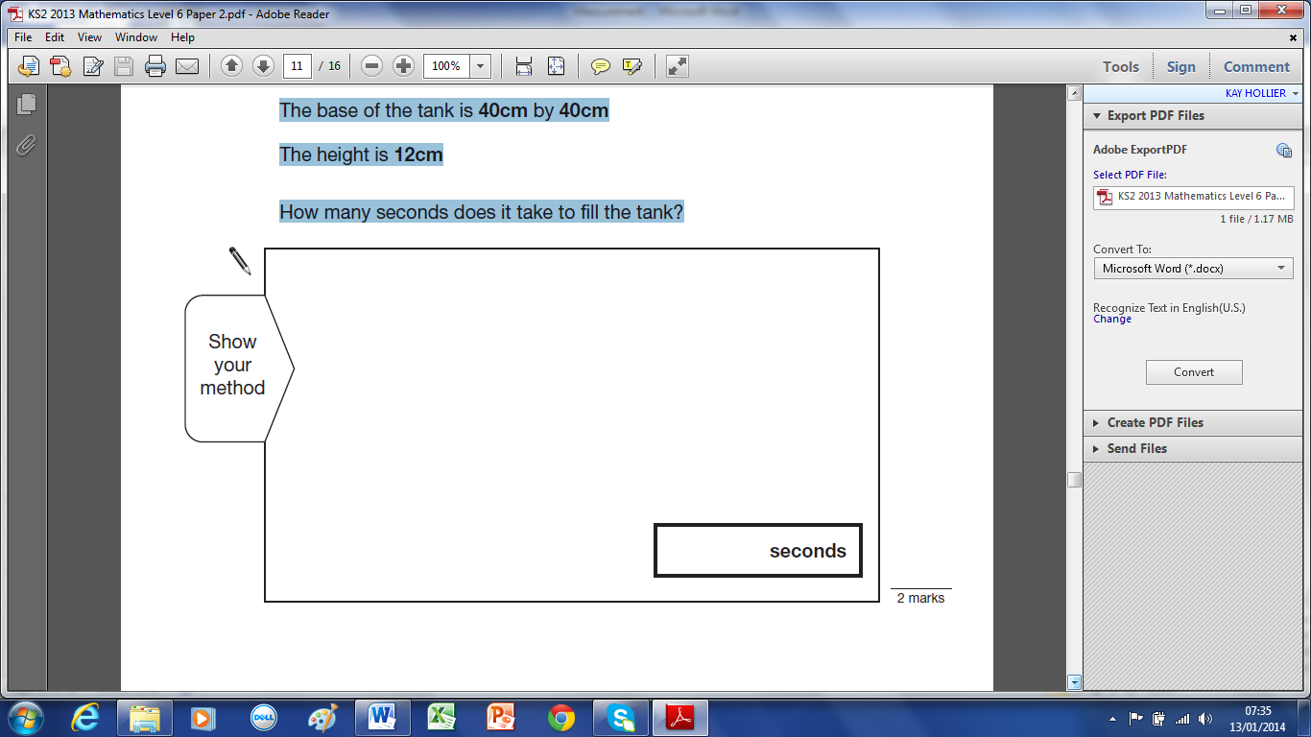

2 marks
8.13b

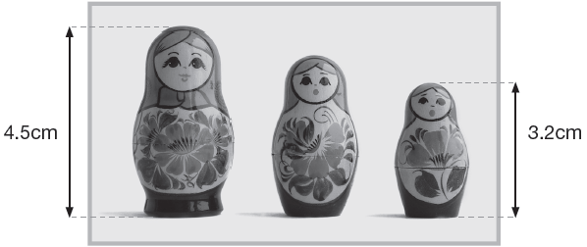
71 This photograph shows three Russian dolls.

The real-life height of the largest Russian doll is 13.5cm
What is the real-life height of the smallest Russian doll?

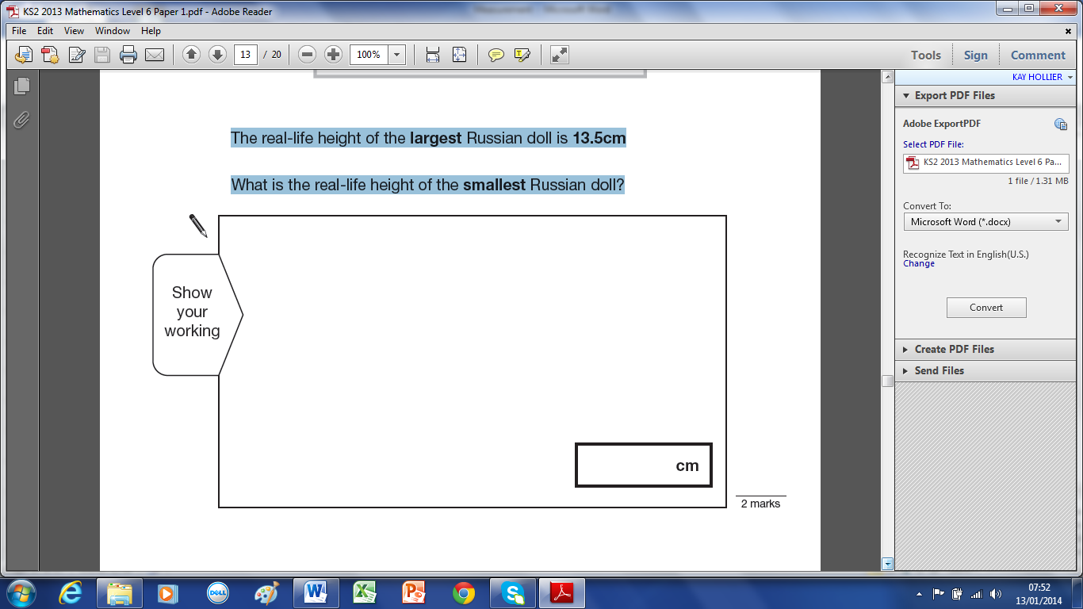

2 marks
10.13a

72 The graph shows the average heights of girls in the UK from age 6 – 11 years.
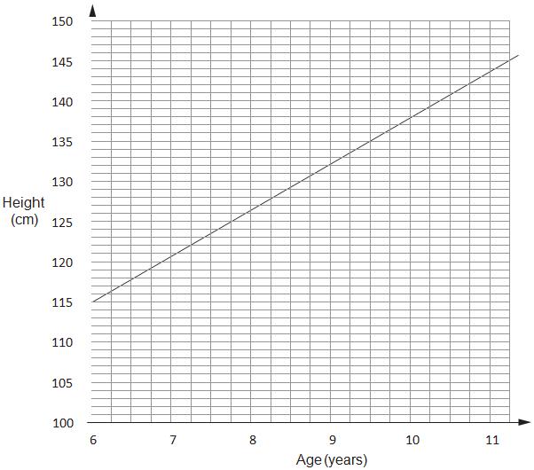
Emily is 1.38m tall.
She is the average height for her age. How old is she?

years old

Zoe is 9$\frac{1}{2}$ years old.
She is also 1.38m tall.
How much taller than average is she? Give your answer in centimetres.

cm

2 marks
1.12b

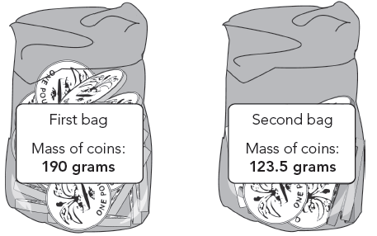
73 Here are two plastic bags of £1 coins.

The first bag contains 20 £1 coins.
How many £1 coins does the second bag contain?

2 marks
5.12b
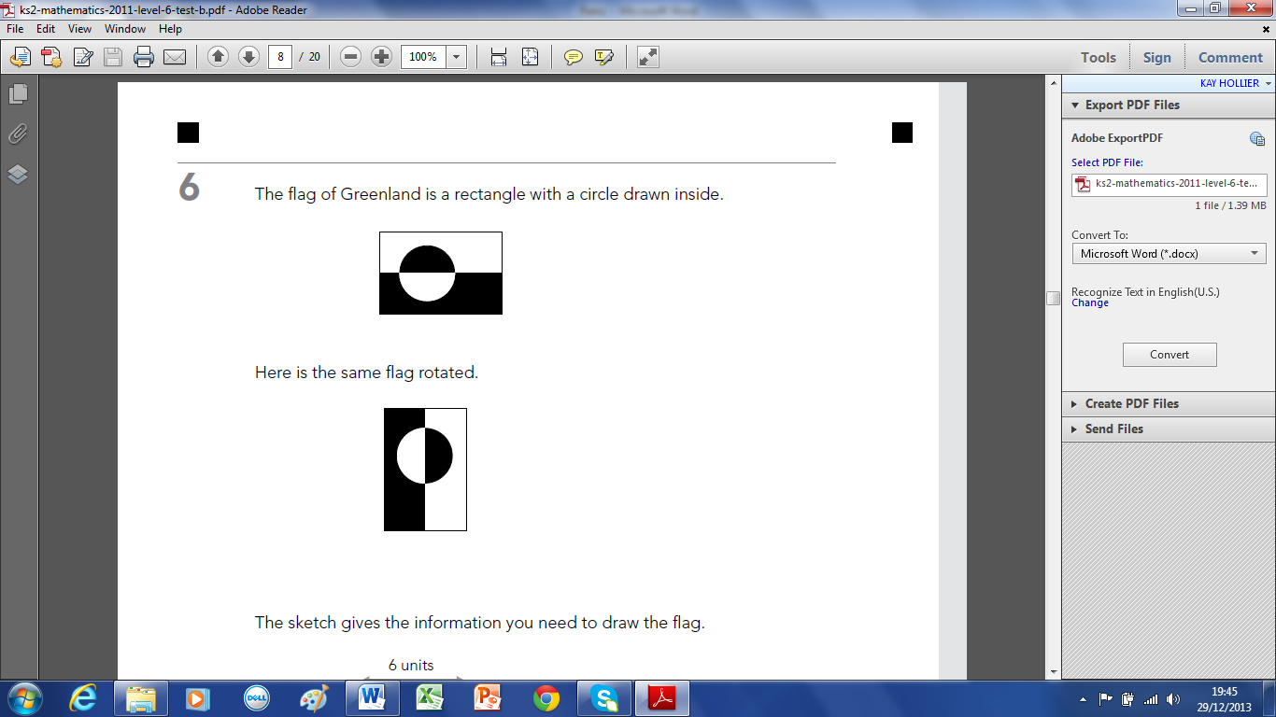
74 The flag of Greenland is a rectangle with a circle drawn inside. Here is the same flag rotated.

The sketch gives the information you need to draw the flag.
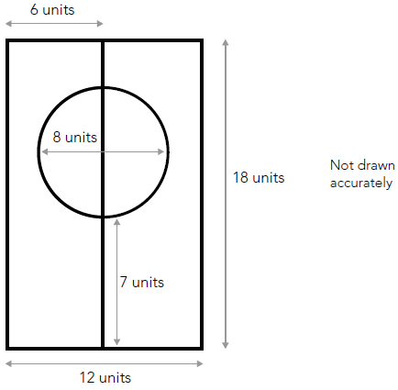
Use the correct mathematical equipment to draw accurately the flag of Greenland.
Some of the flag is drawn for you.
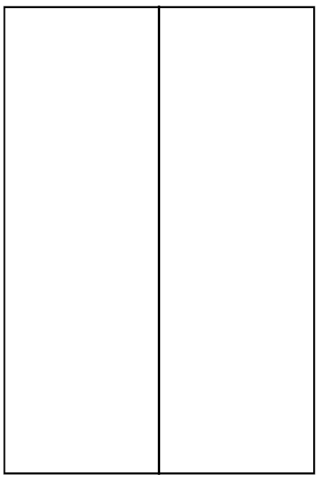

3 marks
6.11b

75 Here are two pieces of information about dogs called German Shepherds.
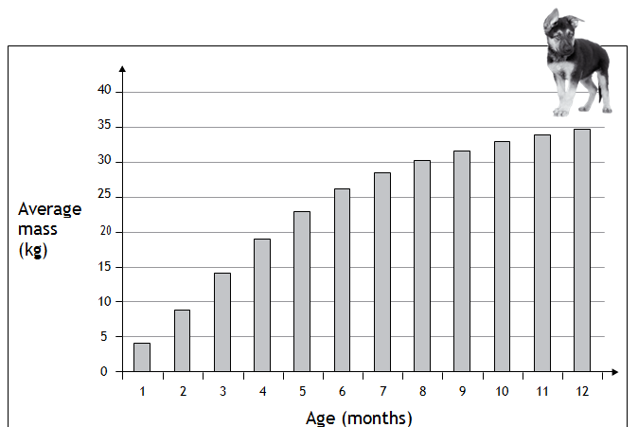

The average mass of an adult German Shepherd is about 35kg.

Use both pieces of information to summarise how German Shepherd dogs grow.

2 marks
12.11b

76 This is a graph of a firework rocket, showing its height at different times.
Estimate from the graph for how many seconds the rocket is more than 20 metres above the ground.

seconds

Estimate from the graph how many metres the rocket falls in the last second of its flight.

m
2 marks
4.1

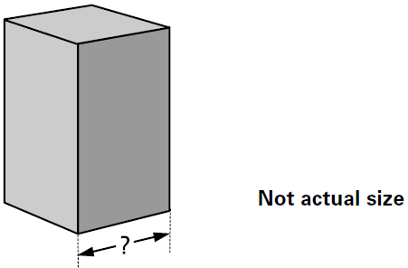
77 A cuboid has a square base.
It is twice as tall as it is wide.
Its volume is 250 cubic centimetres.

Calculate the width of the cuboid.
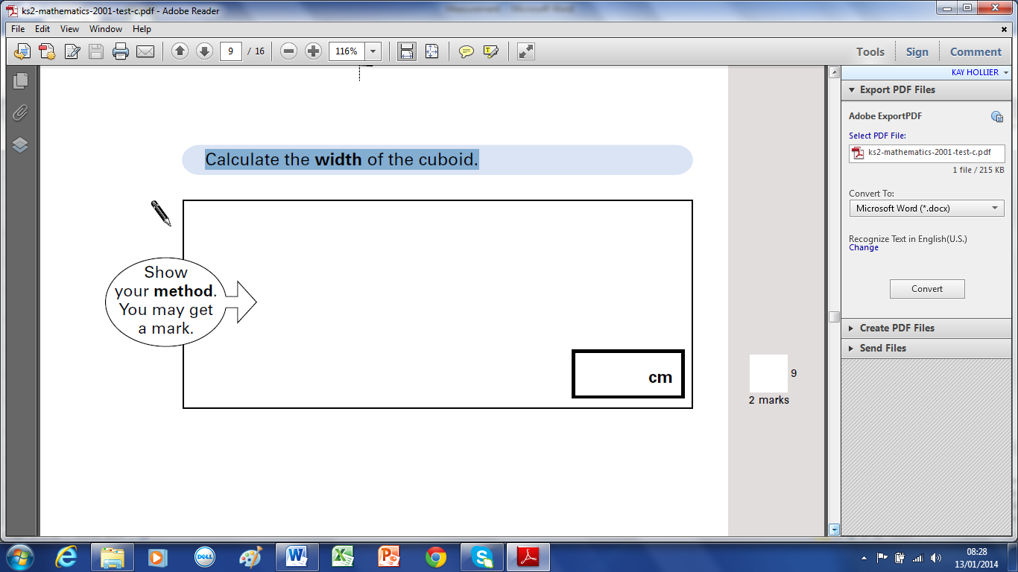

2 marks
9.1

78 Shortcrust pastry is made using flour, margarine and lard.
The flour, margarine and lard are mixed in the ratio 8 : 3 : 2 by weight.
How many grams of margarine and lard are needed to mix with 200 grams of flour?
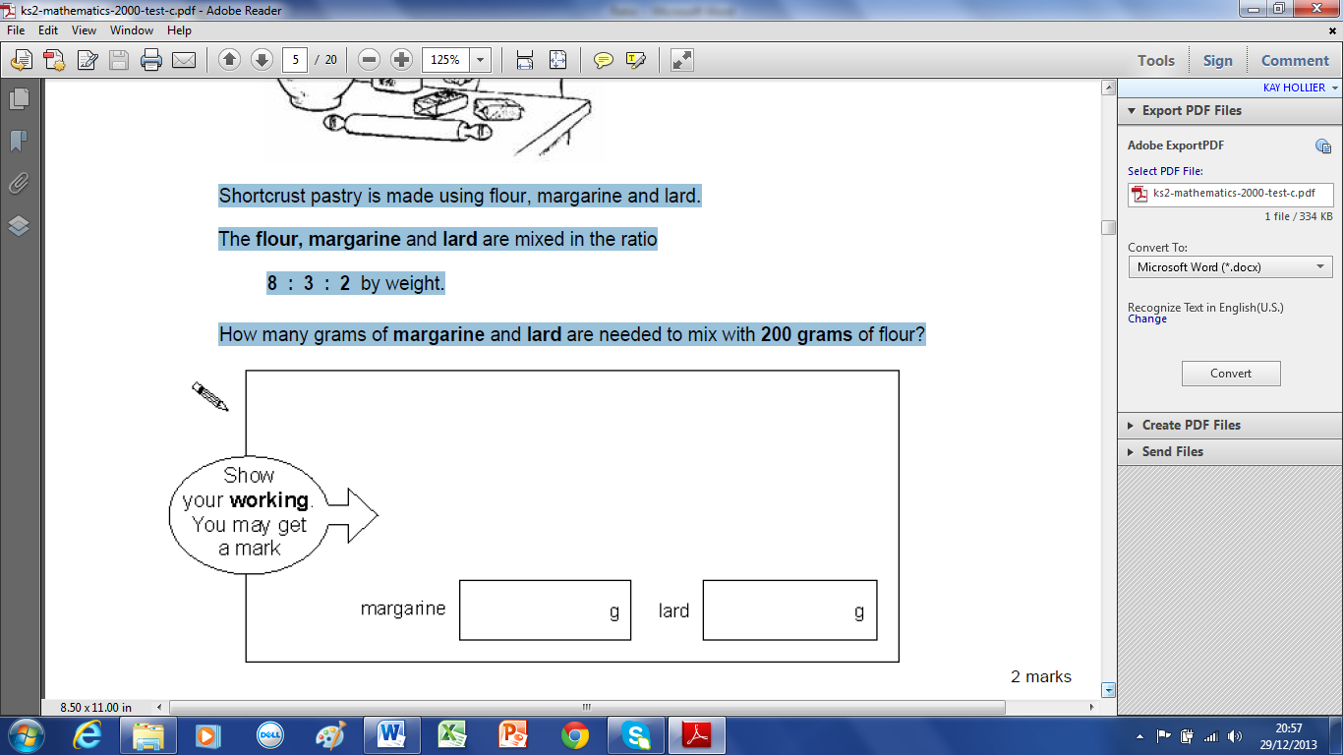

2 marks
1.0

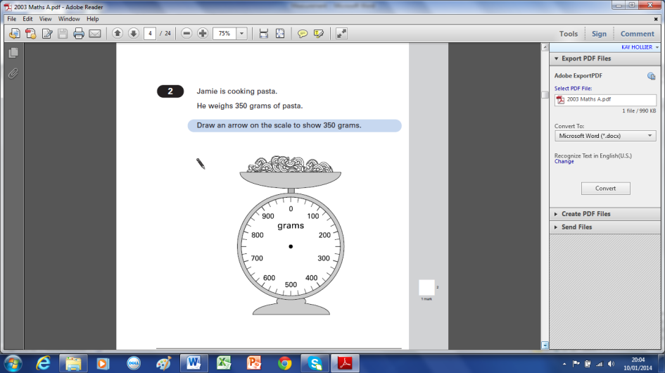
Solutions

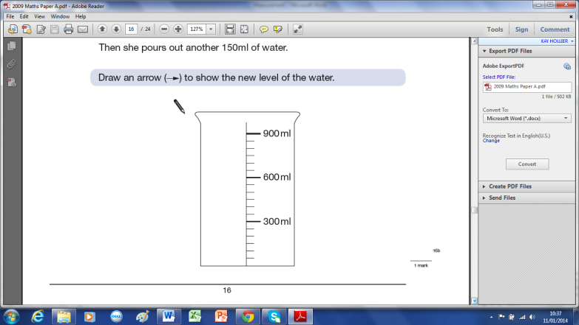
1 2 7.5cm, (accept 7.4 - 7.6cm)
3 8.4cm, (accept 8.3 - 8.5cm) 4 5.5cm, (accept 5.4 – 5.6cm)
5 125ml 6 A and C or C and D, line 10.5cm
7 1.5cm, 1cm 8
9 451km, 110km 10 5ºC, -3ºC
11 1700g 12 325g
13 5m 14 5, 7 degrees
15 50 degrees 16 (6x3)+(2x12)=18+24 = 42cm, 132÷12= 11bricks
17 18
19 20
21 22
23 24
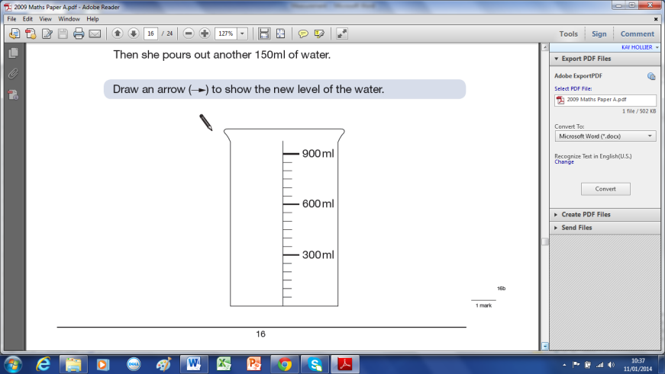
25 6l x 1000 ÷ 500ml = 12 26 Megan, Chen, Alfie, Nina
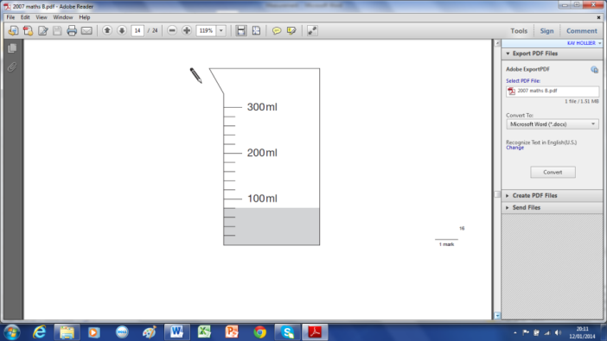
27 4.4kg, 5.6 - 4.4= 1.2kg 28 1200g, 0.25kg, 30g
29 25mm, 3.5cm, 20cm, ½ m 30 ½ kg, 800g, 2kg, 1 tonne
31 350ml, 32
33 500 – 140 = 360ml 34 22cm, 17cm
35 92 + (184 – 92) ÷ 2 = 92+46 = 138cm 36 2.8cm, 50=140m, 45=126cm, 42 =17.6cm
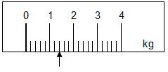
37 F=180 - 100 = 80cm, 80x2= 160cm 38 2C=800g, C=400g, A=400÷2 = 200g (or 800÷4)
39 1.9m, 2.6 - 0.8 = 1.8m 40 (800 – 500) ÷ 5 = 60g
41 42 8.40pm – 8.50pm, 3 degrees
43 (153 – (3x15))÷2 = 54cm 44 B, C, A, E, D
45 1.5kg=1500g, 1500÷30= 50 days 46
47 48
49 50 (320 ÷ 8) x 5 = 200 miles
51 AB is 3parts, BC is 1 part, 60cm = 4 parts, 1 part = 60 ÷ 4 = 15cm (BC), so 3 parts (AB) = 15 x 3 = 45cm
52 2b + 3s = 3m, b + s = 1.4m so 2b + 2s = 2.8m so 1s = 3m – 2.8m = 0.2m or 20cm
53 (45 ÷ 1.25) – (45 ÷ 2.25) = 36 – 20 = 16 54 1 + (280 – 30) ÷ 25 = 11
55 2l = 2000ml, 2000ml ÷ 8 = 250ml
56 4 x 10 = 40, need (0.5 ÷ 2 x 5) = 1.25l, 1.25 – 1 = 0.25l = 250ml
57 400 grams, 1.2kg or 1200g 58 7.2cm ÷ 2 = 3.6cm, 7.2cm + 3.6cm = 10.8cm
59 92cm ÷ 100 = 0.92m, 0.92 x 100 = 9.2m, 100 60 10cm + 8cm + 8cm + 8cm + 8cm = 42cm
61 x = 50 – 16 = 34cm, y = 50 + (2 x 16) = 82cm
62 1l + 1s = 28, 1l + 2s = 36, so 1s = 36 – 28 = 8cm, 1l + 8 = 28 so 1l = 20cm
63 6g x 8 = 48g fibre/loaf, 48g ÷ 20 = 2.4g 64 (45-12) ÷220 = 33÷220 = 3÷20 = 1.5÷10 = 0.15g
65 17.5x4÷5 = 70÷5 = 14cm 66 36÷4=9, 36÷3=12, 12-9=3, 36+3 = 39cm
67 £10÷5p=200, 1.8x200 = 3.6m 68
69 70 a
71 72
73 74
75 76
77 78

