Problem Solving
Measurement and Time

Level 3 – 5 Questions 1 – 36
Level 6 Questions 37 – 43

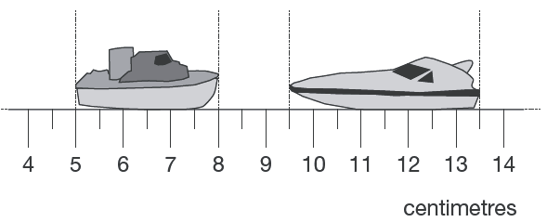
1 Here are two model boats on a centimetre scale.
How far apart are the boats?

cm

What is the difference in the lengths of the two boats? cm
2 marks
7.11b
2 The diagram shows distances on a train journey from Exeter to York.
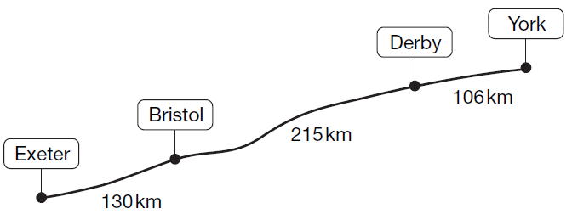

How many kilometres is it altogether from Exeter to York?
km

What is the distance from Derby to York rounded to the nearest 10 km?

km
2 marks
8.6a

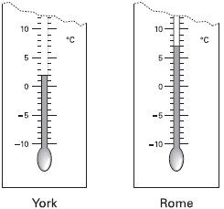
3 These are the temperatures in York and Rome on a day in winter.
How many degrees colder is it in York than in Rome?

ºC

On another day, the temperature in York is 4ºC
Rome is 7 degrees colder than York.
What is the temperature in Rome?
ºC
2 marks
8.0a

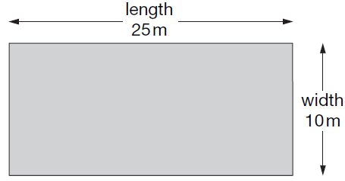
4 A rectangular swimming pool is 25 metres long and 10 metres wide.

David swims 5 lengths. Rosie swims 12 widths.
How much further does David swim than Rosie?
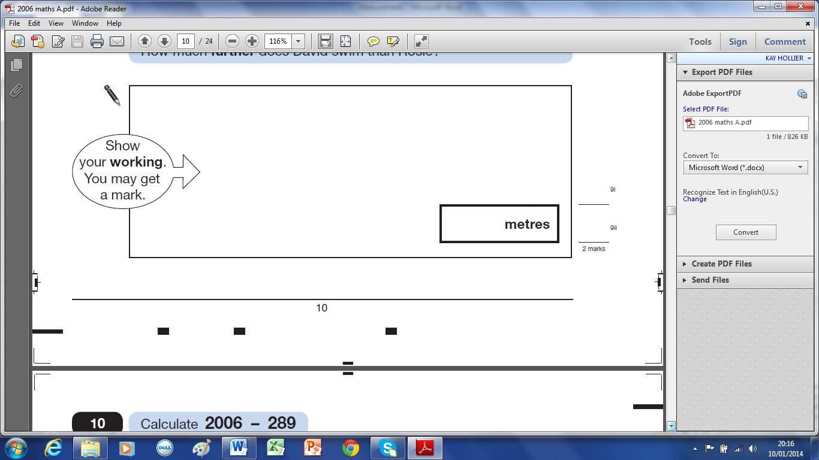

2 marks
9.6a

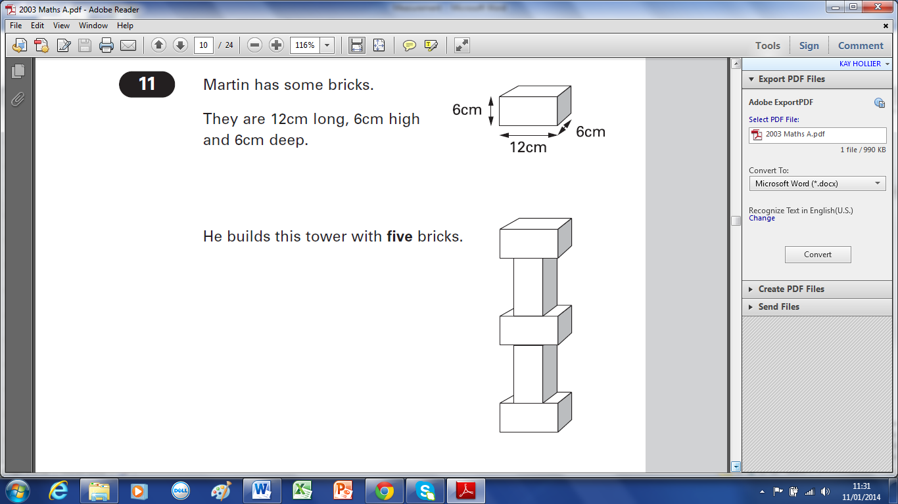
5 Martin has some bricks.
They are 12cm long, 6cm high and 6cm deep.

He builds this tower with five bricks.
How tall is the tower?

cm

Each brick is 12cm long.
Martin makes a line of bricks 132cm long.
How many bricks does he use?
2 marks
11.3a

6 A bottle holds 1 litre of lemonade.
Rachel fills 5 glasses with lemonade. She puts 150 millilitres in each glass.
How much lemonade is left in the bottle?
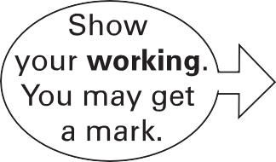
ml

2 marks
12.3a

7 Here are the ingredients for fish pie for two people.
Fish Pie
(for 2 people)
250g fish
400g potato
25g butter

Omar makes fish pie for 3 people.
How many grams of fish should he use?
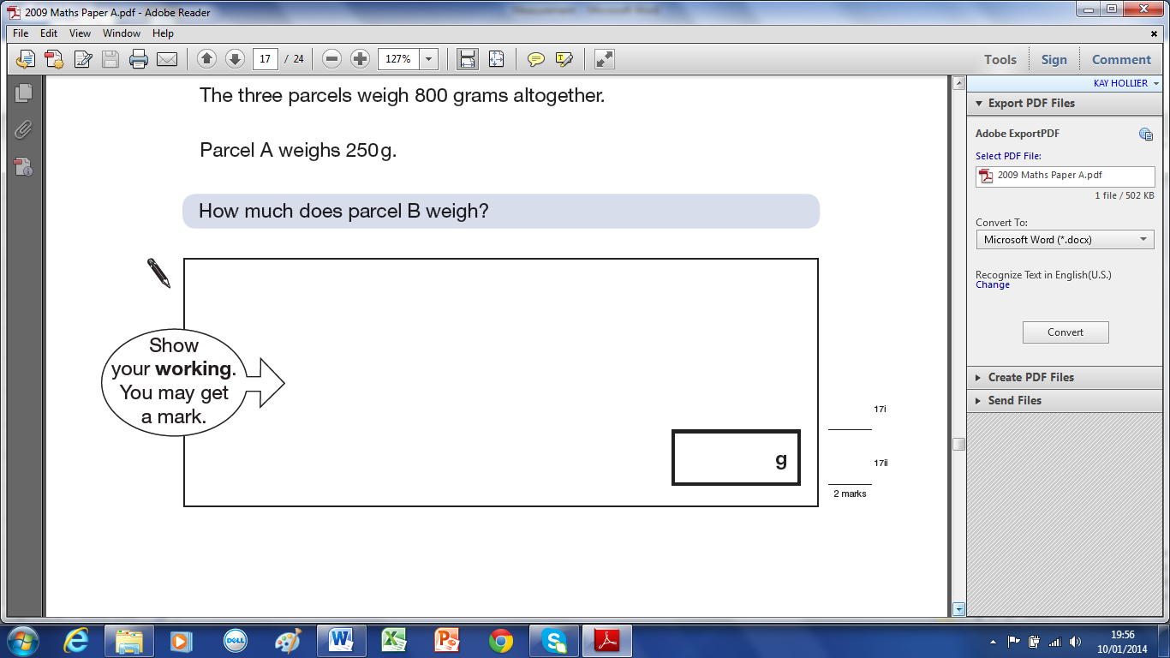

2 marks
14.97b

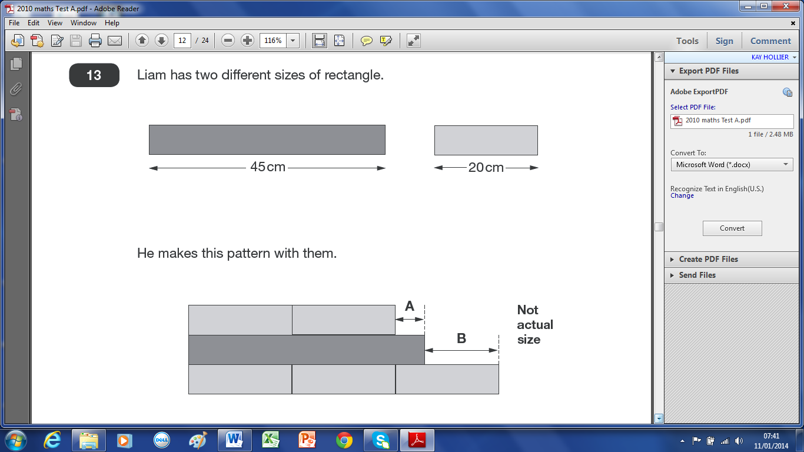
8 Liam has two different sizes of rectangle.

He makes this pattern with them.

Calculate the lengths of A and B.

A = cm B = cm
2 marks
13.10a

9 Megan wants to fill a bucket with water.
A bucket holds 6 litres.
A jug holds 500 millilitres.
How many jugs of water does Megan need to fill an empty bucket?
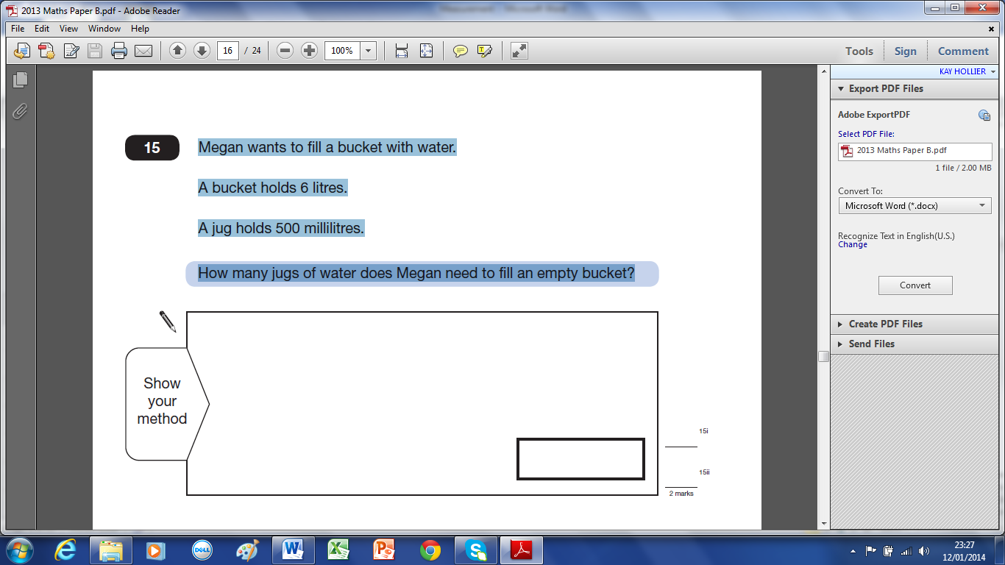

2 marks
15.13b

10 Four children are in a race.
Chen is 2 metres ahead of Alfie.
Nina is 5 metres behind Megan.
Alfie is 3 metres behind Megan.
Write the names of the runners in order, starting with the child who is furthest ahead.

furthest ahead
1 mark
15.13a

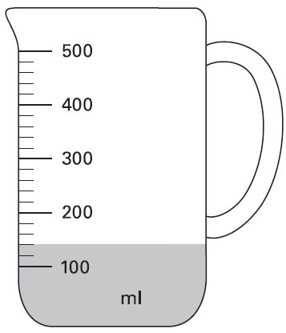
11 Mr Khan makes a blackcurrant drink for a party.
He pours blackcurrant squash into a jug.
How much water must he add to make 500 millilitres
of drink?

ml
1 mark
16.4a
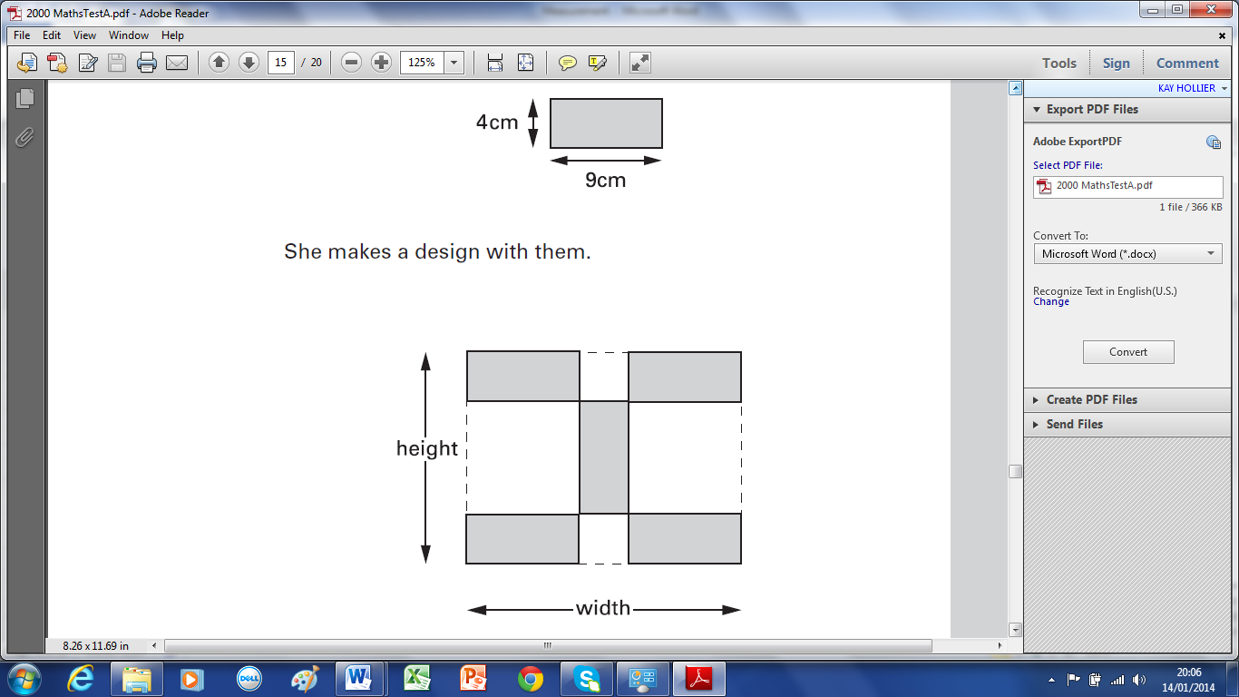
12 Kim has some rectangular tiles.
Each one is 4 centimetres by 9 centimetres.

She makes a design with them.

Calculate the width and height of her design.

width = cm height = cm
2 marks
16.0a

13 Julie is 92cm tall. Tom is 184cm tall.
Lisa’s height is half-way between Julie’s height and Tom’s height.
Calculate Lisa’s height.
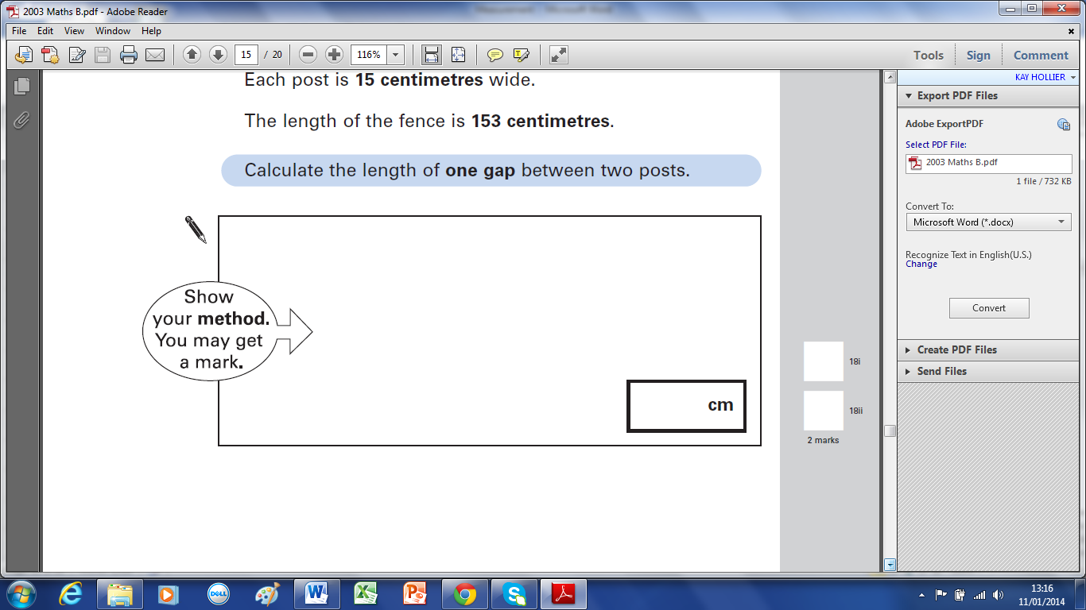

2 marks
16.98b

14 Vicki puts 10 books on a shelf.
The 10 books take up 28 centimetres.
What is mean (average) thickness of her books?

The shelf is 120 centimetres long.
Vicki fills the shelf with a mixture of books like the first ten books.
Estimate how many books she can get on the 120cm shelf.

4 marks
16.96a

15 Freddie is half as tall as his mother.
Freddie is one metre shorter than his father.
Freddie’s father is 180 centimetres tall.
How many centimetres tall is Freddie’s mother? cm
1 mark
17.12a
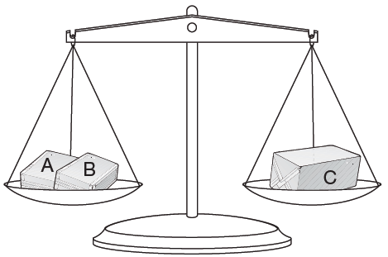
16 Amir has three parcels.

Parcels A and B together weigh the same as parcel C.
The three parcels weigh 800 grams altogether.
Parcel A weighs 250g.

How much does parcel B weigh?

2 marks
17.9a

17 Lin has five books which are all the same.
She balances them on the scale with two weights.

Calculate the weight of one block.
500grams 800 grams

2 marks
17.6b
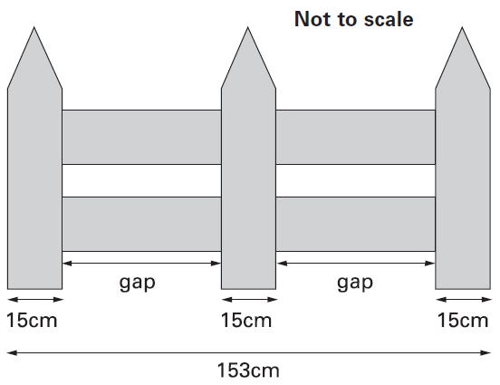
18 This fence has three posts, equally spaced.

Each post is 15 centimetres wide.
The length of the fence is 153 centimetres.

Calculate the length of one gap between two posts.

2 marks
18.3b

19 A packet contains 1.5 kilograms of guinea pig food.
Remi feeds her guinea pig 30 grams of food each day.
How many days does the packet of food last?
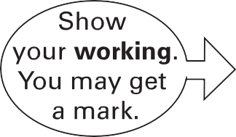

2 marks
19.3a

20 Here is a recipe for raspberry ice cream.
This recipe is for 8 people.
Josie makes enough raspberry ice cream for 12 people.
How much cream does she use?

litres

Fred makes raspberry ice cream in the same way.
He uses 2½ kg of raspberries.
How much sugar does he use?

3 marks
19.1b

21 Chen and Megan each have a parcel.
Chen’s parcel weighs 112kg.
Megan’s parcel weighs 1.2kg.
How many more grams does Chen’s parcel weigh than Megan’s parcel?

grams
2 marks
20.13a

A
60cm
C
B
22 The distance from A to B is three times as far as from B to C.
The distance from A to C is 60 centimetres.
Calculate the distance from A to B.

2 marks
21.2b

23 Mr Jones has two sizes of square paving stones.
1.4m
3m
He uses them to make a path.

The path measures 3 metres by 1.4 metres.
Calculate the width of a small paving stone.
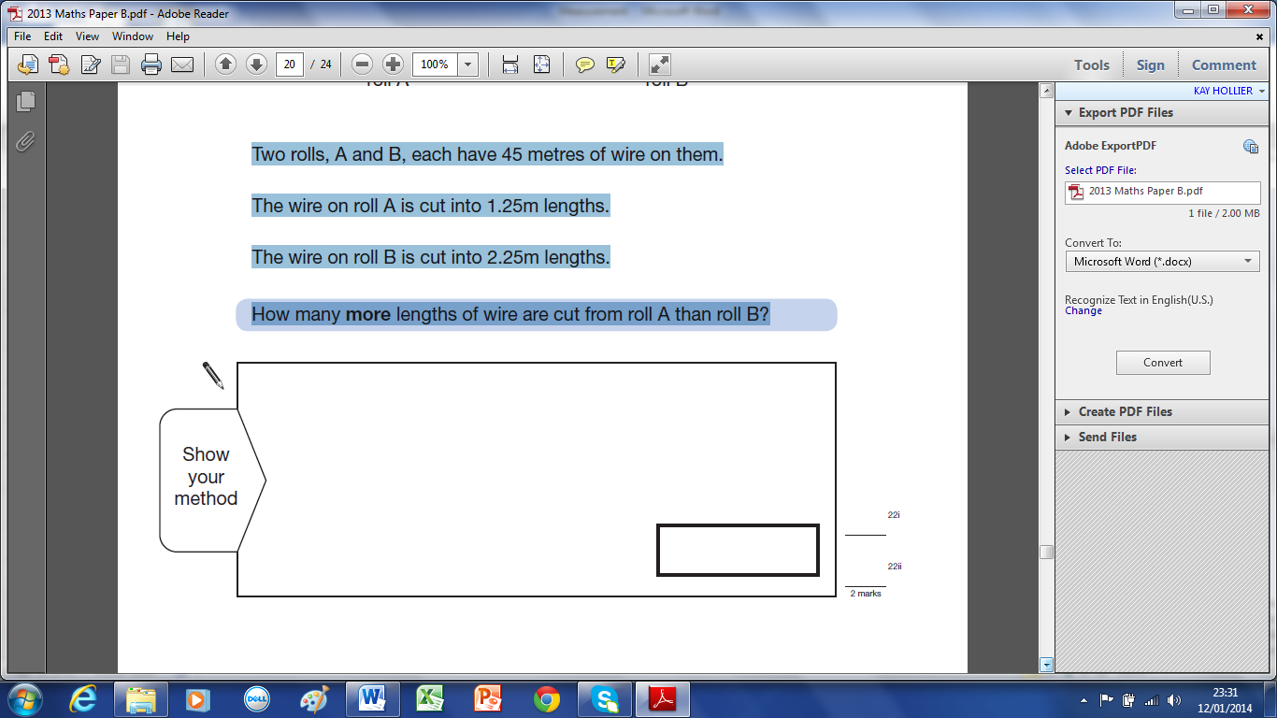

2 marks
21.99b
24 A shop sells rolls of wire.
Two rolls, A and B, each have 45 metres of wire on them.
The wire on roll A is cut into 1.25m lengths.
The wire on roll B is cut into 2.25m lengths.
How many more lengths of wire are cut from roll A than roll B?

2 marks
22.13b
25 Strips of paper are 30 centimetres long.
30cm
Steve joins strips of paper together to make a streamer.
30cm
30cm
5cm
5cm

The strips overlap by 5cm.
How long is a streamer made from only 2 strips? cm

Sunita makes a streamer that is 280cm long.
How many strips does she use?

3 marks
22.97a

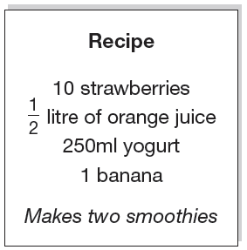
26 Here is a recipe for fruit smoothies.
Stefan uses the recipe to make smoothies.
He uses 1 litre of yogurt.
How many strawberries does he use?

Amir uses the same recipe.
He wants to make 5 smoothies.
He has 1 litre of orange juice.
How many more millilitres of orange juice does he need?
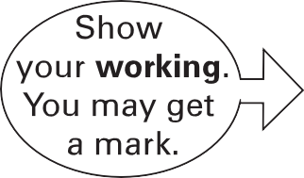

ml
2 marks
22.9b

27 Here is a rectangle with six identical shaded squares inside it.
7.2cm
The width of the rectangle is 7.2 centimetres.
Calculate the length of the rectangle.
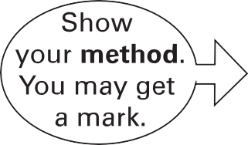

cm
2 marks
22.4b

28 Each paper clip is made from a 9.2 centimetres of wire.
What is the greatest number of paper clips that can be made from 10 metres of wire?

2 marks
22.98b

29 Josh has some tiles.
Each tile is 10cm long. Two tiles fitted together are 18cm long.
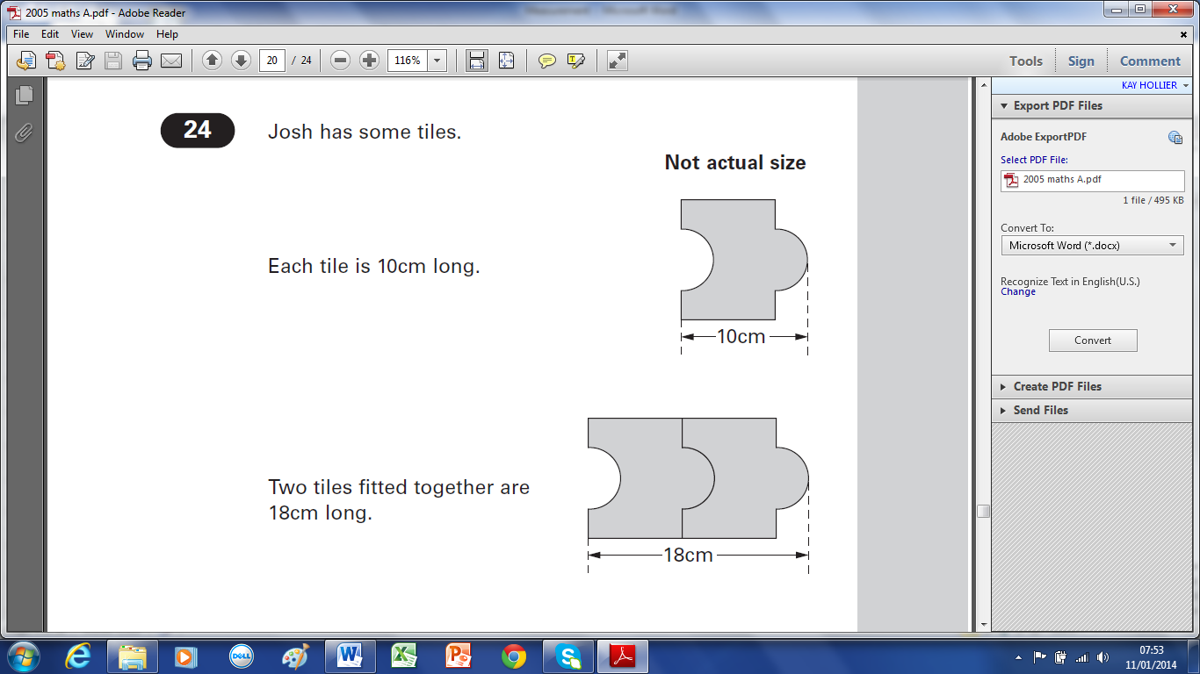

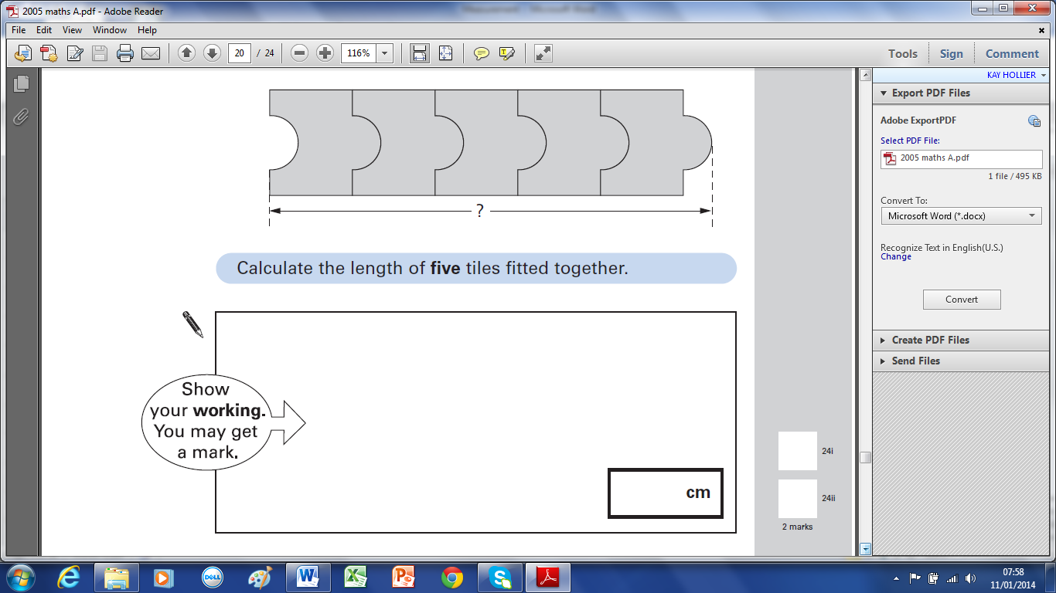
Calculate the length of five tiles fitted together.

2 marks
24.5a

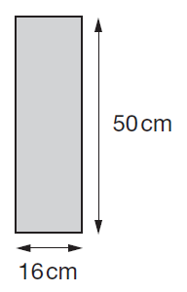
30 Kate has some rectangles.
They each measure 16 centimetres by 50 centimetres.
She makes this design with four of the rectangles.
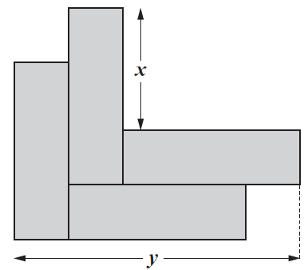

Work out the lengths x and y.
x = cm
y = cm
2 marks
23.7b

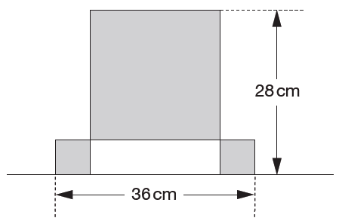
31 This design has one large square and two identical small squares.
The design measures 36 centimetres by 28 centimetres.

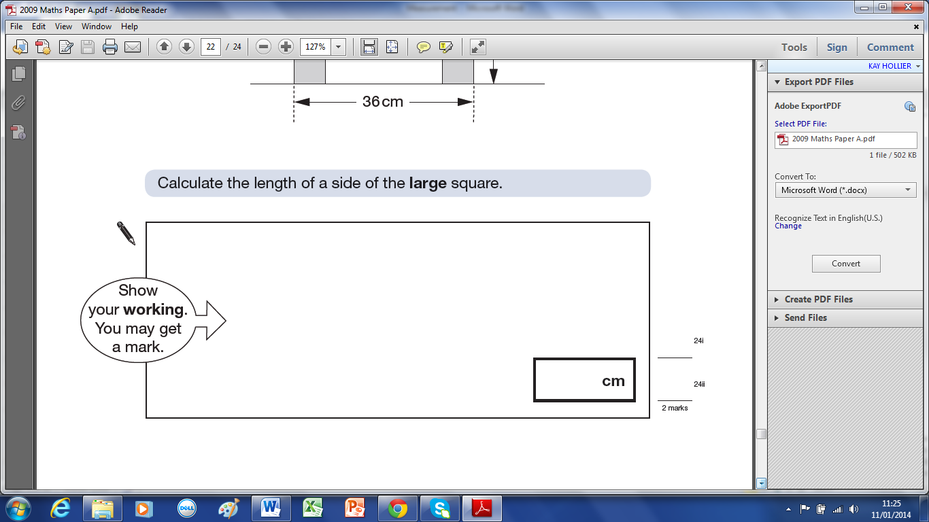
Calculate the length of a side of the large square.

2 marks
24.9a

32 Every 100g of brown bread contains 6g of fibre.
A loaf of bread weighs 800g and has 20 equal slices.
How much fibre is there in one slice?
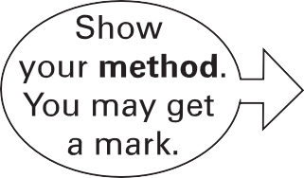

g
2 marks
24.4b

33 A box contains 220 matches and weighs 45 grams. The empty box weighs 12 grams.
Calculate the weight of one match.

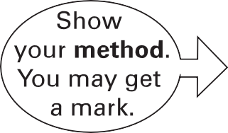

g
2marks
25.5b

34 Four large circles and five small circles fit exactly inside this rectangle.
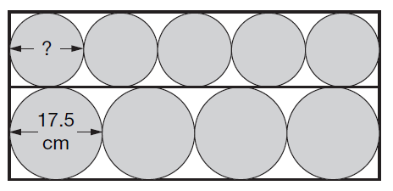

The diameter of a large circle is 17.5 centimetres.

Calculate the diameter of a small circle.

cm
2 marks
25.6b

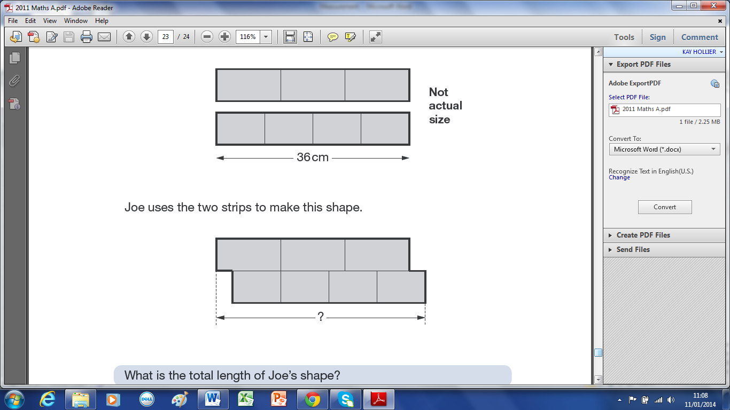
35 Joe has two strips of card.
Each strip is 36 centimetres long.
One strip is divided into three equal parts.
The other strip is divided into four equal parts.

Joe uses the two strips to make this shape.
What is the total length of Joe’s shape?

cm
2 marks
25.11a

36 A 5p coin has a diameter of 1.8 centimetres. Holly makes a straight line of 5p coins worth £10
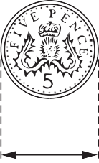
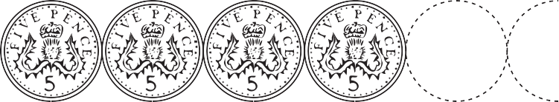

£10
1.8 cm
How long is Holly’s line? Give your answer in metres.

m
2 marks
26.11b

37 In a zoo, the adult polar bear weighs three times more than the baby elephant.
Together they weigh 700 kilograms.
How much does the polar bear weigh?
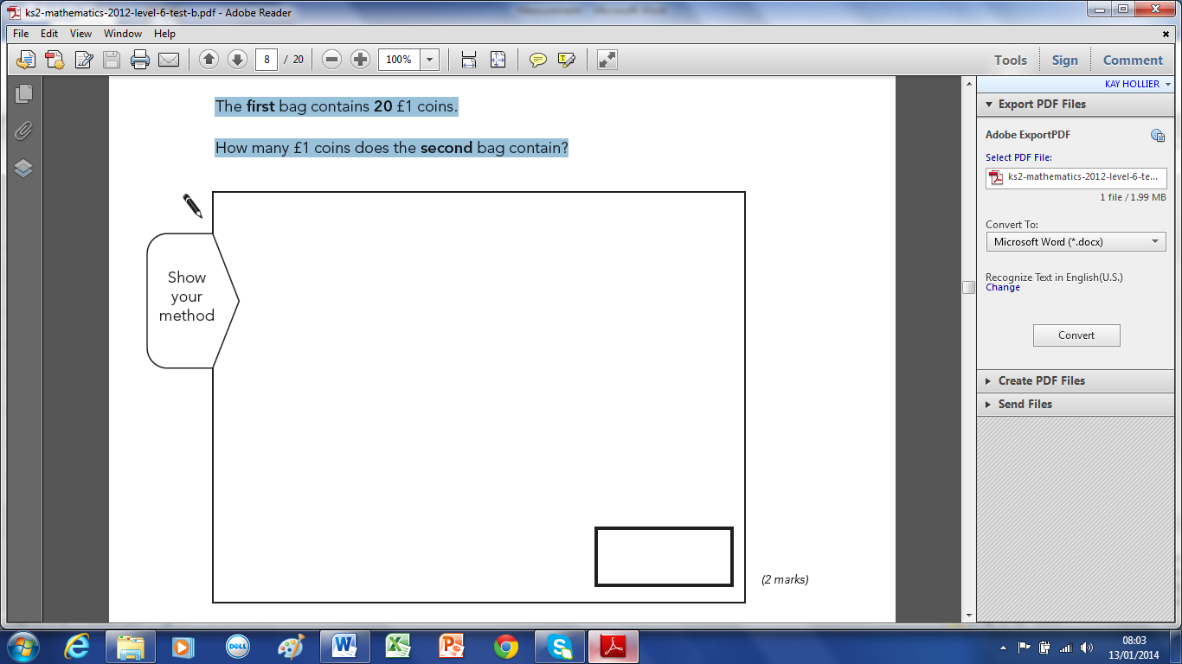

2 marks
2.13b

38 Megan goes on a walking holiday for five days.
The table shows how far she walked on the first four days.
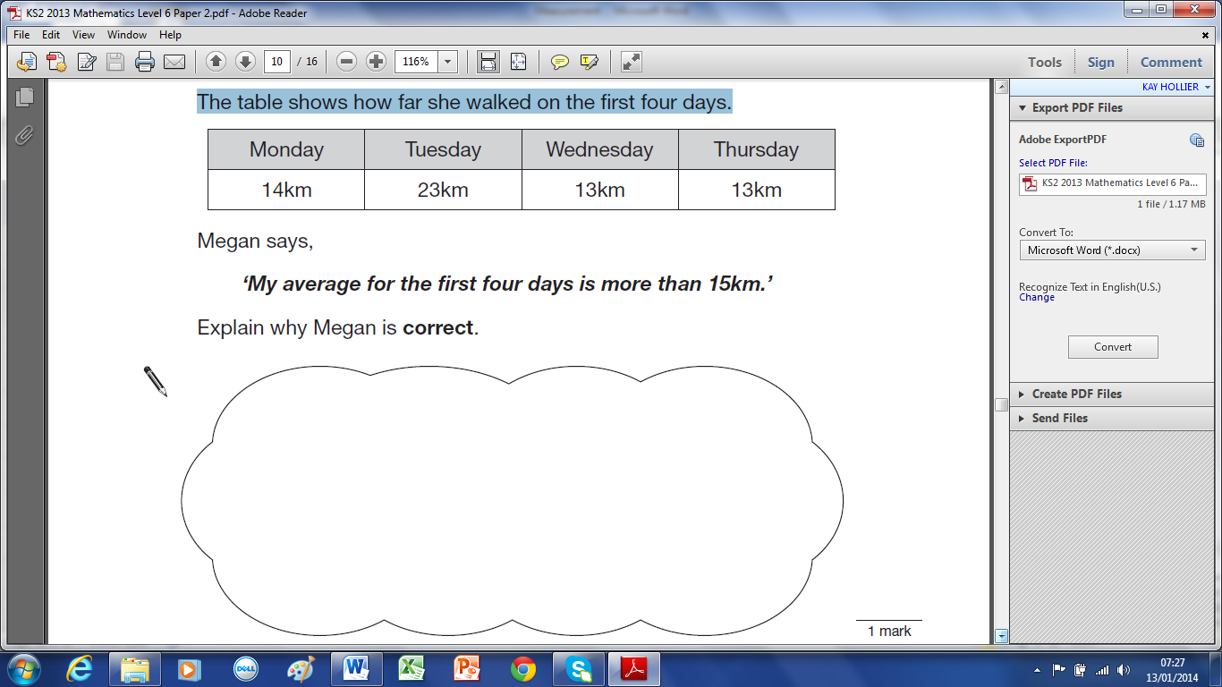

Megan says,
‘My average for the first four days is more than 15km.’
Explain why Megan is correct.

2 marks
7.13b

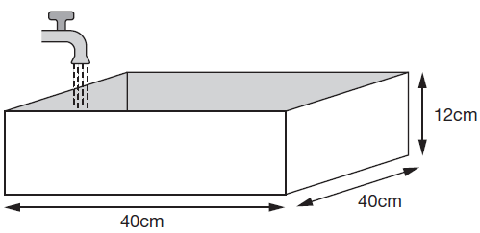
39 Every second, 300cm3 of water comes out of a tap into a cuboid tank.

The base of the tank is 40cm by 40cm
The height is 12cm
How many seconds does it take to fill the tank?
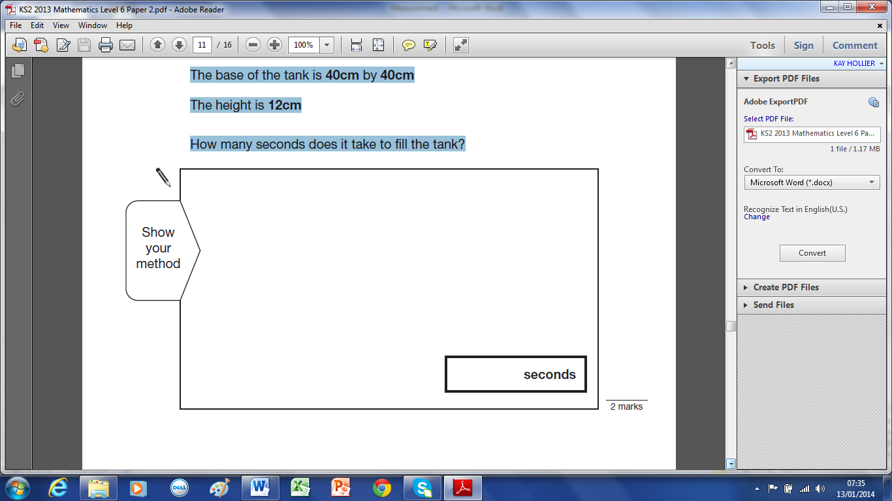

2 marks
8.13b

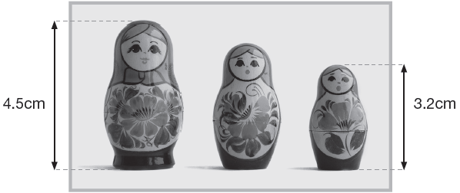
40 This photograph shows three Russian dolls.

The real-life height of the largest Russian doll is 13.5cm
What is the real-life height of the smallest Russian doll?

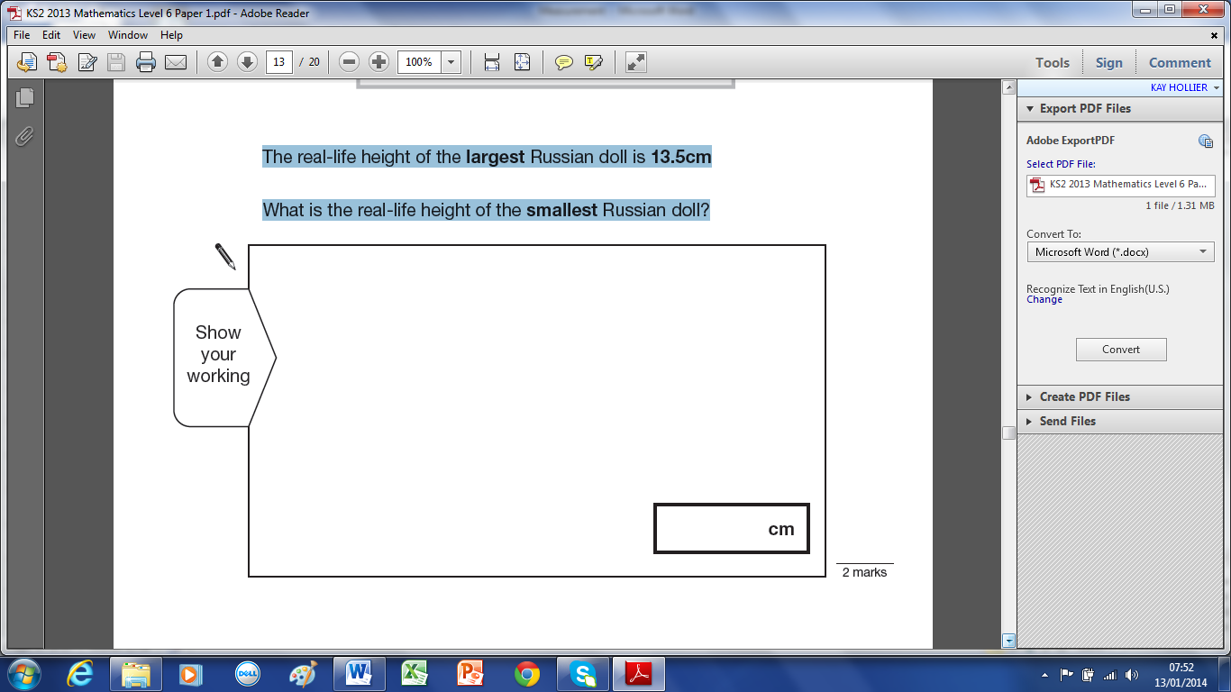

2 marks
10.13a

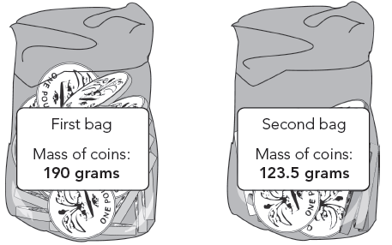
41 Here are two plastic bags of £1 coins.

The first bag contains 20 £1 coins.
How many £1 coins does the second bag contain?

2 marks
5.12b

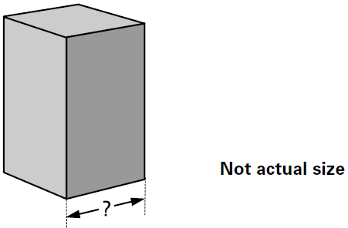
42 A cuboid has a square base.
It is twice as tall as it is wide.
Its volume is 250 cubic centimetres.

Calculate the width of the cuboid.
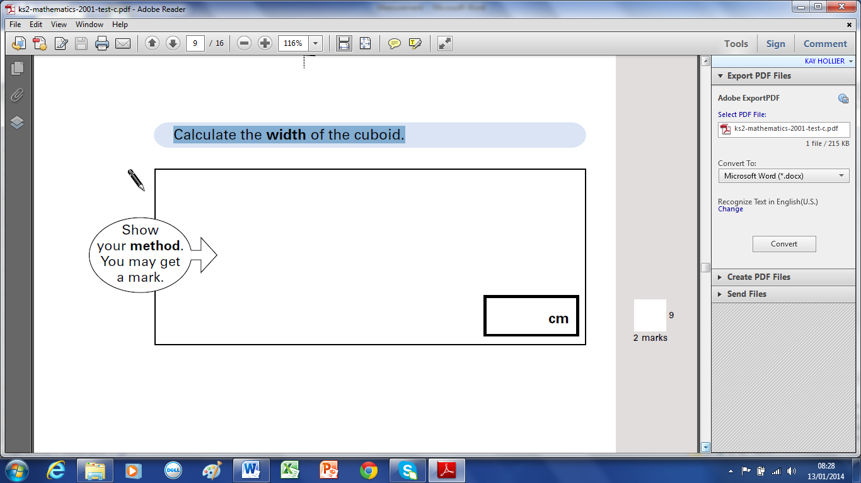

2 marks
9.1

43 Shortcrust pastry is made using flour, margarine and lard.
The flour, margarine and lard are mixed in the ratio 8 : 3 : 2 by weight.
How many grams of margarine and lard are needed to mix with 200 grams of flour?
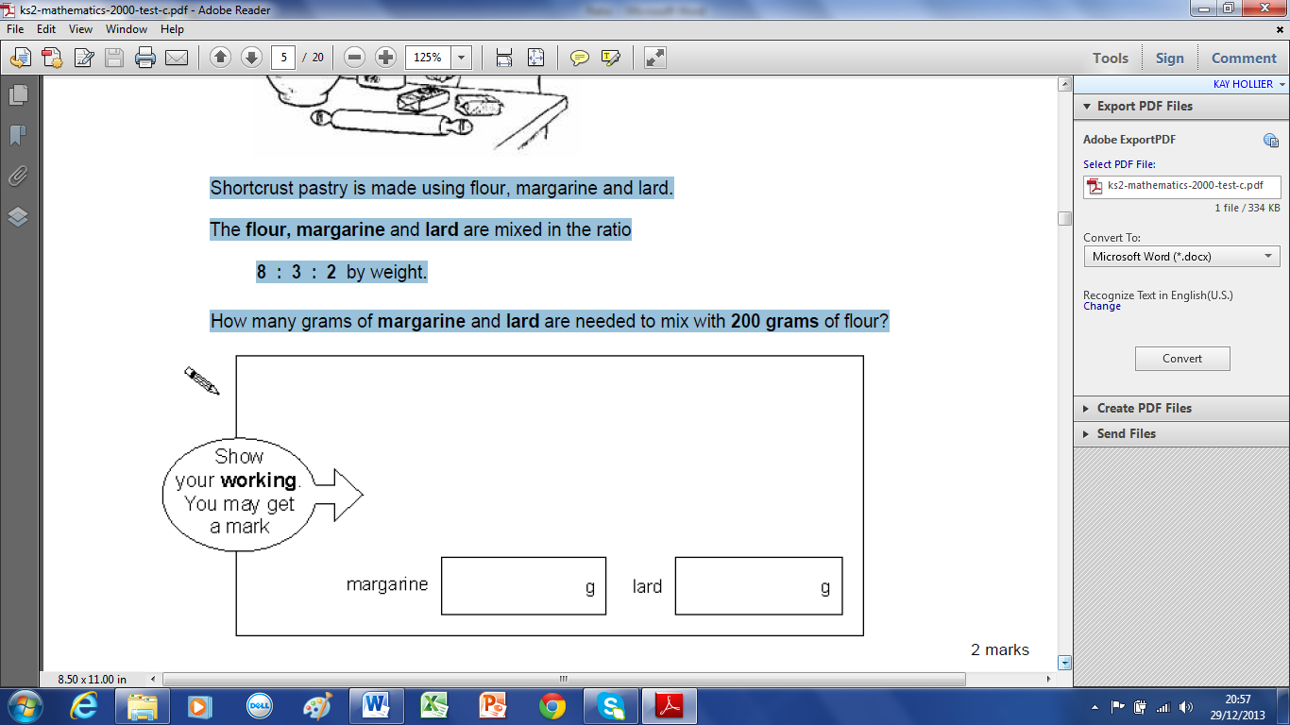

2 marks
1.0

Solutions

1 1.5cm, 1cm
2 451km, 110km
3 5ºC, -3ºC
4 5m
5 (6x3)+(2x12)=18+24 = 42cm, 132÷12= 11bricks
6
7
8
9 6l x 1000 ÷ 500ml = 12
10 Megan, Chen, Alfie, Nina
11 500 – 140 = 360ml
12 22cm, 17cm
13 92 + (184 – 92) ÷ 2 = 92+46 = 138cm
14 2.8cm, 50=140m, 45=126cm, 42 =17.6cm
15 F=180 - 100 = 80cm, 80x2= 160cm
16 2C=800g, C=400g, A=400÷2 = 200g (or 800÷4)
17 (800 – 500) ÷ 5 = 60g
18 (153 – (3x15))÷2 = 54cm
19 1.5kg=1500g, 1500÷30= 50 days
20
21
22 AB is 3parts, BC is 1 part, 60cm = 4 parts, 1 part = 60 ÷ 4 = 15cm (BC), so 3 parts (AB) = 15 x 3 = 45cm
23 2b + 3s = 3m, b + s = 1.4m so 2b + 2s = 2.8m so 1s = 3m – 2.8m = 0.2m or 20cm
24 (45 ÷ 1.25) – (45 ÷ 2.25) = 36 – 20 = 16
25 1 + (280 – 30) ÷ 25 = 11
26 4 x 10 = 40, need (0.5 ÷ 2 x 5) = 1.25l, 1.25 – 1 = 0.25l = 250ml
27 7.2cm ÷ 2 = 3.6cm, 7.2cm + 3.6cm = 10.8cm
28 92cm ÷ 100 = 0.92m, 0.92 x 100 = 9.2m, 100
29 10cm + 8cm + 8cm + 8cm + 8cm = 42cm
30 x = 50 – 16 = 34cm, y = 50 + (2 x 16) = 82cm
31 1l + 1s = 28, 1l + 2s = 36, so 1s = 36 – 28 = 8cm, 1l + 8 = 28 so 1l = 20cm
32 6g x 8 = 48g fibre/loaf, 48g ÷ 20 = 2.4g
33 (45-12) ÷220 = 33÷220 = 3÷20 = 1.5÷10 = 0.15g
34 17.5x4÷5 = 70÷5 = 14cm
35 36÷4=9, 36÷3=12, 12-9=3, 36+3 = 39cm
36 £10÷5p=200, 1.8x200 = 3.6m
37
38
39 a
40
41
42
43

